Integrated Energy Resource Master Plan (IERMP)
25 July 2025

Submitted to the Ministry of Energy and Mineral Development (MEMD)

Resource assessment report


Contributors
This report was prepared by:

Economic Consulting Associates Limited
41 Lonsdale Road, London NW6 6RA,
United Kingdom
tel: +44 20 7604 4546
fax: +44 20 7604 4547
www.eca-uk.com


Norconsult AS
Vestfjordgaten 4, 1338 Sandvika.
Norway
+ 47 67 57 10 00
www.norconsult.com

Research for Transformation and Development
Plot 8-10 Kampala Road, Uganda House, 5th Floor,
P.O. Box 25582, Kampala,
Uganda
+256-776-130913
www.rtdug.org

This report (including any enclosures and attachments) has been prepared for the exclusive use and benefit of the Ministry of Energy and Mineral Development Uganda and solely for the purpose for which it is provided. Unless we provide express prior written consent, no part of this report should be reproduced, distributed, or communicated to any third party. We do not accept any liability if this report is used for an alternative purpose from which it is intended, nor to any third party in respect of this report.

Contents
Contributors 1
Contents 2
Tables and figures 3
Abbreviations and acronyms 7
1 Introduction 9
2 Assessment of Uganda’s energy resources 12
2.1 Crude oil and crude oil distillates 12
2.2 Natural gas 17
2.3 Liquified Petroleum Gas (LPG) 20
2.4 Coal resources 21
2.5 Nuclear resources 22
2.6 Peat resources 24
2.7 Solar resources 24
2.8 Wind resources 28
2.9 Hydro resources 31
2.10 Geothermal resources 33
2.11 Biomass and bioenergy resources 34
2.12 Wave and tidal resources 39
2.13 Fuels price forecast and transportation costs 39
3 Candidate options for the IERMP 46
3.1 Existing power plants 47
3.2 Committed power plants 51
3.3 Candidate power plant options 52
3.4 Screening analysis for candidate power plants 70
3.5 Summary of existing committed and candidate power plants 72
3.6 Transmission and distribution network 74
4 Import options analysis 79
4.1 Potential for imports from Kenya 80
4.2 Potential for imports from Tanzania 81
4.3 Potential for imports from DRC 82
4.4 Potential for imports from Rwanda 83
4.5 Potential for imports from South Sudan 83
4.6 Potential for imports from Ethiopia 84
4.7 Import risk matrix 85
5 Policy considerations and targets 87
5.1 Vision 2040 87
5.2 National Energy Policy for Uganda 2023 88
5.3 Climate change and environment 88
5.4 Renewables 89
5.5 Oil and gas sector policies 90
5.6 Summary of policy targets to be accounted in the IERMP 90
6 Planning criteria and modelling approach 92
6.1 Generation plan 92
6.2 Transmission plan 93
6.3 Distribution plan and electrification 94
6.4 Modelling software 94
6.5 Modelling demand, generators, storage and imports 95
6.6 Planning criteria 97
6.7 Economic and financial parameters 100
6.8 Planning horizon 101
7 IERMP scenarios and sensitivities 102
Annexes 104
A1 Maps with excluded areas for solar PV and wind development 104

Tables and figures
Tables
Table 1 Status of licensing in the Albertine Graben, December 2022 14
Table 2 Historical imports of petroleum products, 2022 16
Table 3 Non-associated and associated gas reserves 18
Table 4 Associated gas profiles and orientation of Kingfisher and Tilenga fields 18
Table 5 Forecast LPG production from Kingfisher and Tilenga fields 20
Table 6 Exclusion parameters for the solar mapping analysis 25
Table 7 Exclusion parameters for the wind mapping analysis 29
Table 8 Energy Potential per year from Uganda key agricultural crop residues 35
Table 9 Energy Potential per year from Uganda key animal residues 36
Table 10 Netback natural gas price in Uganda, 2024 42
Table 11 Existing large (>20 MW) hydro power plants 48
Table 12 Existing small (<20 MW) hydro power plants 50
Table 13 Existing thermal power plants 50
Table 14 Existing solar PV power plants 51
Table 15 Committed power plants 51
Table 16 Generic candidate CCGT – Technoeconomic assumptions 52
Table 17 Generic candidate OCGT – Technoeconomic assumptions 52
Table 18 Generic candidate ICE – Technoeconomic assumptions 53
Table 19 Maximum potential capacity for solar PV development by candidate area 55
Table 20 Generic candidate utility scale solar PV – Technoeconomic assumptions 56
Table 21 Generic candidate floating solar PV – Technoeconomic assumptions 57
Table 22 Maximum potential capacity for wind development by candidate project 59
Table 23 Generic candidate onshore wind – Technoeconomic assumptions 59
Table 24 Candidate geothermal projects 60
Table 25 Generic candidate geothermal – Technoeconomic assumptions 60
Table 26 Candidate biomass and biogas projects – Technoeconomic assumptions 61
Table 27 Generic candidate biomass and biogas power plants – Technoeconomic assumptions 61
Table 28 Generic Peat Plant – Technoeconomic assumptions 62
Table 29 Kampala waste-to-energy plant – Technoeconomic assumptions 63
Table 30 Buyende nuclear candidate power plants – Technoeconomic assumptions 65
Table 31 Generic candidate nuclear plants – Technoeconomic assumptions 65
Table 32 Candidate large hydropower projects 66
Table 33 Candidate small hydropower projects 67
Table 34 Candidate generic hydrogen options – Technoeconomic parameters 68
Table 35 Lithium battery costs with a duration of 1-2 h and a capacity of 1-10 MW 69
Table 36 Summary of Uganda existing power plants 72
Table 37 Summary of Uganda committed power plants 73
Table 38 Summary of Uganda candidate power plants 73
Table 39 Recently completed and ongoing projects Uganda 75
Table 40 Committed Projects 75
Table 41 Regional Interconnection Projects 76
Table 42 Households with grid connection 78
Table 43 Optimised least cost imports from Kenya, % of interconnector capacity 80
Table 44 Electricity tariff assumed for imports from Kenya for the IERMP 81
Table 45 Optimised least cost imports from Tanzania, % of interconnector capacity 81
Table 46 Optimised least cost imports from DRC, % of interconnector capacity 82
Table 47 Optimised least cost imports from Rwanda, % of interconnector capacity 83
Table 48 Electricity tariff assumed for imports from Rwanda for the IERMP 83
Table 49 Optimised least cost imports from South Sudan, % of interconnector capacity 84
Table 50 Import risk matrix 85
Table 51 Selected targets from Uganda’s National Energy Policy 2023 88
Table 52 Execution modes with typical horizons 94
Table 53 Voltage limits under normal and contingency operation (kV) 98
Table 54 EAPP Capacity credit assumptions 99
Table 55 Scenarios and sensitivities for the IERMP 102
Table 56 Exclusion criteria for solar PV development 104

Figures
Figure 1 Overall approach for the development of the IERMP for Uganda 9
Figure 2 Status of licensing for petroleum activities in the Albertine Graben 13
Figure 3 Location of refinery and associated oil and gas infrastructure plan 15
Figure 4 Status of uranium exploration activities in Uganda 23
Figure 5 Uganda GHI yearly KWh/m² 25
Figure 6 Uganda GHI yearly KWh/m² – with exclusion zones 26
Figure 7 Map with filtered areas for solar PV development (red colour) 27
Figure 8 Uganda mean wind speeds at 150m height m/s 28
Figure 9 Uganda mean wind speeds at 150m height m/s – with exclusion zones 29
Figure 10 Map with filtered areas for wind development (green colour) 30
Figure 11 Uganda Rivers and Basins 31
Figure 12 Ugandan River Network and hydropower plants under operation 32
Figure 13 The 25+ known geothermal prospects in Uganda 33
Figure 14 Uganda Crop Residues Spatial Distribution 36
Figure 15 Animal Residues Uganda Spatial Distribution 37
Figure 16 Development of forest cover Uganda 1990-2015 38
Figure 17 International crude oil price forecast (US$/barrel) 40
Figure 18 East African Crude Oil Pipeline route 40
Figure 19 HFO, LFO and Diesel price forecast (US$/GJ) 41
Figure 20 Natural gas price forecast in Uganda (US$/GJ) 43
Figure 21 Uranium price forecast (US$/GJ) 44
Figure 22 Peat price forecast (US$/GJ) 45
Figure 23 Installed generation capacity mix, 2023/24 46
Figure 24 Electricity generation, 2000-2021 47
Figure 25 Sequencing of existing large hydro power plants along Nile river 48
Figure 26 Seasonality of hydro generation within a year by quarter 49
Figure 27 Seasonality of hydro generation within a year by quarter 49
Figure 28 Generic candidate solar PV sites 54
Figure 29 Candidate sites for onshore wind development 58
Figure 30 Potential sites surveyed for a nuclear power plant in Uganda 64
Figure 31 LCOEs of Uganda candidate generation options 70
Figure 32 Screening curve of Uganda candidate generation options 71
Figure 33 Existing and future transmission network in Uganda 74
Figure 34 Map of Uganda’s distribution network 77
Figure 35 Map of existing and planned transmission lines in Uganda and EAPP, 2022 79
Figure 36 Least cost plan modelling process 93
Figure 37 Maps with exclusion areas (in black) for solar PV development 105

Abbreviations and acronyms
ADB | African Development Bank
AEL | Armour Energy Limited
AfDB | African Development Bank
BaU | Business as Usual
CNOOC | Chinese National Offshore Oil Company
CUL | CNOOC Uganda Limited
DSM | Demand side management
EACOP | East African Crude Oil Pipeline
EAPP | Eastern African Power Pool
ECA | Economic Consulting Associates
EE | Energy efficiency
ERA | Energy Regulatory Authority
ESIA | Environmental and Social Impact analysis
ETP | Energy Transition Plan
GDP | Grid Development Plans
GIIP | Gas initial in place
HFO | Heavy Fuel Oil
HIS | Householder Income and Expenditure Survey
HPP | Hydro Power Plan
IEA | International Energy Agency
IRENA | International Renewable Energy Agency
IRP | Integrated Resource Plan
KFDA | King Fisher Development Area
LFO | Light Fuel Oil
LOLE | Loss of Load Expectation
LOLP | Loss of Load probability
LPG | Liquefied Petroleum Gas
MEMD | Ministry of Energy and Mineral Development
MEPS | Minimum energy performance standards
NDC | Nationally Determined Contribution
NDP | National Development Plan
NEP | National Energy Policy
OPL | Oranto Petroleum Limited
PPP | Public-private partnerships
PS | Permanent Secretary
PSA | Production sharing agreement
REFiT | Renewable Energy Feed-in tariff
REP | Renewable Energy Policy
RES | Renewable energy source
RTDU | Research for Transformation and Development Uganda
SC | Steering Committee
SG&A | Sales, General, and Administrative
SOW | Statement of Work
STOIIP | Stock tank oil-initially-in-place
ToR | Terms of reference
TPDC | Tanzania Petroleum Development Corporation
TWG | Technical Working Group
UBOS | Uganda Bureau of Statistics
UEDCL | Uganda Electricity Distribution Company Limited
UEGCL | Uganda Electricity Generation Company Limited
UETCL | Uganda Electricity Transmission Company Limited
UNOC | Uganda National Oil Company
WACC | Weighted average cost of capital
WAPP | Western African Power Pool

Introduction
The Resource assessment report has been prepared by Economic Consulting Associates (ECA), Norconsult AS and RTDC for the Development of an Integrated Energy Resource Master Plan (IERMP) for Uganda. The Resource assessment report is part of the Preparatory studies that set the ground for the development of the IERMP for Uganda’s energy sector. It includes an assessment of energy resources and sets the parameters and scenarios for the development of the least cost plan.
The primary objective of the project is to develop a comprehensive IERMP, for Uganda's energy sector. This plan will serve as a Roadmap to guide the country's energy development over the next years, starting from 2025. The IERMP will define investments, driven by key factors such as enhancing energy security through diversifying energy sources, attracting investment into the energy sector, providing affordable tariffs for vulnerable populations, and aligning the energy sector with national development goals and commitments, including the 2023 Uganda Energy Transition Plan and the Energy Policy for Uganda 2023.
The overall approach to develop the IERMP for Uganda is illustrated in Figure 1. Preliminary studies will assess the demand, energy resources, supply and demand side options and networks before developing the least cost plan. The analyst to define the least cost plan will follow including a financial impact analysis to assess the impact of the plan on system costs. The final deliverables will include the long-term IERMP, the short-term five year Roadmap and the institutional arrangements to implement the IERMP. In parallel, a data collection framework will be established for future updates of the IERMP.
Figure 1 Overall approach for the development of the IERMP for Uganda
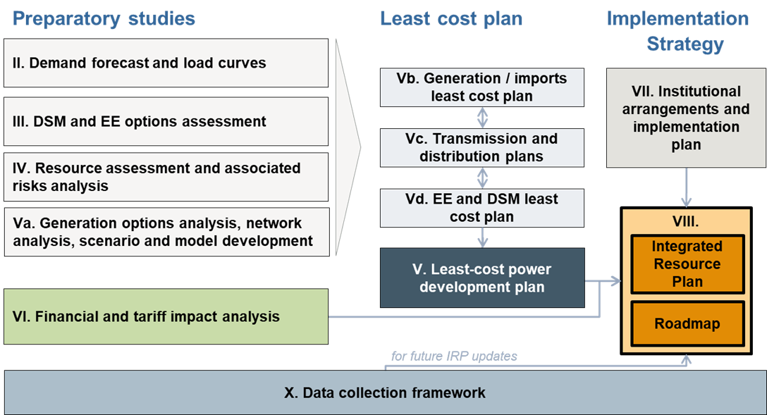
Source: ECA
The Resource assessment report, together with the Demand forecast report and the DSM and EE options report set the foundations for the development of the least cost plan. The Demand forecast report, the DSM and EE options report and the Resource assessment report will be discussed with stakeholders in a Workshop to achieve consensus on all assumptions, inputs, and scenarios before proceeding with the detailed modelling of the least-cost plan.

How an IERMP is prepared
Integrated Resource Planning is an approach to national development planning which incorporates a holistic assessment of available energy resources and opportunities for demand management into deriving a least cost combination of supply and demand side measures to meet long-term requirements for electricity services during a specified period, while furthering broad national objectives such as social equity, security of supply, and environmental sustainability.
The output of the IERMP is a set of short-, medium- and long-term generation and demand-side investment scenarios and reflect current and future supply-side and demand-side options to meet future electricity demand in a sustainable, cost-effective and reliable manner while respecting policy constraints.
Least cost generation development plans for any power system are prepared by identifying a set of candidate plants and supply and demand-side options and assessing the present-valued net costs (capital, fuel, and operating costs) of alternative sequences and combinations of investments that satisfy demand over the planning horizon at a given level of reliability. “Candidate power plants” are options and are distinguished from existing power plants (those already commissioned and operating) and committed:
- A committed power plant is one for which a contract has been signed or some other commitment has been made that makes it costly in financial or political terms to retract from that commitment.
- A candidate power plant is a project with a possibility to enter into operation, but without an agreement to do so. Candidates also include import options or a share of a national plant that may be developed primarily for export.
To be considered as a candidate, a reasonable amount of information must be available on that option, either through project preparation undertaken by the national Utlity, developers or others or, in the case of generic technologies (e.g., solar PV or CCGT plants using LNG) from international sources.
Screening curves and the LCOEs can be used to compare power plant costs and eliminate choices that are clearly uneconomic. However, electricity systems are complex and require detailed analysis for matching demand and supply to be able to determine the least cost power sector development plan. Neither LCOE nor the screening curves can fully capture operating constraints, the variability of renewable energy generators, the dynamic nature of load, and other factors.
Dispatch modelling simulates the operation of the power sector at each time interval (typically by hour) for all possible combinations of power generations options given their technical, financial and economic characteristics. The results of each simulation can be used to identify the least cost plan. Dispatch modelling also allows planners to investigate multiple scenarios in terms of generation mixes as well as any other policies or sensitivities.
The results of the dispatch simulation provide information on total capital expenditures; operating costs; fuel costs; emissions; revenues by unit; average, hourly, and regional prices; realised capacity factors over time; and reserve margins, among others.

Structure of the resource assessment report
The objective of the Resource assessment report is to define the set of current and future supply-side options (generators and import options) to meet future electricity demand and to define the scenarios that will be simulated for the IERMP. The analysis includes an assessment of available energy resources in the country, prioritisation of candidate sites for renewable energy development to include in the least cost planning analysis, the suitability of power plant technologies to be developed in Uganda, environmental and social considerations, cost estimates for the different technologies, technoeconomic specifications of each power generation or import option for the IERMP, fuel price forecasts, planning criteria that will be used for the development of the IERMP and the scenarios that will be simulated for the IERMP.
The main sections of the Resource assessment report explore:
- Section 2: Available energy resources – assesses available energy resources, including oil, gas, coal, solar, wind, hydro, geothermal, biomass, nuclear, and wave energy, alongside projections for fuel and emissions prices. It also analyses transportation logistics and costs for critical fuels like oil, gas, biomass, and nuclear materials.
- Section 3: Candidate options options – assesses the current status of the power sector in Uganda and analyses power generation options that will be considered for the least cost planning analysis of the IERMP.
- Section 4: Import options – evaluates import opportunities from neighbouring countries and EAPP, including associated risks and mitigation strategies.
- Section 5: Policy considerations – reviews policy considerations, policy targets, technical targets and regulatory frameworks (influencing energy planning) that should be considered in the Integrated Resource Plan.
- Section 6: Planning criteria and modelling approach – outlines the least-cost planning approach, criteria, and economic parameters that will be used for the modelling of the IERMP.
- Section 7: IERMP scenarios and sensitivities – presents the scenarios that will be used for the development of the IERMP.

Assessment of Uganda’s energy resources
The assessment of available energy resources is necessary to conclude on candidate options that could be developed to meet future energy requirements and includes an analysis on:
- Availability of resources – which energy resources are available that could be used to satisfy future energy requirements and which energy supply options should be eliminated from the least cost planning analysis due to the absence of relevant resources to operate them (or due to clearly uneconomic costs to obtain/exploit the resource).
- Location of resources – where are the resources located to assess the cost of transferring the resource to the area they will be used. In the case of wind and solar resources which are available throughout the country, a shortlisting of areas that have the maximum/optimum potential for development is also needed.
- Volume of resources – the volume of resources will define the maximum amount that can be utilised per year in the least cost plan to satisfy the demand. This acts as a cap and the least cost planning analysis will define which is least cost volume to utilise.
- Earliest year for the exploitation of resources - the earliest year the resources can be assumed available for exploitation in the least cost plan. The least cost planning analysis will assume that the resource will be available from the indicated earliest year and will define if and when the resource is a least cost option to utilise after the indicated earliest date.
The following subsections discuss the above elements for each type of energy resource relevant for Uganda.

Crude oil and crude oil distillates

Domestic
While Uganda is currently not an oil and gas producer, this is expected to change in the near future. There are significant oil reserves located in the Albertine Graben, which were first discovered in 2006. Oil drilling in the King Fisher Development Area (KFDA) and Tilenga began in 2022 and the MEMD expects oil production to start in 2026.
Production and exploration licenses have been issued to four oil companies: TotalEnergies Exploration & Production Uganda B.V. (TEPU), CNOOC Uganda Limited (CUL), Armour Energy Limited (AEL), and Oranto Petroleum Limited (OPL). A second licensing round was launched in May 2019 with five blocks. PSA negotiations have been concluded for two blocks, with PSAs now signed with the UNOC and DGR Australia.
The map in Figure 2 shows the current status of licensing for petroleum activities in the Albertine Graben.
Figure 2 Status of licensing for petroleum activities in the Albertine Graben
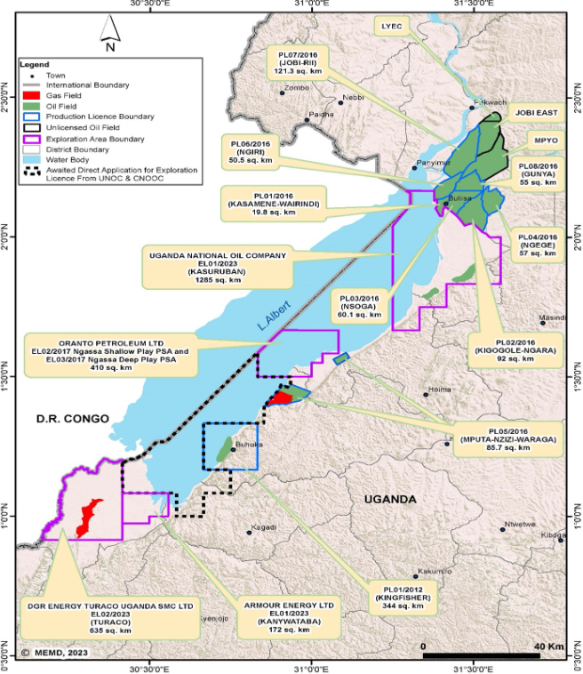
Source: East African Petroleum Conference & Exhibition 2025 (EAPCE’25), Exploration Updates: Republic of Uganda.
Table 1 shows the allocation of production and exploration licenses as of December 2022.
Table 1 Status of licensing in the Albertine Graben, December 2022
Production licenses
License | Contract area | Field | Operator | Area (km²)
PL-01/2012 | KFDA | Kingfisher | CUL | 344
PL-01/2012 | LA-1 | Kasemene-Wahrindi | TEPU | 20
PL-01/2012 | LA-1 | Kigogole-Ngara | TEPU | 92
PL-01/2012 | LA-1 | Nsoga | TEPU | 60
PL-01/2012 | LA-1 | Ngege | TEPU | 57
PL-01/2012 | LA-1 | Mputa-Nzizi-Waraga | TEPU | 86
PL-01/2012 | EA-1 | Ngiri | TEPU | 51
PL-01/2012 | EA-1 | Jobi-Rii | TEPU | 121
PL-01/2012 | EA-1 | Gunya | TEPU | 55
Exploration licenses
License | Contract area | Field | Operator | Area (km²)
EL-01/2004 | EA-1 | Mpyo % Jobi East | TEPU | 256
EL-01/2017 | Kanywataba CA | Kanywataba | AEL | 344
EL-02/2017 | Ngaasa Shallow Play CA | Ngaasa | OPL | 410
EL-03/2017 | Ngaasa Deep Play CA | Ngaasa | OPL
Source: Ministry of Energy and Minerals Development, 2022 Statistical Abstract, Table 2.1. KFDA = Kingfisher Development Area.
For estimated reserves, as of December 2023, there was an estimated stock tank oil-initially-in-place (STOIIP) of 6.574bn bbl in the Albertine Graben, 1.481bn of which is estimated to be economically recoverable. Including undrilled accumulations, an additional 2.1bn bbl of reserves can be expected. Production is expected to increase to up to 230,000 bbl/day by 2030 before gradually falling to under 70,000 bbl/day by 2050. The Albertine Graben crude oil is generally medium to heavy, sweet, waxy and viscous. The wax content ranges from 14 to 35% and in most fields viscous ranges from 4 to 350 cP.
In July 2024 the progress of these production projects was described as on track for production in 2026 by Ruth Nankabirwa Ssesntamu the Minister for Energy and Mineral Development. She confirmed that 120 out of planned 426 wells at Tilenga have been successfully drilled, surpassing the target necessary for first oil. At Kingfisher it was reported 18 out of 31 fields have been successfully drilled.

Refining and associated oil and gas infrastructure
Uganda is planning to develop an oil refinery at the Hoima District in order to fulfil most domestic petroleum demand from domestic crude oil supplies, as shown in the figure below.
Figure 3 Location of refinery and associated oil and gas infrastructure plan
Source: Ministry of Energy and Minerals Development, The Annual Resource Report 2023 - Final Draft
The Government signed an implementation agreement on 29th March 2025 with Alpha MBM Investments to develop a $4bn, 60,000 bbl/d facility, with ¾ of production devoted to transport fuels. As of July 2024, an expected final implementation date has not been set and the refinery is unlikely to be operating when oil production is expected to begin in 2026. The expected year for the operation of the refinery is 2028. Products to be produced from the refinery include diesel, gasoline, kerosene, Jet fuel and LPG. The capacity of the refinery would be enough to displace the sum of existing imported oil resources – across petrol, kerose, diesel and jet fuel.
The planned refinery would be fed by the EACOP, which is intended to transport crude oil from Uganda’s Tilenga and Kingfisher oil fields to the Port of Tanga in Tanzania.
Domestically produced Diesel, Heavy Fuel Oil (HFO) and Light Fuel Oil (LFO) will be assumed available for power generation for the IERMP from 2028 (the refinery is expected operational in 2028).

Imported crude oil and crude oil distillates
Given a lack of domestic production of oil and gas Uganda currently imports fossil fuels to meet domestic energy demand. The 2023 statistical abstract outlines the breakdown of petroleum imports for 2022 shown in Table 2.
Table 2 Historical imports of petroleum products, 2022
Petroleum product | Import volumes (Cubic meters)
Petrol | 1,115,979
Kerosene | 50,490
Diesel | 976,272
Jet Fuel | 152,859
Total | 2,259,600
Source: 2023 MEMD statistical abstract
For the IERMP it will be assumed that imported crude oil and crude oil distillates (including Diesel, HFO and LFO for power generation) will still be available in market after the beginning of local production. Therefore, the economic value of crude oil and oil distillates will be determined by the market value of the petroleum products in Uganda.

Natural gas

Domestic
Of the 21 fields with oil discoveries, 13 fields contained gas resources, most of which is non-associated gas. There is an estimated 429 Bcf of non-associated gas initial in place (GIIP), of which 334 Bcf is estimated to be recoverable. Estimates of associated gas are 837 Bcf of GIIP, of which 252 Bcf is estimated to be recoverable.
Domestic non-associated gas resources are not expected to be recoverable during the planning horizon of the IERMP. Non-associated gas will only be available later in the oil extraction process due to the impact on pressure support for oil extraction. The lifetime of oil production at Kingfisher is estimated to be at least 25 years and in Tilenga at least 16 years. Therefore, non-associated gas will be assumed non-recoverable until 2051 (2026 plus 25 years).
Associated gas will depend on the volume of oil extraction at each field – but will be available for use upon the start of oil production. Recoverable associated gas at all licensed fields totals 251.6 Bcf. The licensees and producers of oil in Tilenga and Kingfisher have proposed utilisation of associated gas for gas power generation, heating, LPG conversion and other utilities. The November 2021 brief “Utilization of associated gas to be produced from Kingfisher and Tilenga projects” provides the most recent thorough breakdown of potential utilisation. This is aligned with the draft gas utilisation strategy that is being developed by the MEMD.
The gas utilisation strategy is driven by the need to harness gas resources to generate more revenue, attract foreign direct investment, create employment opportunities, enhance participation of local companies and improve agricultural productivity with an overarching aim of achieving socio-economic transformation. With the oil and gas industry shifting toward cleaner energy solutions, the Ministry has proactively initiated a unified plan to optimize gas integration into Uganda’s energy mix. This strategy is a guiding framework to support development of the Uganda’s energy portfolio into a more diverse and secure mix, anchored on natural gas. It underpins national priorities, including industrialization, socio-economic transformation, and energy security, while enhancing environmental sustainability by curbing harmful practices such as gas flaring and promoting alternatives such as LPG. In addition, it contributes to public health, job creation, and regional cooperation, aligning with Uganda’s Vision 2040, the National Development Plan IV, the Energy Transition Plan 2023, and international commitments such as SDG7 and the Paris Agreement 2016.
The November 2021 brief outlines that both Tilenga and Kingfisher plan to use a portion of gas for electricity generation to support the oil production processes. More specifically, electricity will be utilised for consumption from machinery and processing facilities with the excess sent to the national grid. In the case of Tilenga power generation will also serve the required heating of the under-construction crude oil export pipeline. The paper also describes a push for LPG production – both directly at the oil fields and as a by-product of the refining process.
The table below lists volumes of non-associated and associated gas by year at the production licensed fields.
Table 3 Non-associated and associated gas reserves
Field | Non-associated recoverable gas (bcf) | Associated recoverable gas (bcf)
Nzizi | 8 | -
Kigogole | 0.2 | 12.7
Kingfisher | - | 53.4
Nsoga | 2.8 | 12.1
Ngege | 1.7 | -
Kasamene | 6.5 | 22
Ngassa | 0.7 | -
Taitai | 1 | -
Turaco | 273.6 | -
JobiRii | 24 | 30.6
Ngiri | 14.3 | 79.6
Gunya | 1.2 | 20.9
Other fields | - | 10.3
Total | 334 | 241.6
Source: 2022 MEMD statistical abstract and 2023 Annual Resources Report
As discussed above, associated gas at Kingfisher and Tilenga fields is planned to be used for power generation in CCGTs to support oil extraction activities at the fields and excess non-associated for LPG production. Therefore, non-associated gas will not be available to develop gas-fired power plants for electricity grid supply or for industrial use. The forecast volumes and orientation of the non-associated gas at Kingfisher and Tilenga fields is shown in Table 4.
Table 4 Associated gas profiles and orientation of Kingfisher and Tilenga fields
Year | Kingfisher field |  |  |  | Tilenga field
 | Total associated gas | Associated gas oriented for power generation |  | Excess associated gas for LPG | Total associated gas | Excess associated gas for LPG
 | (MMSCFD) | (MMSCFD) | (MW) | (tons/year) | (MMSCFD) | (tons/year)
1 | 5.7 | 5.5 | 26.7 | 10,744 | 26 | 18,798
2 | 9.1 | 8.9 | 42.7 | 16,088 | 28 | 36,682
3 | 9.1 | 8.9 | 42.8 | 15,856 | 27 | 36,026
4 | 9.0 | 8.9 | 42.8 | 15,856 | 28 | 37,595
5 | 9.1 | 8.9 | 42.8 | 15,472 | 30 | 40,734
6 | 9.1 | 9.0 | 42.8 | 15,288 | 29 | 39,165
7 | 8.9 | 8.7 | 41.8 | 15,552 | 26 | 34,456
8 | 7.2 | 6.9 | 33.1 | 15,128 | 21 | 29,748
9 | 5.9 | 5.6 | 26.9 | 12,328 | 18 | 25,076
10 | 5.0 | 4.8 | 22.9 | 10,528 | 14 | 18,798
11 | 4.4 | 4.2 | 22 | 9,128 | 13 | 15,659
12 | 3.8 | 3.6 | 18.7 | 7,942 | 12 | 14,089
13 | 3.4 | 3.2 | 16.5 | 7,106 | 11 | 14,089
14 | 3.1 | 2.9 | 14.2 | 6,479 | 9 | 12,519
15 | 2.8 | 2.7 | 11.7 | 5,852 | 9 | 12,519
16 | 2.6 | 2.5 | 12 | 5,434 | 8 | 9,417
17 | 2.4 | 2.3 | 12.1 | 5,016 | - | -
18 | 2.2 | 2.1 | 11 | 4,598 | - | -
19 | 2.1 | 2.0 | 10.2 | 4,389 | - | -
20 | 2.0 | 1.9 | 9.2 | 4,180 | - | -
21 | 1.9 | 1.8 | 8.5 | 3,971 | - | -
22 | 1.8 | 1.7 | 8.1 | 3,762 | - | -
23 | 1.7 | 1.6 | 7.5 | 3,553 | - | -
24 | 1.7 | 1.6 | 7.4 | 3,553 | - | -
25 | 1.6 | 1.6 | 7.3 | - | - | -
Source: Kingfisher LPG Facilities Plan Report, 2021 and Tilenga Carbon Footprint Reduction Technical Screening Report, 2021

Imported natural gas
Currently Uganda does not import natural gas and does not have gas infrastructure.
A gas pipeline is under consideration which would connect Tanzania with Uganda, but it is still in its early stages of conception. The idea is that Uganda would import natural gas from Tanzania for industrial uses and power generation. A feasibility study was agreed upon between the governments of Tanzania and Uganda in November 2023 and was set to start in April 2024. The expectation is that development of the pipeline would take at least 8 years, but its development is still uncertain as there are no justified volumes of demand to make the project viable.
LNG terminals is not an option for Uganda as there is no connection to international seas to allow LNG ships to deliver gas to Uganda.
For the IERMP, imports of natural gas through the proposed gas pipeline will be assumed available from 2033 onwards for some IERMP scenarios. Scenarios will be utilised to deal with the uncertainty for the development of the pipeline and estimate the least cost plan with and without the availability of imported natural gas.

Liquified Petroleum Gas (LPG)

Domestic
The Government of Uganda has acquired 20 acres of land in Mukono for the purpose of constructing an LPG facility as part of its ‘LPG Supply, Promotion, and Infrastructure Intervention’, launched in July 2022, which aims to achieve universal access to clean cooking. The intention is to supply the LPG facility from the Albertine Graben oil fields with non-associated gas to produce LPG. Additionally, crude oil will be used in the planned refinery to produce LPG.
The projected LPG production volumes from Kingfisher and Tilenga non-associated gas and crude oil refined at the planned refinery are shown in the table below – where year 1 represents the first year of oil production at each field. The total annual volume of LPG production is estimated around 235,000 to 291,271 tonnes per year.
Table 5 Forecast LPG production from Kingfisher and Tilenga fields
Year | LPG from Kingfisher associated gas | LPG from Tilenga associated gas | LPG from the oil refinery | Total LPG production
 | (tonnes/year) | (tonnes/year) | (tonnes/year) | (tonnes/year)
1 | 10,744 | 18,798 |  | 29,542
2 | 16,088 | 36,682 | 235,060 | 287,832
3 | 15,856 | 36,026 | 235,060 | 286,945
4 | 15,856 | 37,595 | 235,060 | 288,515
5 | 15,472 | 40,734 | 235,060 | 291,271
6 | 15,288 | 39,165 | 235,060 | 289,519
7 | 15,552 | 34,456 | 235,060 | 285,075
8 | 15,128 | 29,748 | 235,060 | 279,944
9 | 12,328 | 25,076 | 235,060 | 272,473
10 | 10,528 | 18,798 | 235,060 | 264,396
11 | 9,128 | 15,659 | 235,060 | 259,858
12 | 7,942 | 14,089 | 235,060 | 257,103
13 | 7,106 | 14,089 | 235,060 | 256,268
14 | 6,479 | 12,519 | 235,060 | 254,072
15 | 5,852 | 12,519 | 235,060 | 253,446
16 | 5,434 | 9,417 | 235,060 | 249,927
17 | 5,016 | - | 235,060 | 240,093
18 | 4,598 | - | 235,060 | 239,676
19 | 4,389 | - | 235,060 | 239,468
20 | 4,180 | - | 235,060 | 239,260
21 | 3,971 | - | 235,060 | 239,052
22 | 3,762 | - | 235,060 | 238,844
23 | 3,553 | - | 235,060 | 238,636
24 | 3,553 | - | 235,060 | 238,637
25 | - | - | 235,060 | 235,060
26 | - | - | 235,060 | 235,060
Total | 217,803 | 395,370 | 5,876,500 | 6,489,972
Source: MEMD – Brief on utilization of associated gas to be produced from the Kingfisher and Tilenga projects, Oct 2021

Imported LPG
Uganda currently imports all its LPG from Kenya and Tanzania (95% comes through Kenya and 5% through Tanzania). LPG imports will be assumed available throughout the planning horizon of the IERMP.

Coal resources
Academic literature suggests that Uganda has minimal to no coal bearing rock. Although the geology of the African continent is thought to contain approximately 5% of the world’s proven recoverable reserves, this is concentrated in the far south of the continent.
Moreover, reliance on coal for energy production would conflict with Uganda's commitments under the Paris Agreement. Coal is among the most carbon-intensive energy sources, and its use would undermine the country's efforts to achieve a low-carbon development pathway. Prioritising renewable and low-emission energy sources aligns more closely with Uganda's climate action goals and its international obligations to mitigate greenhouse gas emissions.
As a result, domestic coal recovery is not a viable option for Uganda and is therefore excluded as an option for the IERMP.

Nuclear resources
The Energy Policy for Uganda 2023 is promoting the use of nuclear energy for long-term power generation and other peaceful purposes. The current Governmental plan is to enter into a nuclear fuel supply agreement with an international partner for a first reactor planned for 2030, but develop a local nuclear fuel cycle for a second reactor planned for 2034 based on the country’s own uranium deposits (which are so far largely unexplored but thought to be extensive). Ugandan law does not allow the country’s uranium resources to be exported. According to the draft Nuclear fuel supply strategy for Uganda, 2024, Uganda will require about 113.3 tonnes of uranium for the first 1.4 GW candidate nuclear power plant.
In 2008, under the Sustainable Management of Mineral Resources Project (SMMRP), the Government of Uganda acquired airborne geophysical survey data (magnetics, radiometrics) over 80% of the country and electromagnetics (EM) over selected mineral rich areas. The radiometric survey data became useful in assessing the uranium potential of the country.
The Directorate of Geological Surveys and Mines then, started following up the uranium anomalies generated but needed technical assistance to enhance its capacity in uranium exploration. The total speculative resources of uranium are estimated at about 105,000 tU according to the International Uranium Resources Evaluation Project (IUREP) reports. Airborne geophysical survey, ground geophysical and geochemical studies have been undertaken. There are on-going exploration activities in the country to qualify and quantify the Uranium resource.
Uranium is found in scattered deposits in Buganda, Ankole, Karamoja and covers an area of 2,882 km2. Over 80 targets country wide were discovered, with 10 targets being first class order. Figure 4 shows covered anomaly points in Uganda that indicated the potential presence of uranium. The ten priority sites include Arua, Pakwach, Gulu-Kitgum, Masindi, Hoima-Kibaale, Fort-Portal and Mbarara-Ntugamo areas.
Figure 4 Status of uranium exploration activities in Uganda
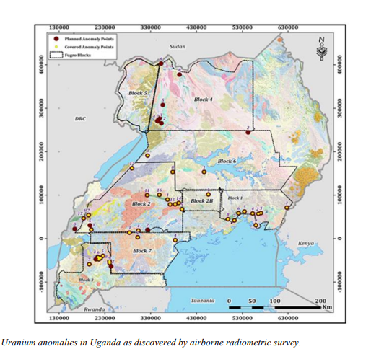
Source: MEMD, 2024
However, the International Atomic Energy Association stated in a recent report that there are no fully proven resources in Uganda. Uranium exploration is highlighted as an important priority in Uganda’s new country programme framework with the international atomic energy agency. The recently incorporated Ugandan national mining company will lead further exploration of uranium in the country with the aim to extract uranium and use it for power generation in the longer run.
The Energy Policy for Uganda 2023 also recognises that many steps need to be undertaken to enable nuclear power production in Uganda. It highlights key issues that need to be tackled including limited data on local nuclear fuel resources and national infrastructure for nuclear power development. The above indicate that the development of a local nuclear fuel cycle in Uganda is still at very early stages and a lot remains to be done to be in a position to develop nuclear power. Internationally, the lead time for the discovery and development of new uranium production facilities has been of the order of one to two decades.
The IERP will assume that national uranium resources could be available the earliest after 7 years (in 2033) and will be adequate to cover the supply of a 24 GW power plant as indicated by current preliminary exploration activities. Until then, imported uranium will be considered as an available option.

Peat resources
Peat represents a distinct surface layer composed of organic matter, primarily originating from plant material that has undergone partial decomposition. It accumulates in environments characterised by waterlogging, oxygen deficiency, and limited nutrient availability.
Uganda has a substantial covering of peat, approximately 7,300 square kilometres according to the world energy council. This could provide an energy source for power generation via combustion as has been applied in some European economies for over 100 years. However, peat reserves are considered a vital sequestration of carbon - the carbon stock in Ugandan peat is estimated at 1.3 gigatonnes according to the Uganda wetlands association - and is thus increasingly being avoided as an energy source in favour of alternative less environmentally damaging options.
Despite the substantial carbon emissions from utilising peat for power generation, its abundance in Uganda mean it is a viable source of electricity generation, the IERMP will assume peat resources will be available for power generation in 2027.

Solar resources
Resource endowment of solar within Uganda is assessed through observing the global horizontal irradiance (GHI) data for the country. A map of Uganda solar resources is presented in Figure 5. As a point of reference, GHI in Southern Europe reaches approximately 1,500 kWh/m² annually. Remarkably, nearly all of Uganda sees GHI values exceeding 1,800 kWh/m², surpassing the highest levels observed in Europe. The only exceptions being around Mount Elgon in the east of the country and in the Rwenzori mountains national park in the southwest.
A notable divide exists between the region around Lake Kyoga with the highest GHI levels tending towards the north of the Lake where much of the lands has a GHI over 2,000 while the south of the Lake where most of the population and urban areas lie GHI numbers are closer to 1,700.
Figure 5 Uganda GHI yearly KWh/m²
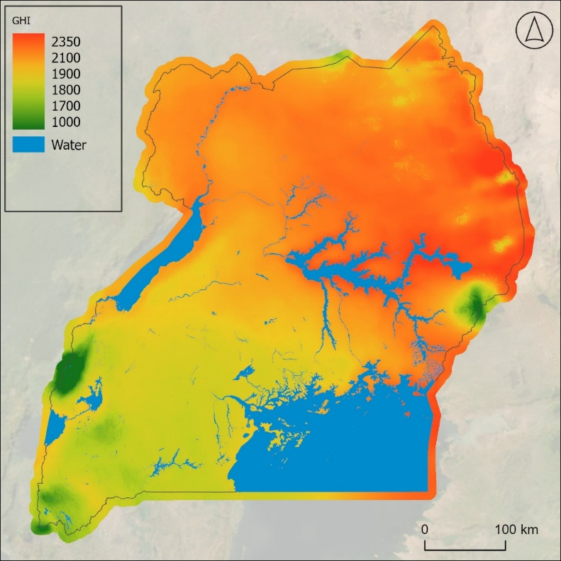
Source: ECA GIS mapping based on global GHI data
To identify suitable sites for Solar PV development, we focus on areas outside land exclusion zones, applying a selection criterion that removes regions dominated by water bodies, forests, flooded vegetation, built-up areas, and snow/ice. The exclusion parameters used in the analysis are detailed in the table below.
Table 6 Exclusion parameters for the solar mapping analysis
Exclusion criterion | Assumption | Source of GIS data
Land use | Excludes solar development in areas that have water, trees, flooded vegetation, built area, snow/ice due to the inability to develop photovoltaic projects in those areas. | Living Atlas Esri | Sentinel-2 Land Cover - https://livingatlas.arcgis.com/landcoverexplorer/
Slope | Excludes the development of solar PV in areas with a slope higher than 20%. | USGS Earth Explorer - SRTM 1 arc – usgs.gov
Wetlands | Excludes solar development in wetlands, lakes, rivers and bio regions. | MEMD dataset
Protected areas | Excludes solar development in protected areas. | MEMD dataset
Distance from the existing or planned grid | Prioritizes sites that are closer to the existing or planned grid and are therefore less costly to connect. | MEMD dataset

Despite these exclusions, the usable solar resource remains substantial. Assuming a panel density of 60 MWp / km², the availability of land does not pose any constraints on the amount of solar power that can be developed.
In identifying priority zones for solar development, we focus on three key areas that exhibit high GHI, and that are also located close to existing transmission infrastructure. These zones are highlighted in the figure below. The estimated Capacity Factor (CF) of Solar PV power plants in the identified areas ranges between 18% and 21%.
Figure 6 Uganda GHI yearly KWh/m² – with exclusion zones
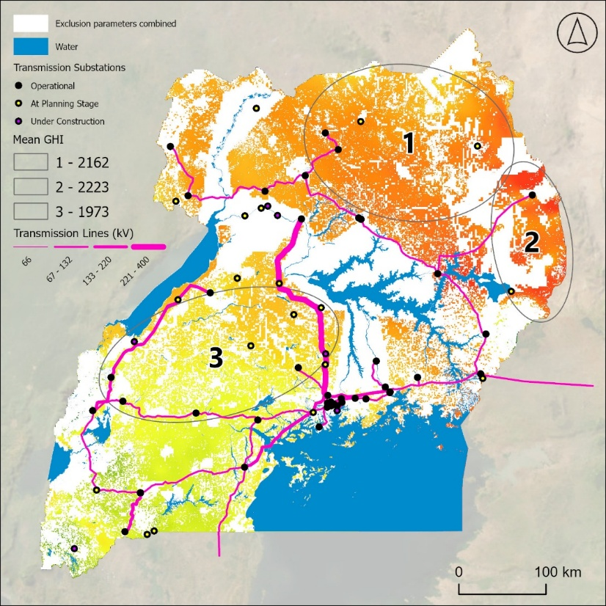
Source: ECA GIS mapping based on global GHI data
Strengthening the exclusion criteria to select areas with the highest potential, results in the following map with potential areas highlighted with red.
Figure 7 Map with filtered areas for solar PV development (red colour)
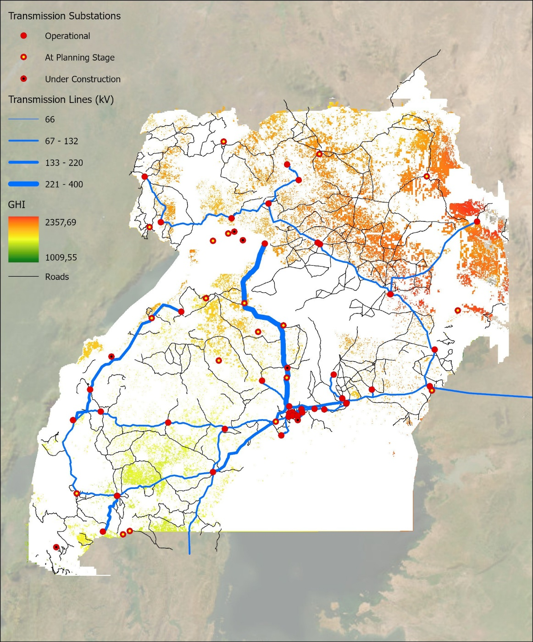
Source: ECA and Norconsult. GIS mapping based on global GHI data

Wind resources
Uganda, like much of southern central Africa, experiences low wind speeds. The figure below details the spatial spread of wind speeds across the country. There are limited areas where average wind speeds are above 5 metres per second, a common benchmark for the viability of wind turbines development with current technology.
The mountainous north-east of the country experiences the highest wind speeds, with average speeds creeping up to over 7 metres per second. However, some of this area is in the Kipedo valley national park and driven by high mountainous terrains, which would likely pose significant challenges for the development of wind turbines.
The far southeast of the country also experiences some areas of more than 7 metres per second wind speeds. However, these areas are located in the mountainous Rwenzori national park so leveraging this small pocket of resource could also be challenging.
Figure 8 Uganda mean wind speeds at 150m height m/s
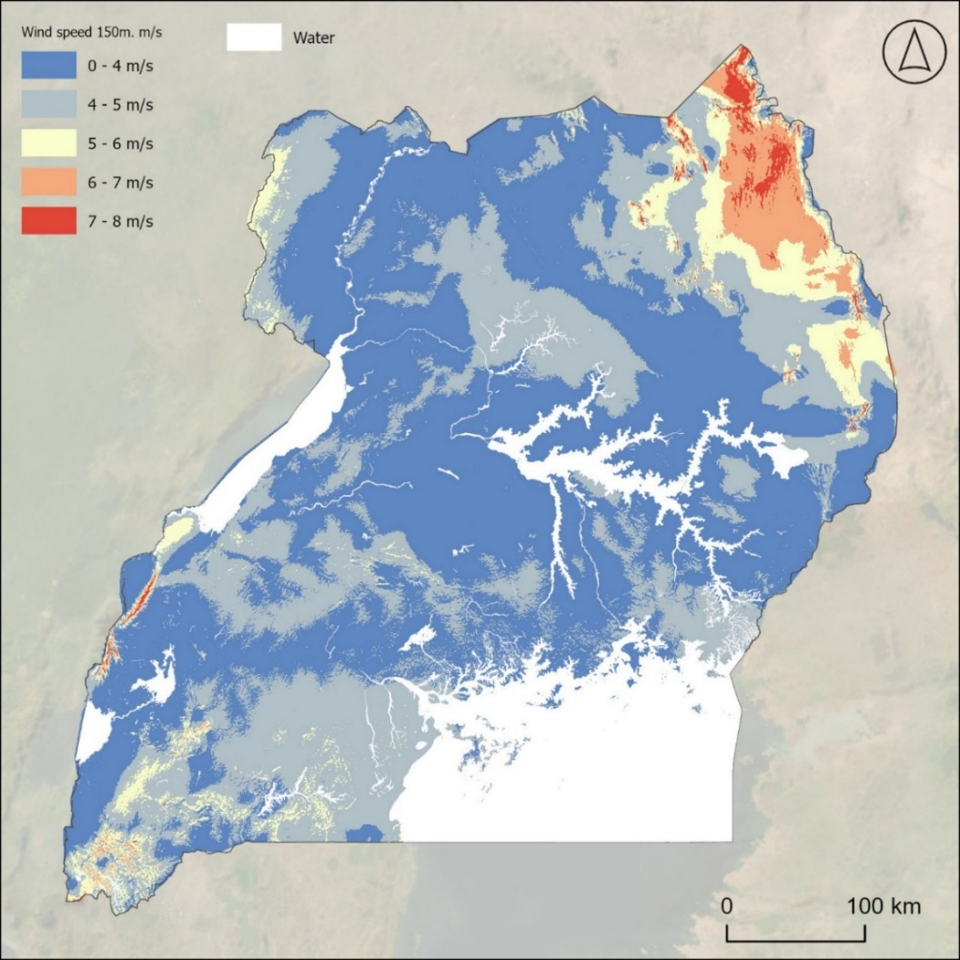
Source: ECA GIS mapping based on global wind speed atlas
As with solar resources, to further analyse Uganda's wind resource potential for electricity generation, we focus on areas outside land exclusion zones, applying a selection criterion that removes regions dominated by water bodies, forests, flooded vegetation, built-up areas, and snow/ice. The exclusion parameters used in the analysis are detailed in the table below.
Table 7 Exclusion parameters for the wind mapping analysis
Exclusion criterion | Assumption | Source of GIS data
Land use | Excludes wind farms development in areas that have water, trees, flooded vegetation, built area, snow/ice due to the inability to develop photovoltaic projects in those areas. | Living Atlas Esri | Sentinel-2 Land Cover
Wetlands | Excludes wind farms development in wetlands, lakes, rivers and bio regions. | MEMD dataset
Protected areas | Excludes wind farms development in protected areas. | MEMD dataset
Distance from the existing or planned grid | Prioritizes sites that are closer to the existing or planned grid and are therefore less costly to connect. | MEMD dataset
In identifying priority zones for wind development, we focus on three key areas that exhibit constant wind speeds at 150m height, and that are also located close to existing transmission infrastructure. These zones are highlighted in the figure below. The estimated capacity factor (CF) of wind power plants in the identified areas ranges between 38% and 53%.
Figure 9 Uganda mean wind speeds at 150m height m/s – with exclusion zones
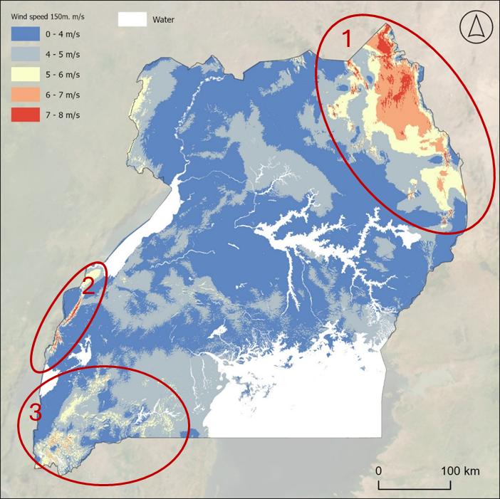
Source: ECA GIS mapping based on global GHI data
Strengthening the exclusion criteria to select areas with the highest potential, results in the following map with potential areas highlighted with green.
Figure 10 Map with filtered areas for wind development (green colour)
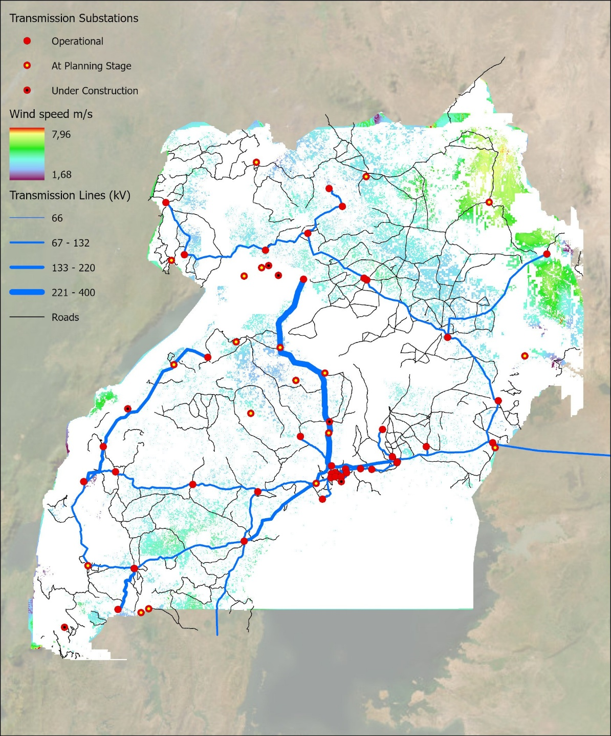
Source: ECA and Norconsult analysis

Hydro resources
Uganda is endowed with an extensive river network and many natural lakes. Major rivers include the Nile, Ruizi, Katonga, Kafu, Mpologoma and Aswa, as shown in Figure 117 below. This substantial resource is already significantly leveraged as Hydro power already makes up for over 80% of installed electricity generating capacity in Uganda at around 1,100 MW. Most of this hydropower capacity is located on the Victoria Nile, primarily in large-scale hydropower plants (>20 MW) that operate as run-of-river facilities.
Figure 11 Uganda Rivers and Basins
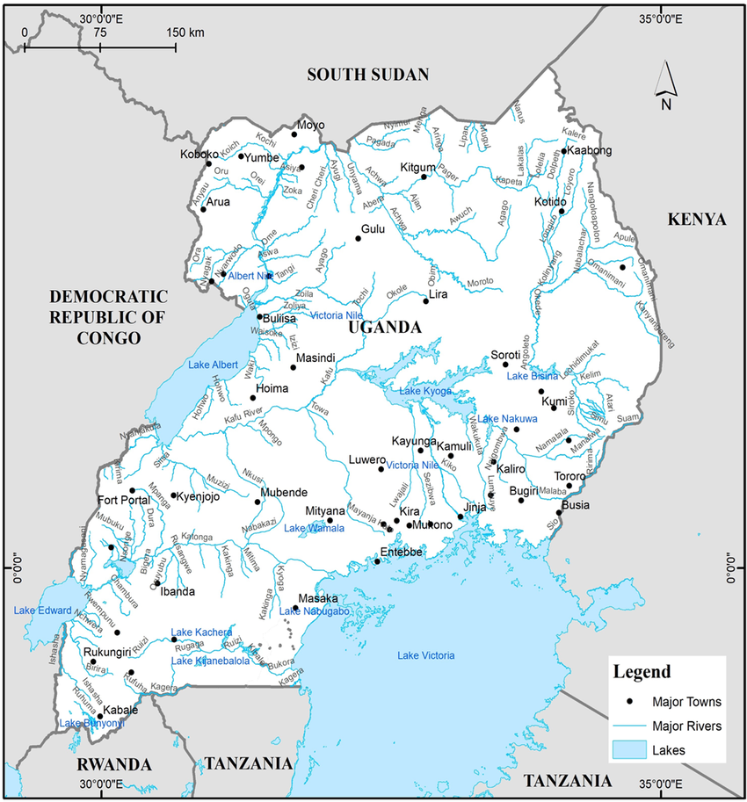
Source: Overview of hydropower resources and development in Uganda, Katusi et al. 2021
Several studies estimate the total Ugandan hydropower potential at about 4 – 4.5 GW, with about 2,000 MW concentrated on the Nile river. Proposed large hydropower projects are found across the key river basins, they have the potential to offer an additional nearly 2 GW of capacity to the existing hydro fleet.
Existing leveraged hydropower resources are shown in the Figure 12 below. The largest operational hydropower sites are east and north of Kampala with numerous smaller sites in the West of the country near the border to the Democratic Republic of Congo.
Figure 12 Ugandan River Network and hydropower plants under operation
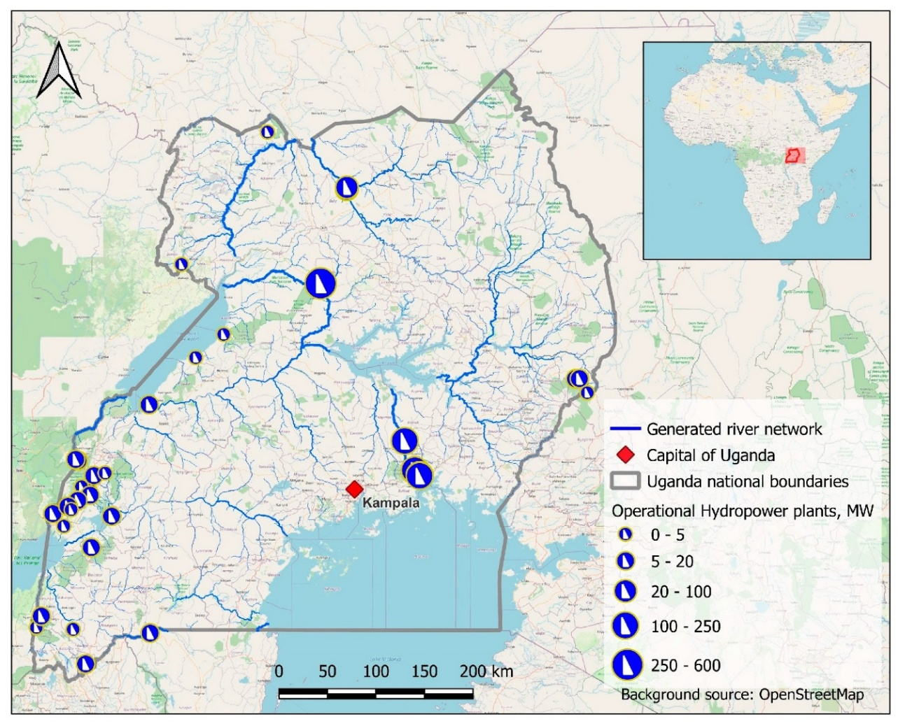
Source: Small Hydropower Assessment of Uganda Based on Multisource Geospatial Data, 2023, Punys et.al
The IEA has conducted an analysis on climate risk examining how a changing climate could impact water security of African countries. Their findings indicated that countries within the Nile basin were more likely to see water volume and therefore hydropower capacity factors increase under a warmer climate. However, other sources acknowledge that climate change could increase the variation in water available. Between 2005 and 2007, Uganda experienced a sharp drought which affected hydropower electricity generation, showing that increased rainfall could pose a threat to the resilience of the physical capital itself, floods and high levels of rainfall can cause significant damage to hydropower plants.

Geothermal resources
Geothermal energy has been considered for Uganda’s domestic supply since the 1950s, but systematic exploration did not begin until the 1990s. Today, exploratory drilling has reached two viable locations, Panyimur and Kibiro, where temperature‑gradient holes (TGH) have been completed to establish subsurface thermal profiles and inform the siting of full‑scale exploration wells. At Panyimur, these efforts have now progressed to planned feasibility studies.
All of Uganda’s most promising prospects, Panyimur, Kibiro and Buranga, as well as Katwe (see Figure 13), lie along the western branch of the East African Rift System, where elevated heat flow favors energy extraction. Surface exploration is also under way at four additional sites, including Karungu, Kanangorok and the newly identified Okidi. In each case, measuring the thermal gradient, the rate at which temperature increases with depth, is crucial, since electricity generation typically requires reservoir temperatures of 150 °C to 400 °C.
Figure 13 The 25+ known geothermal prospects in Uganda
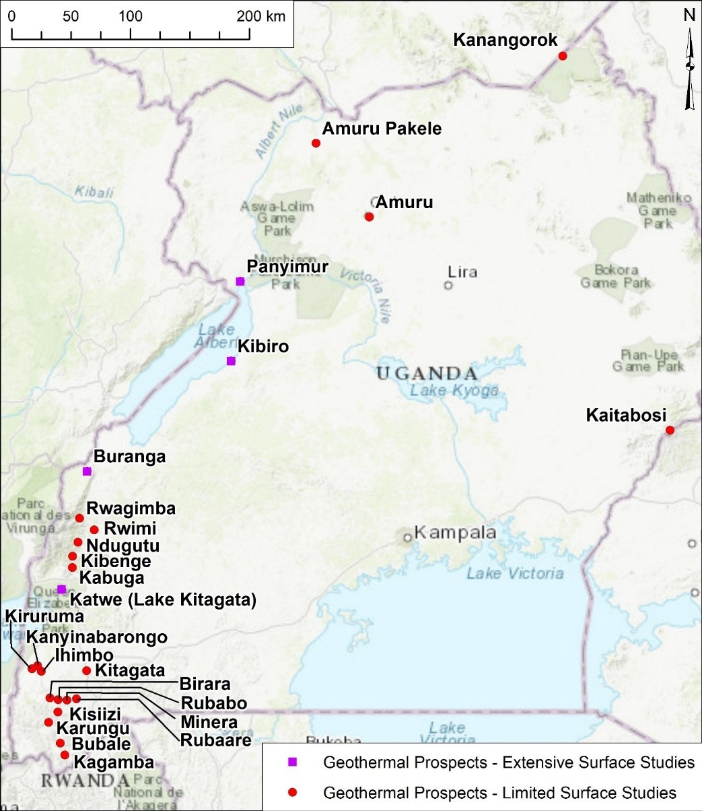
Source: MEMD. Note: Square symbols correspond to prospects for which extensive surface studies have been completed. Circles correspond to prospects for which limited surface studies have been completed.
Additional observations in Panyimur, Buranga and Kibiro suggest subsurface temperatures of 110° – 140°C 120°-130°C and 150-200°C respectively. If ratified under further observation this would be high enough for electricity production. The spent hot brine out of the power plant finds ready use in agriculture, industry and tourism, thereby improving project economics.
In terms of realised feasibility studies to leverage this resource – evidence is limited. However, UETCL mentions two large geothermal power plants in its 2023-2040 investment plan. Additionally, ERA reported a notice for license application from Batu Energy limited to start a feasibility study to develop a 10 MW geothermal plant in Panyimur in 2023. Measuring the total potential of geothermal in Uganda as an energy resource is a complex calculation but this has been approximated at a varying level over the past 25 years – the vision 2040 report details a prospective 1,500 MW of total potential in the country.

Biomass and bioenergy resources
Uganda has abundant biomass resources and currently meets 89% of the country’s energy requirements coming from firewood (78.6%), charcoal (5.6%) and agricultural (4.7%) residues. However, the collection of resources is informal, utilising traditional methods and prone to causing environmental harm such as undesirable changes in biodiversity and degradation of soil and water resources.
In accordance with the EC 2009 RES directive on the promotion of the use of renewable energy sources, biomass is defined as: biodegradable fraction of products, wastes and residues from organic farming (animal and plant substances), forestry and assimilated industries, fishing, crops and municipal and industrial wastes. Biomass energy resource assessment is therefore focused on the following four categories: Food crop residues, Animal residues, Forestry/Wood and Urban waste.

Food Crop Residues
Obtaining energy from food crop residues such as stalks and leaves is a more sustainable way of harnessing bioenergy – as opposed to say forestry. Direct combustion of residues produces heat which can be converted into electricity in a biomass power plant.
Estimating the food crop residue potential in a region can be completed via a simple linear function. The calculation is presented below. Energy potential for a specific crop residue is equal to the product of total crop production C, the reside to product ratio RPR and the lower heating value HV ($Energy Potential=C x RPR x LHV$).
Academic studies based on such an approach include “Bioenergy potential of agricultural and forest residues in Uganda” by Okello et. al (2013). In that study they calculate the annual crop production, residue to product ratio and lower heating value for a set of the predominant crops in Uganda – the values for each component of the calculation and the final energy potential are presented in the following table.
Table 8 Energy Potential per year from Uganda key agricultural crop residues
Crop | Annual Crop Production (kt) | Residue to Product Ratio | Lower Heating Value (MJ/kg) | Energy Potential (PJ/year)
Maize | 2,363 | 2.00 | 16.3 | 72.9
Millet | 264 | 1.40 | 13.0 | 4
Sorghum | 373 | 1.40 | 13.0 | 6.3
Rice | 189 | 0.45 | 8.83 | 1.5
Beans | 929 | 1.40 | 14.7 | 16.4
Groundnuts | 245 | 2.10 | 11.2 | 5.3
Banana | 4,297 | 2.00 | 13.1 | 16.4
Cassava | 2,894 | 0.40 | 13.1 | 7.6
Sweet Potato | 1,818 | 0.40 | 16.0 | 9.3
Pigeon Peas | 11 | 1.40 | 12.8 | 0.2
Soybean | 23 | 2.66 | 18.0 | 1.1
Sesame | 98 | 2.00 | 15.5 | 3.0
Sugar | 197 | 0.25 | 15.4 | 0.9
Coffee | 212 | 1.00 | 15.9 | 2.9
Cotton | 23 | 2.10 | 15.9 | 0.8
Total |  |  |  | 148.6
Source: Bioenergy potential of agricultural and forest residues in Uganda” by Okello et. al (2013)
As shown in the figure below the spatial distribution of residue is a widespread outside of the north-eastern mountainous regions and to the north of Lake Albert.
Figure 14 Uganda Crop Residues Spatial Distribution
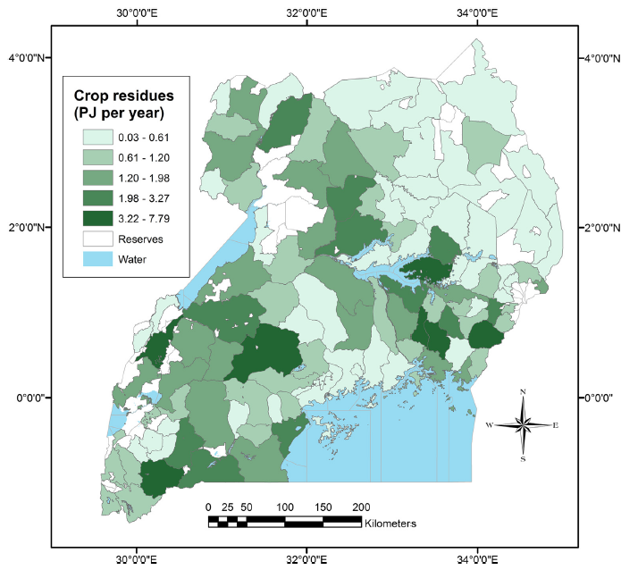
Source: Bioenergy potential of agricultural and forest residues in Uganda” by Okello et. al (2013)

Animal Residues
The same 2013 paper provides a calculation of energy from animal residue. This is largely a function of volume of cattle and goats used for farming in the country. The calculation for energy potential from animal residue is presented in the equation below. It is the product of total animal population A, the annual organic matter production per animal in kg and the biogas yield per kg of organic matter for each animal ($Energy Potential=A x VS x B$).
The components of this calculation for the predominant livestock in Uganda are shown in the table below as well as the total energy potential per year for each animal category.
Table 9 Energy Potential per year from Uganda key animal residues
Animal category | Population (millions) | Annual organic matter production (kg/animal) | Biogas (yield /kg organic matter) | Energy Potential (PJ/year)
Cattle | 11.71 | 2.67 | 0.20 | 45.64
Goats | 12.29 | 0.33 | 0.31 | 9.18
Sheep | 3.58 | 0.30 | 0.31 | 2.43
Pigs | 3.18 | 0.59 | 0.31 | 4.25
Chicken | 37.58 | 0.02 | 0.18 | 0.99
Total |  |  |  | 62.49
Source: Bioenergy potential of agricultural and forest residues in Uganda” by Okello et. al (2013)
As shown in the following figure the spatial distribution of energy potential is centred around a path from southwest to northeast in the southern portion of the country and the far north east. This stretch of land is known as the cattle corridor and the home of most cattle in Uganda.
Figure 15 Animal Residues Uganda Spatial Distribution
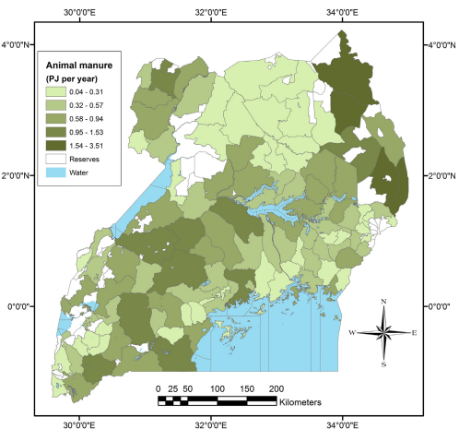
Source: Bioenergy potential of agricultural and forest residues in Uganda” by Okello et. al (2013)

Forestry
Uganda historically has been covered by extensive forestry. However much of it has been removed to make way for agricultural fields and used for in combustion for domestic heating and cooking. In the maps below published by the National Environment Management authority, light and dark green colours indicate woodland and tropical forest respectively.
Figure 16 Development of forest cover Uganda 1990-2015
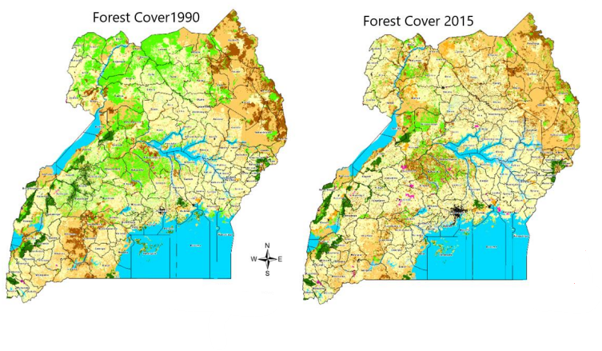
Source: National Environment Management Authority Information Bulletin 2019
The extent of the decline in woodland is clear. The remaining woodland is concentrated in the centre and southwest of the country. The Ugandan statistical abstract from 2023 outlines the numbers of the decline in forest and wood cover – forest cover reduced from 18% of the country in 2005 to 13% of the country in 2019 – while woodlands cover declined from 28,347km² to 17,399km² between 2000 and 2019.

Urban Waste
Urban centres generate significant amounts of municipal solid waste (MSW) originating from residential, commercial and industrial sectors. This waste can be converted into energy including electricity and heat through various conversion processes.
The scale of urban centres largely dictates the availability of this resource. Kampala, Uganda’s capital contains over 10% of the country’s population within its metropolitan area. Within the city, approximately 28,000 tonnes of MSWis collected and delivered to landfill every month and this represents only approximately 40% of the waste generated in the city.
This represents a vast potential energy source. The lower heating value of waste in Uganda has been estimated at 6.12 MJ/kg per tonne of MSW and could imply based on common incineration technology 774 KWh of electrical production per ton of MSW. This would imply a potential of 260 GWh of electricity production per year just from Kampala’s collected and delivered MSW supply.

Wave and tidal resources
Due to its landlocked position wave and tidal resources situated in Uganda are negligible. Lake Victoria is unconnected to the ocean and not large enough to be independently exposed to significant tidal movements, thus tidal resources will not be considered.
Wave energy potential can be estimated via wave height and frequency. Waves are primarily a product of winds blown across the surface of water. Although Lake Victoria can be exposed to strong winds, its size and surface area relative to the ocean limit the consistency and height of waves.
Academic studies place maximum wave heights in Lake Victoria not above 1 metre, with a typical height of 0.14m. These heights are less than required to produce consistent magnitudes of electricity from available technology, while the consistency of wave inducing windy conditions also limits potential of a consistent energy source. As a result, wave resources will not be considered further.

Fuels price forecast and transportation costs
Given dispatch is based on the costs of production, fuel costs must be estimated for each technology to derive the least cost plan. The following subsection analyse the fuel price forecasts and the transportation costs that will be used for the assessment of the least cost generation plan.

Crude oil distillates forecast price and transportation costs
Despite Uganda’s plan to produce crude oil domestically (expected in 2026), crude oil distillates price forecasts will be estimated following international market prices. Prices need to be assessed based on the opportunity costs of selling crude oil distillates to the international markets. The objective of the IERMP is to ensure that the maximum economic value of crude oil will be extracted for Uganda.
Crude oil forecast prices were source from the International Energy Agency (IEA) World Energy Outlook 2023 for three scenarios as shown in the figure below.
Figure 17 International crude oil price forecast (US$/barrel)
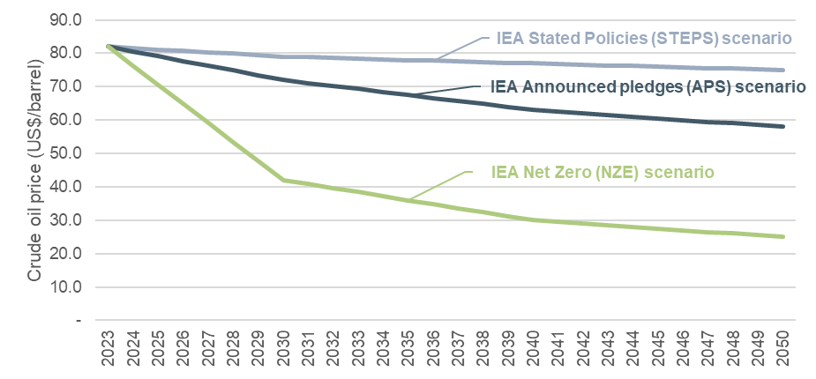
Source: International Energy Agency (IEA) World Energy Outlook 2023

Transportation options and costs
Currently Uganda imports all of its fuel from the internal market through rail or trucks. However, this is set to change when the crude oil pipeline connecting Uganda with Tanzania will be development. The EACOP’s route is mapped in Figure 18.
Figure 18 East African Crude Oil Pipeline route
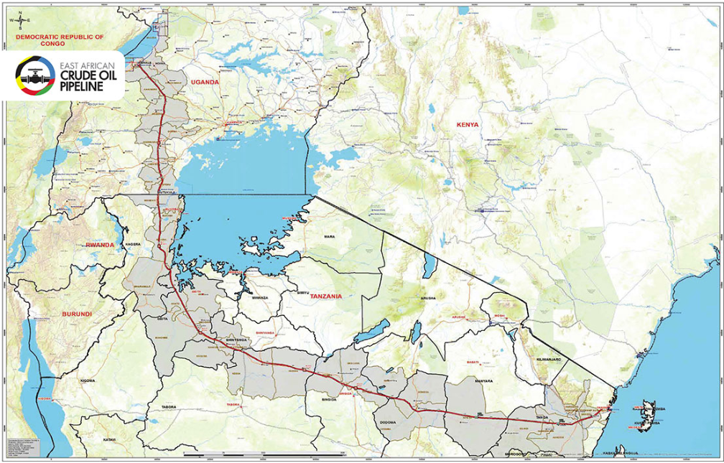
Source: https://www.eacop.com/route-description-map/
The EACOP will have a length of 1,443 km, a diameter of 61 cm, and a peak daily capacity starting at 213,000 bbl/day, then ramping up to 246,000 bbl/day. The EACOP is joint-owned by TotalEnergies, UNOC, the Tanzania Petroleum Development Corporation (TPDC), and the Chinese National Offshore Oil Company (CNOOC). FID for the EACOP was first taken on 1 February 2022 and field developments are underway, but official construction has yet to commence, with final financing for the project close to being confirmed.
Storage terminals exist in Jinja of volume 30 million litres and an additional storage terminal is being developed in Kampala at a greenfield site and is planned to have capacity of 320 million litres. The storage terminal is expected to cost $300 million.

HFO, LFO and Diesel price forecast
HFO, LFO and Diesel prices were linked to the international crude oil forecast price (see section 2.13.1). For HFO this was set at 1.41 times the price of crude oil, for LFO 1.75 times the price of crude oil, and for Diesel 1.36 times the price of crude oil. The ratios were calculated using actual historical international crude oil prices and actual historical HFO, LFO and Diesel prices in Uganda. The ratios applied are assumed to include costs for maritime and land transport as they were estimated using the delivered prices of fuels. The derived forecast prices for crude oil distillates are shown in the figure below for the IEA Stated Policies scenario.
Figure 19 HFO, LFO and Diesel price forecast (US$/GJ)
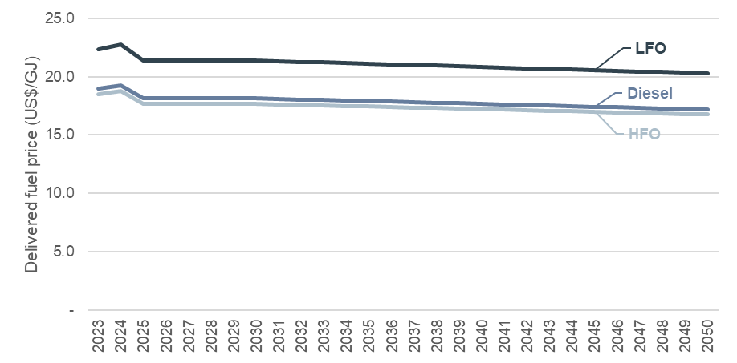
Source: ECA analysis following IEA World Energy Outlook 2023 crude oil price forecast. The calculations also assume a heat content value of 39.60 MJ/l for HFO, 40.60 MJ/l for LFO and 37.30 MJ/l for Diesel.

Natural gas price forecast and transportation costs
As discussed in section 2.2, a gas pipeline between Tanzania and Uganda has been under consideration for future development and the IERMP will assume that natural gas may be available from 2033 for some scenarios.
Data on the cost of gas for the vast majority of gas fields is not in the public domain due to the confidential nature of this data. This also applies to the gas fields in Tanzania.
A methodology known as ‘netback price’ can be applied to approximate the economic floor value of gas at the field. That is, the minimum value of gas below which the gas would be exported rather than supplied domestically. The floor is estimated by the LNG netback price from Qatar, ie, the maximum price of gas Tanzania producers could charge to export in the international market natural gas through LNG. To derive the delivered price of natural gas to Uganda’s prospective power stations, gas pipeline transportation costs were added on top of the calculated netback price in Tanzania. The table below shows all input parameters used in the calculation of the ‘netback price’ in Tanzania and gas pipeline transportation costs assumed to transfer natural gas to Uganda.
Table 10 Netback natural gas price in Uganda, 2024
Parameter | Unit | Value | Source
South East Asia DES LNG price in November 2024 | $/MMBtu | 13.6 | https://www.spglobal.com/commodity-insights/en/news-research/latest-news/lng/090324-southeast-asian-lng-hits-over-10-month-low-versus-jkm-on-strong-selling-interest
Freight costs of LNG shipment from South East Asia to Tanzania | $/MMBtu | 2.8 | Calculated as y = 70 + 0.01605 * x where y is freight cost in $/tonne and x is distance in km. The distance between South East Asia and Tanzania is assumed 5,093 km and 1 tonne LNG is assumed to equal 53.5 MMBtu.
Liquefaction costs | $/MMBtu | 2.12 | Qian Zou et al, 2022, Global LNG market: supply-demand and economic.
Netback price in Tanzania | $/MMBtu | 8.66 | = DES LNG price - Freight costs of LNG ship from Qatar to Tanzania - Liquefaction costs
Pipeline transportation costs (Tanzania to Uganda) | $/MMBtu | 1.80 | https://link.springer.com/chapter/10.1007/978-3-030-86884-0_2 with assumed distance of the pipeline 1,443 km. Assumes the full utilisation of the pipeline.
Pipeline transportation costs to the power plants from main pipeline | $/MMBtu | 0.74 | https://cdn.wartsila.com/docs/default-source/power-plants-documents/downloads/white-papers/wartsila-bwp---comparing-various-lng-to-power-solutions-for-myanmar.pdf?sfvrsn=c4559d45_6
Delivered price to the power station | US$/GJ | 10.62 | = (Netback price in Tanzania + Pipeline transportation costs (Tanzania to Uganda) + Pipeline transportation costs to the power plants from main pipeline) * 0.948 MMBtu to GJ
Source: Stated in the table.
Forecast natural gas prices were calculated using the 2024 natural gas price in Uganda calculated above and applying forecast growth rates for natural gas seen in the International Energy Agency (IEA) World Energy Outlook 2023 for three scenarios. The results are shown in the figure below.
Figure 20 Natural gas price forecast in Uganda (US$/GJ)

Source: ECA analysis following IEA World Energy Outlook 2023 natural gas price growth rate forecast.

Coal price forecast and transportation costs
As described in section 2 domestic or imported coal will not be considered as an option for the IERMP.

Biomass and bioenergy price forecast and transportation costs
Bioenergy and biofuels will be considered to have zero costs. Bioenergy and biofuels are essentially a waste product, and from an economic perspective, the only cost is the cost of transporting it to the power plant. However, for the IERMP, it will be assumed that potential biomass fired power plants will be located close to biomass fuel and therefore transportation costs will be minor.

Uranium price forecast and transportation costs
Uranium ore is typically transported by road, rail or sea according to the world nuclear transport institute. Given the current uncertainty of the presence of uranium deposits in Uganda any uranium would need to be imported from abroad. Kenya plans to import uranium from overseas for its own proposed nuclear generators expected in operation in 2027. Railway lines and road currently link Uganda to Kenya to the east. Uranium produced in Namibia or South Africa could be an alternative option to import the fuel for power generation.
As part of it’s April 2024 nuclear supply strategy the MEMD detailed some key issues to resolve before Uganda can safely transport uranium:
- Inadequate legal, regulatory and institutional frameworks for transport of nuclear material.
- Inadequate transport infrastructure. The need to identify transport routes that can enable the transportation uranium and nuclear fuels should be considered.
- Inadequate human resources with expertise on transportation of nuclear material.
- Inadequate specialised vehicles to transport nuclear material safely and securely.
- Multiple layers of regulation and a lack of international consistency. Shipments are occasionally denied due to national competent authorities not being recognized by other countries.
- Limited number of ports to handle uranium concentrates.
The uranium price forecast for the IERMP will be based on the uranium price of Namibia. The 2021 Namibia Integrated Resource Plan assumes a price for domestically produced uranium of US$1/GJ. Adding transportation costs would lead to a price of US$2.8/GJ which is in the same range as the price assumed in the Study on Integrating Nuclear Power in generation capacity plan 2015-2040”, Report for MEMD 2015 of US$9.97/MWh.
Figure 21 Uranium price forecast (US$/GJ)
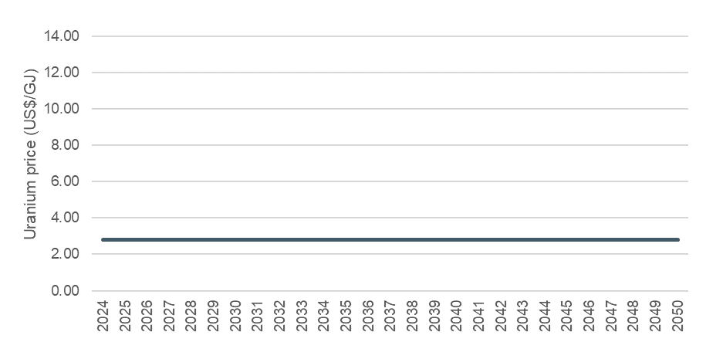
Source: Study on Integrating Nuclear Power in generation capacity plan 2015-2040”, Report for MEMD 2015.

Peat price forecast and transportation costs
To be utilised for power generation peat is required to be extracted from the ground and transported to the relevant power plant. Any peat extraction needs to be carefully managed to protect wetland and biodiversity destruction and damage to eco-systems.
Peat is bulky and has a low energy density, this means long distance transportation to power plants is typically uneconomical and the development of peat thermal power generation is targeted at locations where there is sufficient local source of peat.
The forecast peat price is provided by the MEMD and reflects the cost of extraction and transportation to peat power plants.
Figure 22 Peat price forecast (US$/GJ)
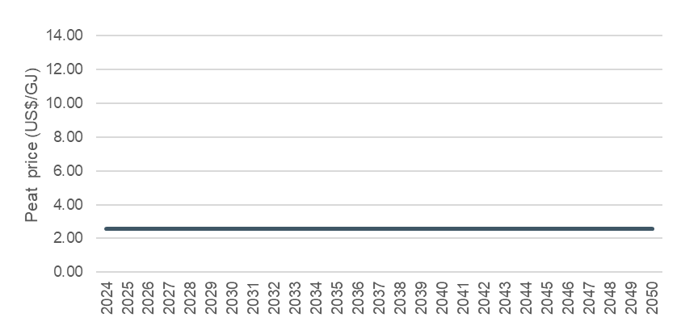
Source: MEMD

Candidate options for the IERMP
The current generation capacity mix in Uganda is dominated by hydro power, making up 83% of installed capacity. The split between large hydro (>20 MW) and small hydro (<20 MW) is 69% and 14% of total installed capacity, respectively. This is followed by 8% from co-generation/bagasse/biomass, 5% thermal generation (fuel oil), and 4% solar. The cvapcity mix in 2023/24 is illustrated in the figure below.
Figure 23 Installed generation capacity mix, 2023/24
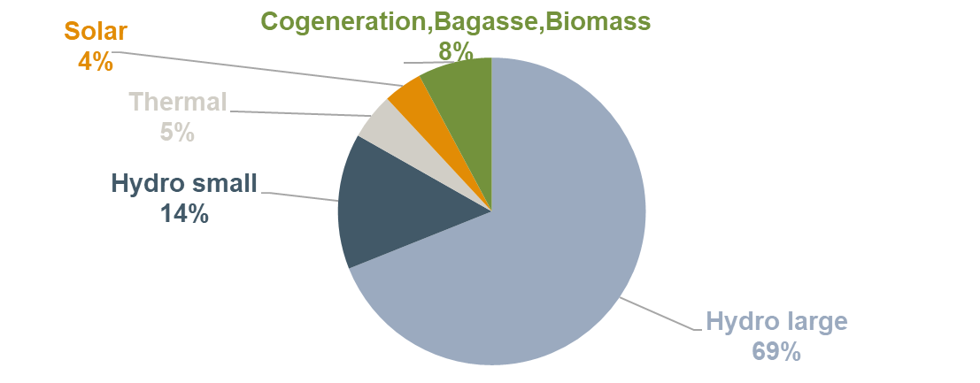
Source: An analysis of Grid Development Plan 2023-40, UETCL
Figure 13 shows the evolution of installed capacity against peak demand from 2018/19 to 2023/24. The addition of Karuma HPP at 600 MW in 2022/23 increased the installed capacity significantly to around 2,050 MW. The installed capacity was adequate to cover peak demand in the past six years with the reserves margin ranging from 65% to 138% (assuming hydro availability).
Figure 13 Installed capacity and peak demand 2018/19-2023/24
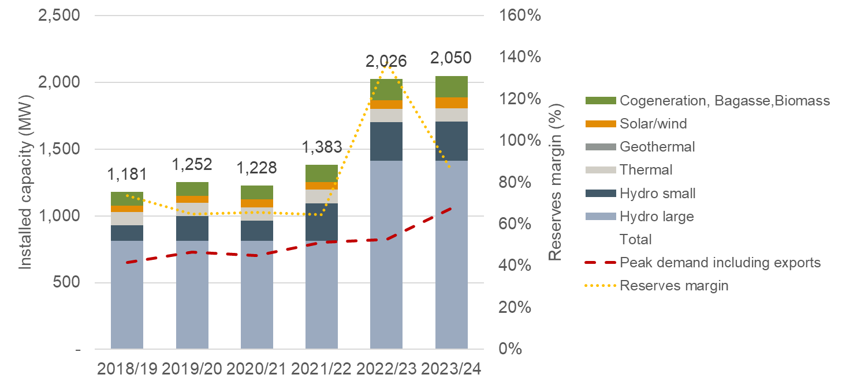
Source: ECA analysis of Grid Development Plan 2023-40, UETCL; Notes: Electromaxx thermal power plant with 50 MW installed capacity has been included in graph above although appears to be unavailable for years 2019/20 – 2022/23 (inclusive), 2022/23 and 2023/24 include Karuma HPP at 600 MW.
Most of the existing hydro power plants are run-of-river meaning that they cannot store water in reservoirs to dispatch it in peak hours or other hours when the value of energy is higher. Similarly, it means that hydro generation is sensitive to climate conditions and especially susceptible to drought periods where thermal generators, including emergency units in past periods of drought, cover supply deficits from hydro.
Figure 24 illustrates the energy generation mix between 2000 and 2023. Hydro generation has been the dominant generation technology. In the period from 2005 and 2012 thermal power in the form of oil was brought in for security of supply reasons. This was partly driven by a drought that minimised the supply from hydro but also the unavailability of some hydro units which were out for maintenance. Since then, a larger fleet of hydro, better dispatch practices, new GET FiT capacity pushing existing thermal plants out of dispatch, and the expensive thermal power plants PPAs have reduced the need for expensive thermal oil plants to only being used at peak hours. Bioenergy has also played an increasing role in meeting demand from 2010 onwards and more recently Solar PV as well.
Figure 24 Electricity generation, 2000-2021
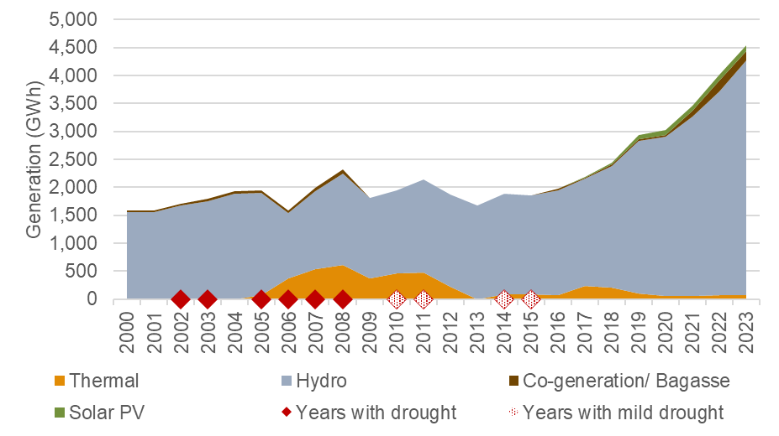
Source: Uganda 2023, Energy Policy Review, IEA, 2023 and 2024 Generation Statistics of ERA.

Existing power plants
The following subsections analyse existing power plants in Uganda and analyse their technical and economic characteristics which will be used to assess the least cost plan for the IERMP.

Existing hydro power plants
The analysis of existing hydro power plants is split between large hydro power plants (>20 MW) and small hydro power plants (<20 MW).

Large hydro power plants (> 20 MW)
Uganda has seven large hydro power plants as of December 2024. The technoeconomic characteristics of the existing large hydro power plants that will be considered for the IERMP are detailed in the table below.
Table 11 Existing large (>20 MW) hydro power plants
Source: Installed capacities, available capacities and commissioning dates were sourced from ERA in 2024 (GenerationStatistics2024.xlsx); Average historical capacity factors were calculated using actual generation data from 2009 sourced from ERA (GenerationStatistics2024.xlsx); Costs and dry year available energy were sourced from Master plan study on hydropower development in Uganda, 2011.
The majority of the largest hydropower plants are on the Victoria Nile and the rest are developed along Achwa river. The location and the sequencing of the large hydro power plants between Lake Victoria and Lake Kyoga and those located between Lake Kyoga and Lake Albert are shown in the figure below.
Figure 25 Sequencing of existing large hydro power plants along Nile river
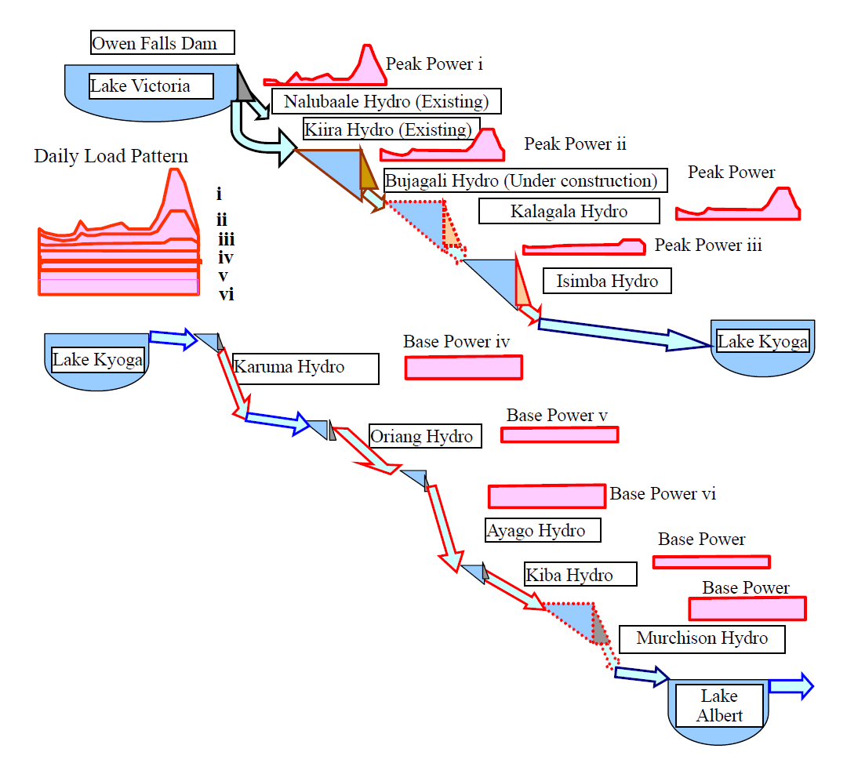
Source: Master plan study on hydropower development in Uganda, 2011
Very low seasonal variation of hydro generation by quarter is observed in the operation of the hydro power plants suggesting that seasonal variations do not affect hydropower generation in Uganda. The figure below shows historical generation of large hydro power plants by quarter relative to the average annual generation for each of the past 14 years. As can be seen, there are very low seasonal variation of hydro generation by quarter in each year. On average, hydro generation was 1% higher in quarter 1, 3% lower in quarter 2, 3% higher in quarter 3 and 1% lower in quarter 4 each year. Modelling of seasonality for hydro power plants in Uganda is not as significant as in other hydro heavy systems.
Figure 26 Seasonality of hydro generation within a year by quarter
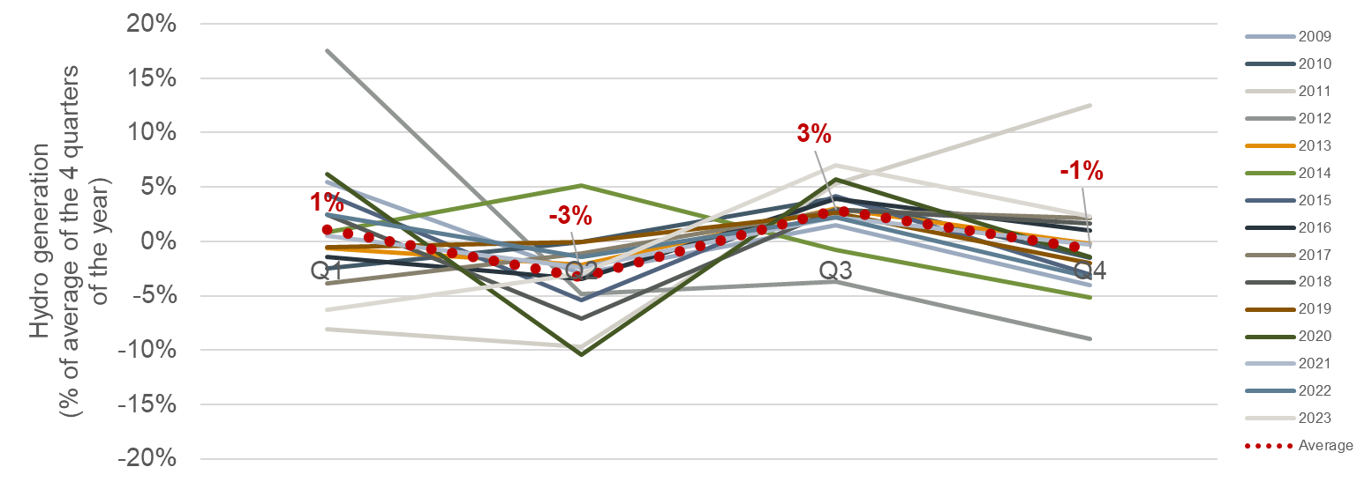
Source: ECA analysis using actual generation data from GenerationStatisticsQ1_2024.xlsx
Average annual precipitation did not fluctuate significantly over the past fourteen years but years with drought have affected hydro generation. This is illustrated at the figure below which shows annual average capacity factors of large hydro power plants against annual average precipitation in Uganda over the past fourteen years.
Figure 27 Seasonality of hydro generation within a year by quarter
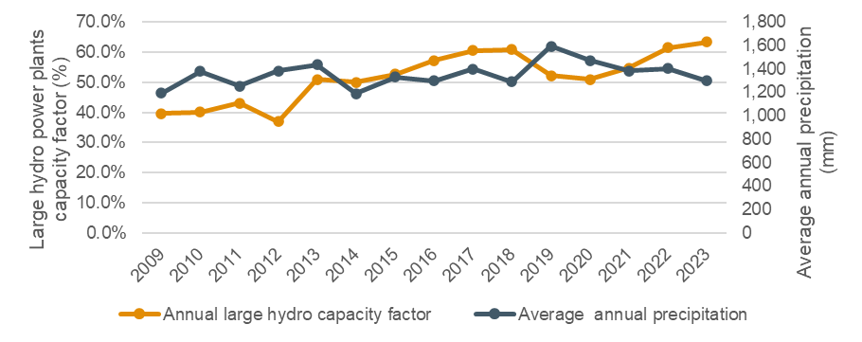
Source: ECA analysis using actual generation data from GenerationStatisticsQ1_2024.xlsx and World Bank data for average precipitation.

Small hydro power plants (<20 MW)
A large number of small hydropower plants also exist throughout Uganda. These are all run of river plants typically connected to the distribution grid. The technoeconomic characteristics of the existing small hydro power plants that will be considered for the IERMP are detailed in the table below.
Table 12 Existing small (<20 MW) hydro power plants
Source: Installed capacities, available capacities and commissioning dates were sourced from ERA in 2024 (GenerationStatistics2024.xlsx); Average historical capacity factors were calculated using actual generation data from 2009 sourced from ERA (GenerationStatistics2024.xlsx); Costs and dry year available energy were sourced from Master plan study on hydropower development in Uganda, 2011.

Existing thermal power plants
Seven thermal power plants are currently installed and connected to the grid in Uganda. Two Internal Combustion Engines (ICE) operation with Heavy Fuel Oil (HFO) and five co-generation power plants operating with bagasse. The technoeconomic characteristics of the existing thermal power plants that will be considered for the IERMP are detailed below.
Table 13 Existing thermal power plants
Source: MEMD and ERA, 2024. Note: 8 MW of the Electromaxx ICE were transferred to supply off-grid in 2021. The co-generation units are owned by sugar companies and most of their capacity is used for their own use – the effective available capacity for the grid is much lower than the installed capacity of the power plants as detailed in the table above.

Existing Solar PV power plants
Seven utility scale solar PV power plants are currently connected to the grid. The first one (Access Solar) was developed in 2016 and the newest power plant (Xsabo Nkonge Solar) was connected in 2024. The total installed capacity of existing solar PV power plants is 84 MW. The technoeconomic characteristics of the existing solar PV power plants that will be considered for the IERMP are detailed in the table below.
Table 14 Existing solar PV power plants
Source: MEMD and ERA, 2024. Note: *The actual historical capacity factor of Busitema Solar and Xsabo Nkonge Solar is unknown and was considered to be equal to the average of the other existing solar PVs.

Committed power plants
A committed power plant is one for which a contract has been signed or some other commitment has been made that makes it costly in financial or political terms to retract from that commitment. Committed power plants will be considered certain for development in the IERMP.
Three hydro power plants which are under construction will be considered as committed power plants for the IERMP. These are shown in the table below. No other power plants have reached commitments to be considered as committed power plants for the IERMP.
Table 15 Committed power plants
Source: UTCL grid development plan (2023-2024); Deep Earth International 2024, "Testing of Kigwabya hydro to start soon"; Synatra Energy - Kiraboha hydro specification; UEGCL, 2023, "Nyagak III nears completion"; AMEA Power announces groundbreaking of 24 MWp Solar PV Project in Uganda and MEMD.

Candidate power plant options

Gas-fired power plants
UETCL’s transmission master plan 2023-2040 identifies possible gas power plants adjacent to Kingfisher and Tilenga oil fields, these would utilise associated gas obtained through the oil extraction process. However, these assets will be used to operate oil extraction and the newly built oil pipeline rather than delivering to the grid. We therefore do not include these assets as candidate plants.
Candidate generic gas fired power plants could be considered as possible options in Uganda after the development of the potential gas pipeline between Tanzania and Uganda. However, as discussed in section 2.2.2, it is assumed that such an option could become feasible after 10 years (eg from 2035 onwards). Generic candidates for Open Cycle Gas Turbines (OCGTs) and Combined Cycle Gas Turbines (CCGTs) of varying sizes will be considered for the IERMP with the technical parameters shown below.
Table 16 Generic candidate CCGT – Technoeconomic assumptions
Item | CCGT small  (~60 MW) | CCGT medium  (~300 MW) | CCGT large  (>450 MW)
Nominal net power output (MW) | 60 | 300 | 450
Unit sizes (MW) considered to size the least cost capacity | 60 | 100 | 150
Heat rate (GJ/MWh) | 7.316 | 7.251 | 7.234
Capital costs ($/kW) | 1,839 | 1,208 | 1,137
Economic lifetime | 25 | 25 | 25
Fixed O&M costs ($/kW/year) | 48.33 | 8.07 | 4.57
Variable O&M costs ($/MWh) | 8.47 | 4.57 | 4.27
CO₂ emissions intensity (kg/MWh) | 414 | 407 | 404
Forced outage rate (%) | 4.4 | 4.4 | 4.4
Maintenance outage rate (%) | 8.8 | 8.8 | 8.8
Lead time (years) | 3 | 3 | 3
Earliest year available (year) | 2033 | 2033 | 2033
Source: ECOWAS WAPP masterplan and AEMO ISP assumptions 2024, costs inflated to 2023 US$
Table 17 Generic candidate OCGT – Technoeconomic assumptions
Item | OCGT small  (~45 MW) | OCGT medium  (~100 MW) | OCGT large  (>150 MW)
Nominal net power output (MW) | 45 | 100 | 150
Unit sizes (MW) considered to size the least cost capacity | 45 | 100 | 150
LHV net heat rate (GJ/MWh) | 11.503 | 10.945 | 10.698
Capital costs ($/kW) | 1080 | 735 | 688
Economic lifetime | 25 | 25 | 25
Fixed O&M costs ($/kW) | 21.11 | 19.73 | 18.44
Variable O&M costs ($/MWh) | 5.68 | 5.32 | 4.96
CO₂ emissions intensity (kg/MWh) | 641 | 603 | 592
Forced outage rate (%) | 2.3 | 2.3 | 2.3
Maintenance outage rate (%) | 7.5 | 7.5 | 7.5
Lead time (years) | 2 | 2 | 2
Earliest year available (year) | 2033 | 2033 | 2033
Source: ECOWAS WAPP masterplan and AEMO ISP assumptions 2024, costs inflated to US$ 2023

Oil-fired power plants
ICE are a well-established and widely used technology for utilising Heavy Fuel Oil (HFO) to generate electricity. Their sizes range from small kW engines to large 80 MW power units. ICE technology has improved dramatically over the past three decades, driven by economic and environmental pressures for power density improvements, increased fuel efficiency, and reduced emissions. The technoeconomic characteristics of generic ICE (HFO) that will be considered for the IERMP are discussed in the table below.
Table 18 Generic candidate ICE – Technoeconomic assumptions
Item | ICE (HFO)
Installed capacity (MW) | 20
Nominal net power output (MW) | 16.64
Heat rate (GJ/MWh) | 9.095
Capital costs ($/kW) | 1,236
Economic lifetime | 20
Fixed O&M costs ($/kW/year) | 22.45
Variable O&M costs ($/MWh) | 7.89
Emissions production rate (kgCo2/MWh) | 715
Forced outage rate (%) | 10
Maintenance outage rate (%) | 7
Lead time (years) | 2
Earliest year available (year) | 2027
Source: ECOWAS WAPP masterplan

Utility scale solar PV
14 generic candidate utility scale solar PV sites were prioritised for development, following the solar mapping analysis discussed in Section 3.1. The analysis considered solar irradiation, land use, land slope, wetlands, protected areas and distance from the existing or planned grid to assess and prioritise areas utility scale solar PV could be developed. The analysis also assessed the maximum solar PV capacity that could be developed in each area. The least cost capacity of solar PV power plants to be developed in each area will be assessed in the least cost planning simulations for each area with the maximum potential capacity acting as a cap.
The location of the 14 candidate solar PV zones that will be considered for the IERMP are shown in Figure 28. The specifications for each area in terms of size, potential capacity and capacity factor are detailed in the following table.
Figure 28 Generic candidate solar PV sites
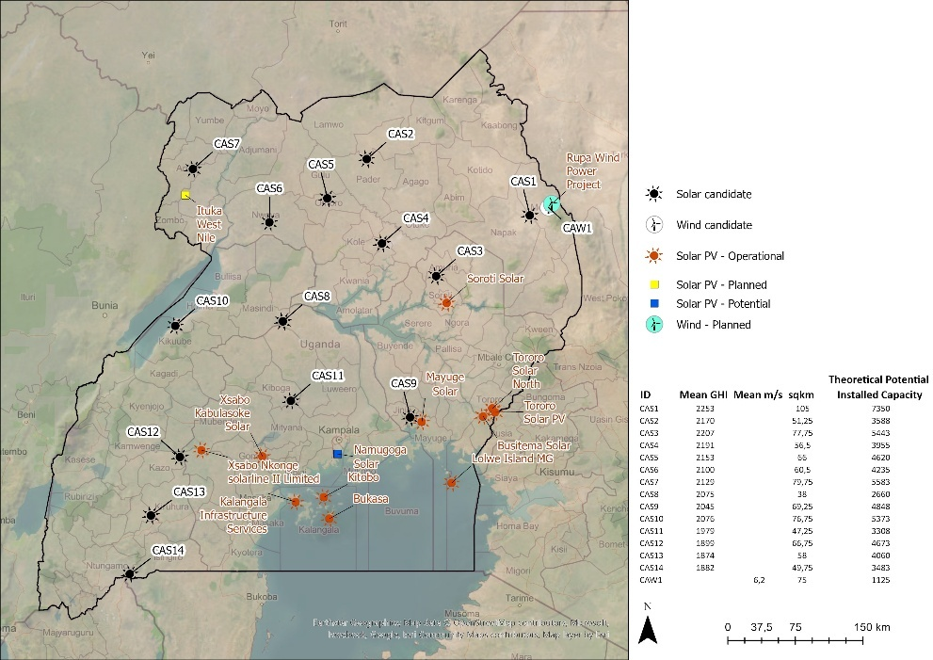
Source: ECA analysis
Table 19 Maximum potential capacity for solar PV development by candidate area
Project name | Mean GHI (KWh/m²) | Area (km²) | Capacity factor (%) | Maximum potential capacity for development in each area (MW)
Generic CAS1 | 2,253 | 105 | 20.58% | 7,350
Generic CAS2 | 2,170 | 51.25 | 19.82% | 3,588
Generic CAS3 | 2,207 | 77.75 | 20.16% | 5,443
Generic CAS4 | 2,191 | 56.5 | 20.01% | 3,955
Generic CAS5 | 2,153 | 66 | 19.66% | 4,620
Generic CAS6 | 2,100 | 60.5 | 19.18% | 4,235
Generic CAS7 | 2,129 | 79.75 | 19.44% | 5,583
Generic CAS8 | 2,075 | 38 | 18.95% | 2,660
Generic CAS9 | 2,045 | 69.25 | 18.68% | 4,848
Generic CAS10 | 2,076 | 76.75 | 18.96% | 5,373
Generic CAS11 | 1,979 | 47.25 | 18.07% | 3,703
Generic CAS12 | 1,899 | 66.75 | 17.34% | 4,673
Generic CAS13 | 1,874 | 58 | 17.11% | 4,060
Generic CAS14 | 1,882 | 49.75 | 17.19% | 3,483
Kabale Energy Ltd | 1,882 | Ntungamo | 17.19% | 80
SUNFarming Food and Energy | 2,076 | Kikuube | 18.96% | 30
Source: ECA analysis, SUNFarming Food and Energy, Sandea Uganda.
Capex for solar PV installation comprises all costs for installation of the plant, including civil structures and interconnection to the closest electrical substation. The major driving factor of Capex is the cost of solar PV panels. Capex for grid-scale solar PV projects are now nearing USD 1,000 / kW.
Further cost reductions are expected on the capital costs of Solar PV power plants over the planning horizon. Solar PV capital cost forecasts from the Australian Energy Market Operator, National Renewable Energy Laboratory (NREL) and the International Energy Agency (EIA) expect a steady reduction in costs across the horizon to 2050, with some forecasts expecting a significant reduction by 2030. We assume an annual reduction of 2.2% to 2050 sourced from National Renewable Energy Laboratory (NREL), 2023 estimates.
Table 20 Generic candidate utility scale solar PV – Technoeconomic assumptions
Item | Candidate grid-scale Solar PV
Nominal net power output (MW) | 1 (units of 1 MW up to the maximum available capacity of each area will be considered for the IERMP to size the least cost capacity for development)
Capital costs ($/kW) | 999
Capex AAGR until 2050 (%) | -2.2
Economic lifetime (years) | 25
Fixed O&M costs ($/kW) | 13.03
Variable O&M costs ($/MWh) | 0.33
Forced outage rate (%) | -
Maintenance outage rate (%) | -
Lead time (years) | 2
Earliest year available (year) | 2027
Source: Australian Energy Market Operator Integrated System Plan 2024

Floating solar PV
As-well as fixed mount solar on dry land another approach to leveraging solar resource is via floating solar PV panels. Although typically associated with coastal regions where land is limited floating solar is also viable in reservoirs and other lakes. One example comes from Ghana which in 2024 installed the largest floating solar panel system in Africa in one of its reservoirs. Floating solar on lakes and reservoirs has additional benefits of reducing water evaporation and reducing the bloom of harmful algae.
The suitability of a floating solar site depends on several factors. The area must be free from restrictions like protected zones, aquaculture sites, or port routes. Proximity to shore balances visual impact with easier grid connection, while water depth affects anchoring and cabling costs. Distance from a grid connection and port influences installation expenses, and solar radiation levels determine energy generation potential. Finally, the site must be large enough to support the installation.
Given the extent of Lake Victoria -- the total area of the lake is 66,000 km² and 45% (31,000 km²) is within the Ugandan borders – we put no limit on the amount of floating solar. Even only 1% of the Ugandan lake area could host over 30,000 MW of floating solar.
Table 21 Generic candidate floating solar PV – Technoeconomic assumptions
 | Candidate floating Solar PV
Nominal net power output (MW) | 10 (units of 10 MW up to the maximum potential capacity will be considered for the IERMP to size the least cost capacity of Floating Solar if it is selected as least cost option)
Capital costs ($/kW) | 1,680
Capex AAGR until 2050 (%) | -2.2
Economic lifetime | 25
Capacity factor (%) | Capacity factors like fixed solar will be dependent on the location within Uganda but can be expected to range from 17% to 20% aligned with fixed solar PV depending on the exact location.
Fixed O&M costs ($/kW) | 11.0
Variable O&M costs ($/MWh) | 0.33
Forced outage rate (%) | -
Maintenance outage rate (%) | -
Lead time (years) | 3
Earliest year available (year) | 2027
Source: Capital costs calibrated on basis of the ratio of Floating to Land Solar PV, as provided by Floating Photovoltaic System Cost Benchmark, NREL, 2021 – Fixed O&M costs from ESMAP, Where sun meets water, 2022

Onshore wind
As with solar PV, an analysis was conducted to prioritised sites for wind development (see Section 3.1. The analysis considered wind speeds across a year, land use, land slope, wetlands, protected areas and distance from the existing or planned grid to assess and prioritise areas onshore wind farm could be developed. The analysis also assessed the maximum wind capacity that could be developed in each area. The least cost capacity of wind farms to be developed in each area will be assessed in the least cost planning simulations with the maximum potential capacity acting as a cap.
Out of the three zones identified from the analysis for wind development, one was selected to be included as a generic candidate option for the IERMP. The Northeast area of Uganda has the highest potential for wind development and was prioritised over the other two shown in the map below. The map also shows the location of the generic candidate wind farm that will be considered for the IRP together with the maximum available potential.
Figure 29 Candidate sites for onshore wind development


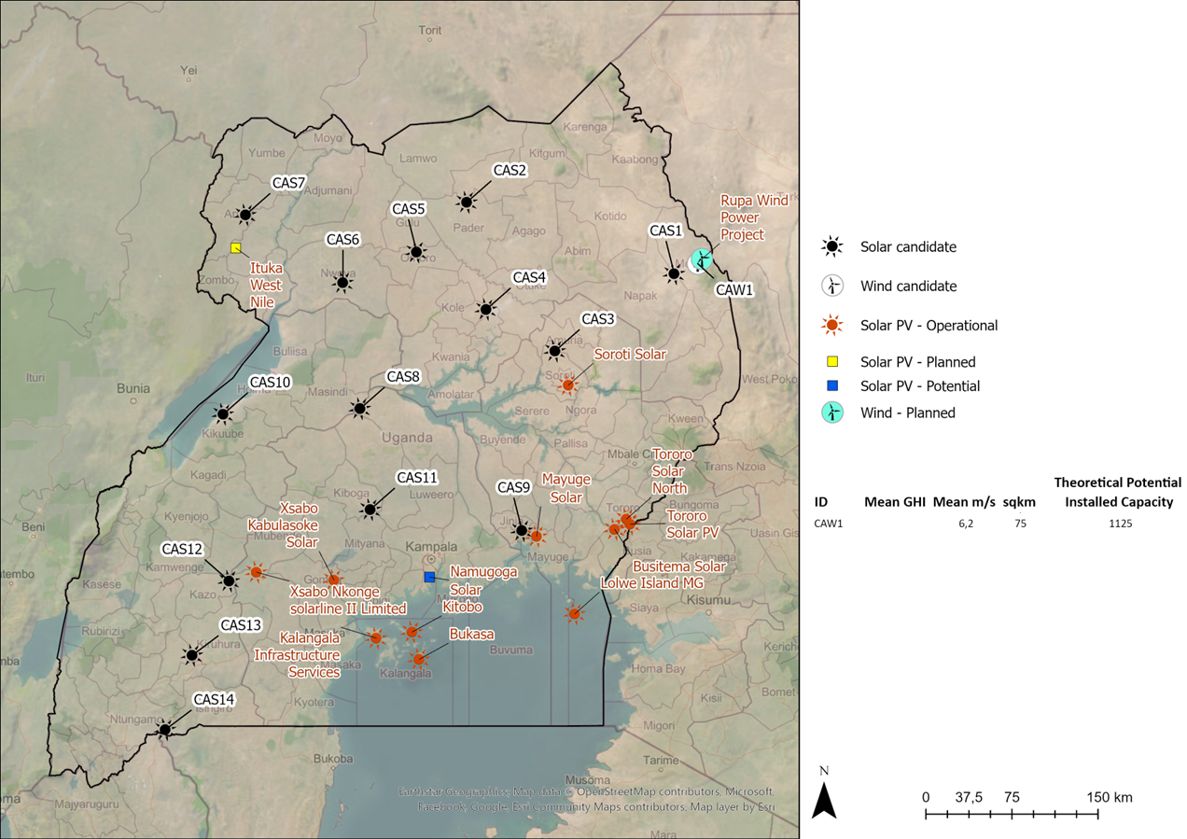
Source: ECA GIS mapping based on global GHI data
A candidate wind project is also under consideration in Karamoja-Rupa by Sri Lankan firm Senok Wind Uganda, a Senok Wind Power Pvt subsidiary. Senok Wind Power Pvt has installed data-gathering windmills in Karamoja-Rupa and is looking to develop a wind farm with a maximum capacity of 40 MW.
The specifications for the potential capacity and capacity factor for the generic candidate projects that will be considered in IERMP are detailed in the following table.
Table 22 Maximum potential capacity for wind development by candidate project
Project name | Mean wind speed (m/s) | Area (km²) | Capacity factor (%) | Maximum potential capacity for development in each area (MW)
Generic CAW1 | 6.2 | 75 | 23.8% | 1,125
Rupa wind (Senok Wind Uganda) | - | Rupa | 23.8% | 40
Source: ECA analysis
Wind energy is a mature renewable technology that has seen significant uptake and cost reduction over the past decade. According to IRENA, the global weighted average total installed cost of onshore wind fell by 49%, from $ 2,179/kW in 2010 to $ 1,160/kW, with a 10% decline year-on-year to 2023. Both NREL and AEMO foresee future cost reductions of approximately 2.2% to 2030 before a relative levelling off in capex costs. The assumptions that will be used for the IERMP for generic candidate wind farms are shown in the table below.
Table 23 Generic candidate onshore wind – Technoeconomic assumptions
 | Candidate onshore wind CAW1
Nominal net power output (MW) | 1 (units of 1 MW up to the maximum potential capacity will be considered for the IERMP to size the least cost capacity of wind farms if it is selected as least cost option)
Capital costs ($/kW) | 1,788
Capex AAGR until 2050 (%) | -2.2
Economic lifetime | 25
Fixed O&M costs ($/kW) | 19.17
Variable O&M costs ($/MWh) | 0.66
Forced outage rate (%) | -
Maintenance outage rate (%) | -
Lead time (years) | 2
Capacity factor | 23.8%
Max capacity (MW) | 1,125
Earliest year available (year) | 2027
Source: Costa data from AEMO Integrated System Plan 2024

Geothermal
Uganda is understood to have geothermal resource to support 1.5GW of generation capacity mainly along the Western border of the country. The UETCL grid development plan 2023-2040 details the development of possible geothermal site in Uganda within the next 20 years. The site at Panyimur is projected do increase to 150MW by 2035.
Given the lack of pre-feasibility or feasibility studies the site at Panyimur is only included as a candidate plant for the purposes of the IERMP. We additionally include generic geothermal candidates reflecting the extensive known accessible geothermal energy resource in a similar area to Panyimur.
Table 24 Candidate geothermal projects
Project name | Maximum potential capacity (MW) | Area | Unit sizes considered to size the least cost capacity (MW) | Earliest commissioning year
Panyimur (Batu Energy limited) | 10 | Panyimur | 10 | 2027
Panyimur extension | 140 | Panyimur | 140 | 2035
Generic geothermal | 1,350 | Buranga, Katwe, Panyimur or Kibiro | 50 | 2030
Source: ECA analysis
Table 25 Generic candidate geothermal – Technoeconomic assumptions
 | Generic candidate geothermal unit
Nominal net power output (MW) | 50
Capital costs ($/kW) | 5,583.63
Economic lifetime | 25
Heat rate (GJ/MWh) | 3.600
Fixed O&M costs ($/kW) | 50.26
Variable O&M costs ($/MWh) | 9.77
Forced outage rate (%) | 5
Maintenance outage rate (%) | 5
Lead time (years) | 3
Earliest year available | 2030
Source: Study on Integrating Nuclear Power in Generation Capacity Plan 2015-2040”, Report for MEMD, 2015, costs inflated to US$ 2023

Biomass/biogas
Two candidate biogas or biomass project are under consideration in Uganda and they are outlined in the UETCL 2023-2040 development plan. A biogas plant in Masindi and a bagasse plant in Kyankwanzi. Both will be considered as candidate power plants in the IERMP with the following technoeconomic specifications.
Table 26 Candidate biomass and biogas projects – Technoeconomic assumptions
 | Masindi Biogas | Kyankwanzi Bagasse
Earliest commissioning date | 2028 | 2028
LHV heat rate (GJ/MWh) | 17.37 | 17.37
Nominal net power output (MW) | 20 | 9
Capital costs ($/kW) | 3,490 | 3,490
Economic lifetime | 25 | 25
Fixed O&M costs ($/kW) | 48.87 | 48.87
Variable O&M costs ($/MWh) | 4.6 | 4.6
Forced outage rate (%) | 7.5 | 7.5
Maintenance outage rate (%) | 7.5 | 7.5
Lead time (years) | 3 | 3
Max capacity (MW) | 9 | 9
Source: “Study on Integrating Nuclear Power in Generation Capacity Plan 2015-2040”, Report for MEMD, 2015 costs inflated to 2023 US$, LHV heat rate based on AEMO ISP report 2023
Generic candidate biomass/biogas power plants will also be considered for the IERMP. Animal and crop residues will be assumed as the operating fuel. As discussed in section 2.22 over 200 PJ of biomass is available from residues per year resulting to a maximum potential of 2,500 MW for biomass/biogas power plants. The technoeconomic specifications that will be considered for candidate generic biomass/biogas power plants in the IERMP are shown below.
Table 27 Generic candidate biomass and biogas power plants – Technoeconomic assumptions
 | Plant parameters
Heat rate (GJ/MWh) | 17.37
Nominal net power output (MW) | 40
Unit sizes considered to size the least cost capacity (MW) | 20
Capital costs ($/kW) | 3,490
Capex AAGR until 2050 (%) | -
Economic lifetime | 25
Fixed O&M costs ($/kW) | 48.87
Variable O&M costs ($/MWh) | 4.6
Forced outage rate (%) | 5
Maintenance outage rate (%) | 5
Lead time (years) | 3
Earliest year available (year) | 20282027
Source: “Study on Integrating Nuclear Power in Generation Capacity Plan 2015-2040”, Report for MEMD, 2015 costs inflated to 2023 US$, LHV heat rate based on AEMO ISP report 2023

Peat
Candidate peat burning power plants will also be considered for the IERMP. The location of candidate peat plants is limited to sites already defined by the ministry of energy as being suitable for peat generation.
Table 28 Generic Peat Plant – Technoeconomic assumptions
 | Kabale Peat | Kyoga Peat
Heat Rate (GJ/MWh) | 14.243 | 13.715
Nominal net power output (MW) | 30 | 50
Unit sizes considered to size the least cost capacity (MW) | 30 | 50
Capital costs ($/kW) | 1,700 | 1,700
Capex AAGR until 2050 (%) | - | -
Economic lifetime | 30 | 30
Fixed O&M costs ($/kW) | 55.56 | 75
Variable O&M costs ($/MWh) | 2.50 | 2.50
Forced outage rate (%) | 5 | 5
Maintenance outage rate (%) | 5 | 5
Lead time (years) | 3 | 3
Max capacity (MW) | 30 | 50
Earliest year available (year) | 2028 | 2028
Source: MEMD

Waste-to-energy
Generic candidate waste-to-energy power plants will also be considered for the IERMP. Estimating CAPEX for waste-to-energy plants is typically challenging and subject to local constraints. However insights can be drawn from existing waste-to-energy projects in Africa. Examples from African WtE Projects include:
- Reppie WtE plant (Ethiopia): Commissioned in 2019, this plant has a capacity of 25 MW and was constructed at a cost of USD 118.95 million, resulting in a CAPEX of approximately USD 4,758 per kW.
- Dandora WtE Power Station (Kenya): Planned with a capacity of 45 MW and an estimated cost of USD 197 million, leading to a CAPEX of about USD 4,378 per kW.
The assumed capital costs for a candidate waste to energy power plant in Uganda will be USD 4,378 per kW.
Table 29 Kampala waste-to-energy plant – Technoeconomic assumptions
 | Candidate waste-to-energy parameters
LHV Heat Rate (GJ/MWh) | 20.53
Nominal net power output (MW) | 10
Unit sizes considered to size the least cost capacity (MW) | 10
Capital costs ($/kW) | 4,378
Capex AAGR until 2050 (%) | -
Economic lifetime | 25
Fixed O&M costs ($/kW) | 88
Variable O&M costs ($/MWh) | 3
Forced outage rate (%) | 5
Maintenance outage rate (%) | 5
Lead time (years) | 3
Max capacity (MW) | 10
Earliest year available (year) | 2028
Source: ECA Analysis of existing units in Africa and industry benchmarks from IRENA and FAO BEFS

Nuclear
The MEMD has carried out a screening of possible reactor sites as shown in the figure below. This accounted for geology, meteorology, population density and water availability. The leading candidate site was in Buyende district where further studies are taking place with the help of international consultants.
Figure 30 Potential sites surveyed for a nuclear power plant in Uganda
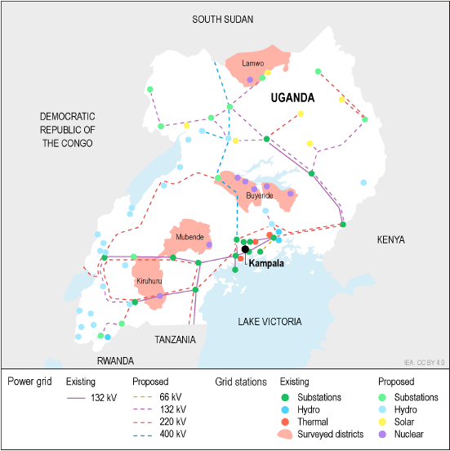
Source: IEA Uganda 2023 Energy Policy Review
The average construction and commissioning time of a nuclear power plant is seven years which indicates that a nuclear power plant could be developed the earliest in 2033, if feasibility studies started in 2025. This will be considered as the earliest year Buyende candidate nuclear project could be commissioned.
Two candidate nuclear projects will be considered in Buyende as shown in the table below.
Table 30 Buyende nuclear candidate power plants – Technoeconomic assumptions
 | Buyende I Nuclear candidate power plant | Buyende II Nuclear candidate power plant
Maximum capacity (MW) | 1,429.1 | 2,410.4
Unit sizes considered to size the least cost capacity (MW) | 1,000 | 1,000
Base load heat rate (GJ/MWh) | 11.988 | 11.988
Capital costs ($/kW) | 4454 | 4454
Economic lifetime (years) | 60 | 60
Fixed O&M costs ($/kW) | 71.43 | 71.43
Variable O&M costs ($/MWh) | 8.99 | 8.99
CO₂ emissions intensity (kg/MWh) | - | -
Forced outage rate (%) | 5 | 5
Maintenance outage rate (%) | 5 | 5
Lead time (years) | 6 | 6
Earliest year available (year) | 2033 | 2035
Source: “Study on Integrating Nuclear Power in generation capacity plan 2015-2040”, Report for MEMD 2015, costs inflated to 2023 US$
Generic candidate nuclear plants will also be considered in the IERMP with the maximum potential being 24 GW as analysed in Section 2.5. The technoeconomic characteristics that will be considered are shown in the table below.
Table 31 Generic candidate nuclear plants – Technoeconomic assumptions
 | Generic candidate nuclear power plant 1 | Generic candidate nuclear power plant 2 | Generic candidate nuclear power plant 3 | Generic candidate nuclear power plant 4
Maximum potential capacity | 24 GW
Unit sizes considered to size the least cost capacity | 750 MW | 1,000 MW | 1,300 MW | 1,500
Base load heat rate (GJ/MWh) | 11.988 | 11.988 | 11.988 | 11.988
Capital costs ($/kW) | 5,399 | 4,454 | 4,454 | 4,454
Economic lifetime (years) | 60 | 60 | 60 | 60
Fixed O&M costs ($/kW) | 84.93 | 71.43 | 71.43 | 71.43
Variable O&M costs ($/MWh) | 8.99 | 8.99 | 8.99 | 8.99
CO₂ emissions intensity (kg/MWh) | - | - | - | -
Forced outage rate (%) | 5 | 5 | 5 | 5
Maintenance outage rate (%) | 5 | 5 | 5 | 5
Lead time (years) | 10 | 10 | 10 | 10
Earliest year available (year) | 2035 | 2035 | 2035 | 2035
Source: “Study on Integrating Nuclear Power in generation capacity plan 2015-2040”, Report for MEMD 2015, costs inflated to 2023 US$

Hydro power plants
Four large candidate hydropower plants projects have been identified to be considered in the IERMP. None of the included plants have completed feasibility studies and are still at a conceptual stage.
Capital expenditure for hydropower projects is typically very locational specific – each river and site have specific locational and engineering challenges resulting in a large range of observed hydropower capital cost figures. The assumed parameters for the IERMP are taken from existing studies on these locations and outlined in the table below.
Table 32 Candidate large hydropower projects
Source: ECA analysis of report “Study on integrating nuclear power in generation capacity plan 2015-2040”, 2015 and the UETCL 2023-2040 development plan. costs inflated to 2023 US$
Several smaller candidate run-of-river hydropower plants are documented in the 2023-2040 UETCL generation development plan and will be considered in the IERMP. The parameters for each are outlined in the table below.
Table 33 Candidate small hydropower projects
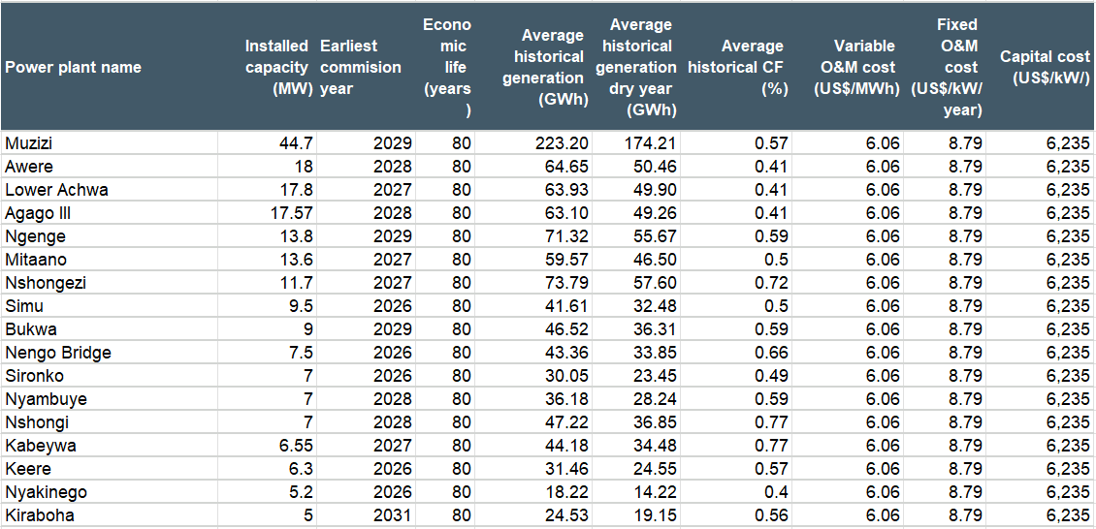
Source: ECA analysis of report “Study on integrating nuclear power in generation capacity plan 2015-2040”, 2015 and the UETCL 2023-2040 development plan, costs inflated to 2023 US$

Hydrogen
Hydrogen is produced using electrolysis, i.e., a chemical process whereby electricity is used to separate the hydrogen molecules from water. It is most commonly transported in a gaseous state and the most common current usage is in industrial processes. Recent developments and cost reductions have seen hydrogen becoming a key feature of national and international decarbonisation policies. However, costs are still higher than other alternatives and projects without financial support have not materialised yet.
There are two primary low carbon methods for producing hydrogen:
- ‘Grey’ or ‘Blue’ hydrogen – from natural gas through a process called steam methane reforming (SMR) (sometimes called ‘blue’ hydrogen if the resulting CO₂ is then captured and stored; without CO₂ capture this is called ‘grey’ hydrogen) or
- ‘Green’ hydrogen – from renewable electricity with an electrolyser (‘green’ hydrogen). The hydrogen could then be directly fed to fire a gas turbine, but this would be at a cost premium due to the inherent efficiency losses in producing hydrogen.
The promise of hydrogen-for-power is highest when demand is low and/or renewable energy supply (RES) production is high or following seasonal demand patterns, to then be dispatched during peak times or extended periods of low renewable output, e.g., periods of low solar and wind output.
There is broad consensus that the use for hydrogen in some industrial applications is feasible. However, its usage at this juncture in transport, heating and cooling and power generation is more questionable.
Three types of set-ups will be considered as generic candidate options for the Uganda IERMP. In all cases hydrogen is produced from electricity, stored and then used to fuel a thermal power generator:
- Grid electricity for hydrogen production with hydrogen then used as a fuel for power generation.
- Solar PV generation for hydrogen production (electrolyser co-located with a solar PV plant) with hydrogen then used as a fuel for power generation.
- Green hydrogen production with hydrogen then used as a fuel for power generation. Electrolyser operates to only consume green electricity; in Uganda this will primarily come from existing or future hydro plants.
IRENA forecasts that the cost of electrolysers is expected to reduce from USD 500-1000 / kW for Alkaline options in 2020 to less than USD 200 /kW for both PEM and Alkaline options 2050. The cost of electricity and the electrolyser and the utilisation rate are key contributors to the cost of green hydrogen.
For the analysis, we assume that the electrolyser is alkaline based given this is the most common technology; however new methods are being developed, and Polymer electrolyte membrane (PEM) is becoming a considerable option.
Table 34 Candidate generic hydrogen options – Technoeconomic parameters
Parameters | Units | Value
Electrolyser Technical parameters
Electrolyser Efficiency | % | 67%
Heating value (LHV) | kWh/kg H₂ | 33
Alkaline electrolyser capacity | MW | 21
Electrolyser degradation factor | % | 1%
Lifetime | Years | 20
Outages | (%) | 5
Electrolyser cost parameters
Capital costs | $/kW | 967
Fixed costs | $/kW | 14.51
Water costs | $/kg | 0.02
Storage and compressor cost parameters
Capital costs | $/kg | 600
OPEX | $/kg | 7.2
Power plants
Power plants that will be considered for hydrogen usage | CCGT or OCGT
Source: Lazard LCOH analysis 2021, UC Davis: Hydrogen storage and transport costs report,

BESS Storage
BESS can play a prominent role in ensuring security of supply and operation within system limits in a decarbonised power system with increased levels of intermittent renewable generation. The IERMP will capture a variety of different battery parameters in terms of their duration and installed capacity. The assumed technoeconomic parameters for BESS for the IERMP are shown in the table below.
Table 35 Lithium battery costs with a duration of 1-2 h and a capacity of 1-10 MW
Item | Unit | 1-10 MW - 1h | 1-10 MW - 2h | 1-10 MW - 4h
Maximum capacity potential | MW | Unlimited | Unlimited | Unlimited
Power capacity per unit | MW | 1 | 1 | 1
Energy capacity per unit | MWh | 1 | 2 | 4
Duration | h | 1 | 2 | 4
Economic and Technical Lifetime | years | 20 | 20 | 20
Annual degradation | % per annum | 2.2% | 2.2% | 2.2%
Power capital costs | €/kW | 626.15 | 904.37 | 1468.10
Fixed Operation and Maintenance (O&M) costs | €/kW/year | 5.7 | 9.2 | 14.9
Variable O&M costs | €/MWh | 0 | 0 | 0
Charge efficiency | % | 92% | 92% | 92%
Discharge efficiency | % | 92% | 92% | 92%
Total efficiency | % | 84% | 84% | 85%
Max allowed state of charge | % of capacity | 100% | 100% | 100%
Min state of charge | % of capacity | 0% | 0% | 0%
Firm capacity provision | % of capacity | 0% | 25% | 50%
Source: AEMO ISP assumptions (2023)

Screening analysis for candidate power plants
The screening stage compares unit power plant costs to exclude candidate options that are clearly uneconomic to be developed in Uganda.
LCOE provide a simple, common basis for comparing generating technologies in US$/kWh but has several limitations. It does not capture the intermittent nature of renewable energy sources (RES), it cannot assess the actual operating time of power plans (and thus assumes a load factor) and cannot assess the ability of power plants to provide capacity at different times of the day. At a high level, LCOE can be used to compare power plant costs but cannot be used to formulate the least-cost plan.
Screening curves can provide some additional insights into the costs of different generation options. A screening curve shows the LCOE for different load factors. This provides information as to whether a certain technology is economically competitive as a base or peak load plant.
Figure 31 shows the LCOEs for the candidate IERMP options using the technical and economic parameters provided in Section 3 and the estimated cost of fuels provided in Section 2.13. LCOEs were calculated using the average fuel price over the planning horizon. Non-renewable power plants were assumed to operate with load factor of 75% to provide base load power.
Figure 31 LCOEs of Uganda candidate generation options
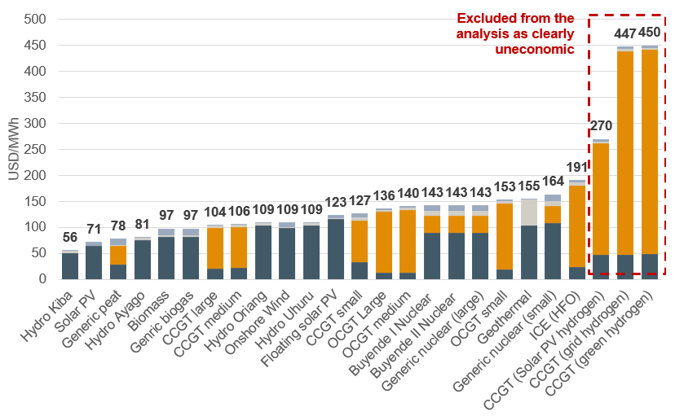
Source: ECA Analysis
Screening curves illustrate the LCOE for different technologies across a range of capacity factors. They highlight how the structure of costs influences the LCOE. Technologies with high capital costs and low variable or fuel costs, such as renewables, tend to have screening curves that decline steeply as capacity factor increases, since fixed costs are spread over greater electricity output.
In contrast, thermal generation assets, which typically have lower capital costs but higher variable and fuel costs, exhibit flatter screening curves because operating expenses remain significant regardless of output levels. Power plants with the lowest LCOE at 70-80% are better suited for baseload power, whereas power plants with the lowest LCOE at 10-30% are better suited for peaking power.
Figure 32 Screening curve of Uganda candidate generation options
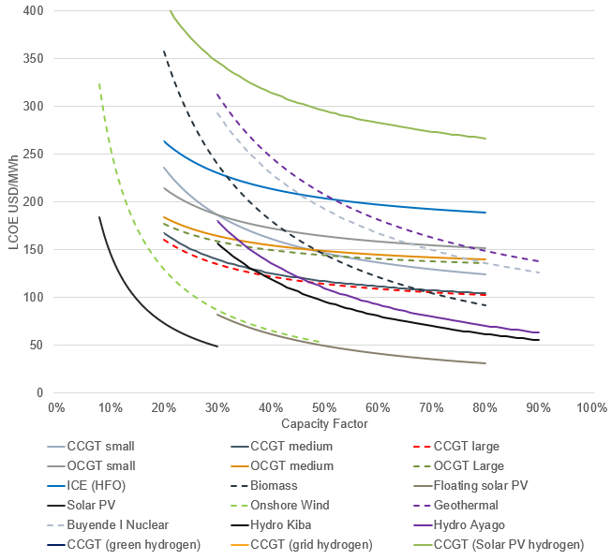
Source: ECA Analysis
Both the screening curves and the LCOE illustrate that hydrogen as an option is clearly uneconomic to be developed in Uganda.

Summary of existing committed and candidate power plants
Table 36 Summary of Uganda existing power plants
Table 37 Summary of Uganda committed power plants
Table 38 Summary of Uganda candidate power plants

Transmission and distribution network
The existing transmission network, depicted in the figure below (shown as solid lines), comprise mainly of 132 kV, 220 kV and 400 kV lines plus a short 66 kV line. The figure also includes future planned projects shown as dotted or dashed lines.
Figure 33 Existing and future transmission network in Uganda
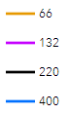
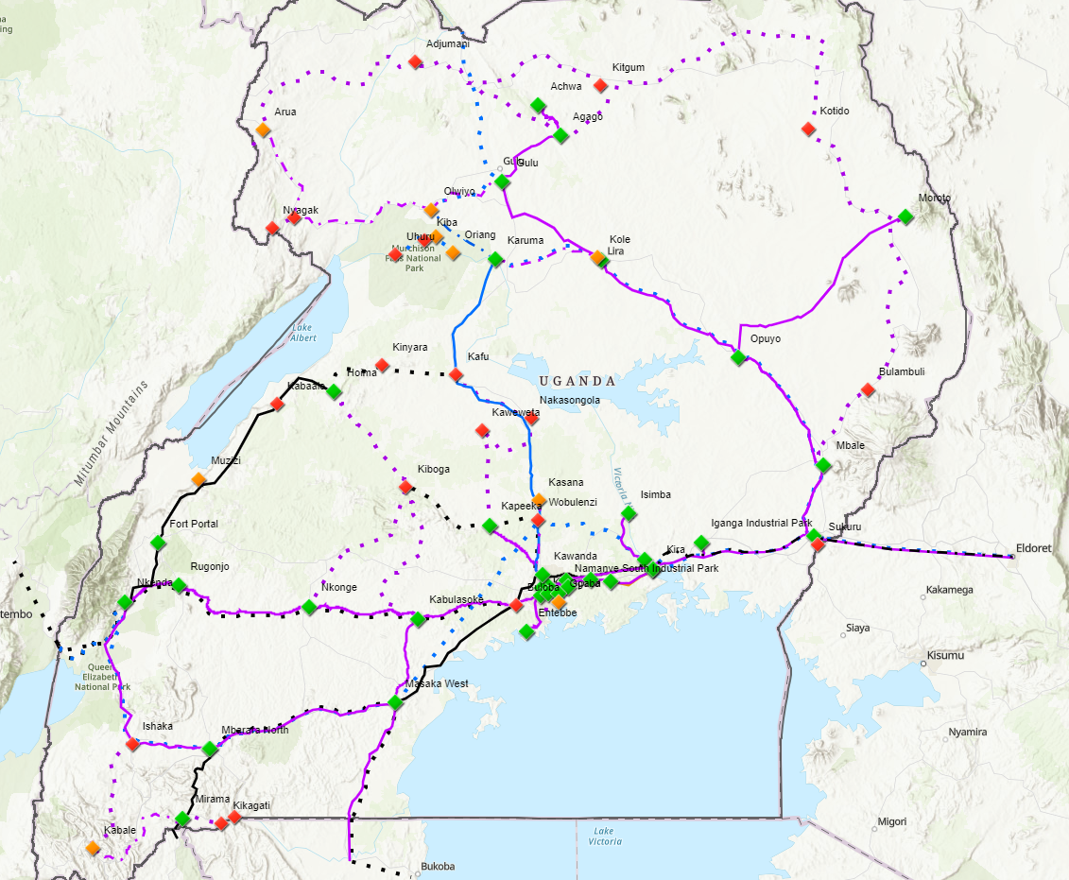
Source: UETCL Grid 2024
Recently completed and ongoing projects as well as committed projects as reported by UETCL in their annual report 2022-2023 and they are presented in the following tables.
Table 39 Recently completed and ongoing projects Uganda
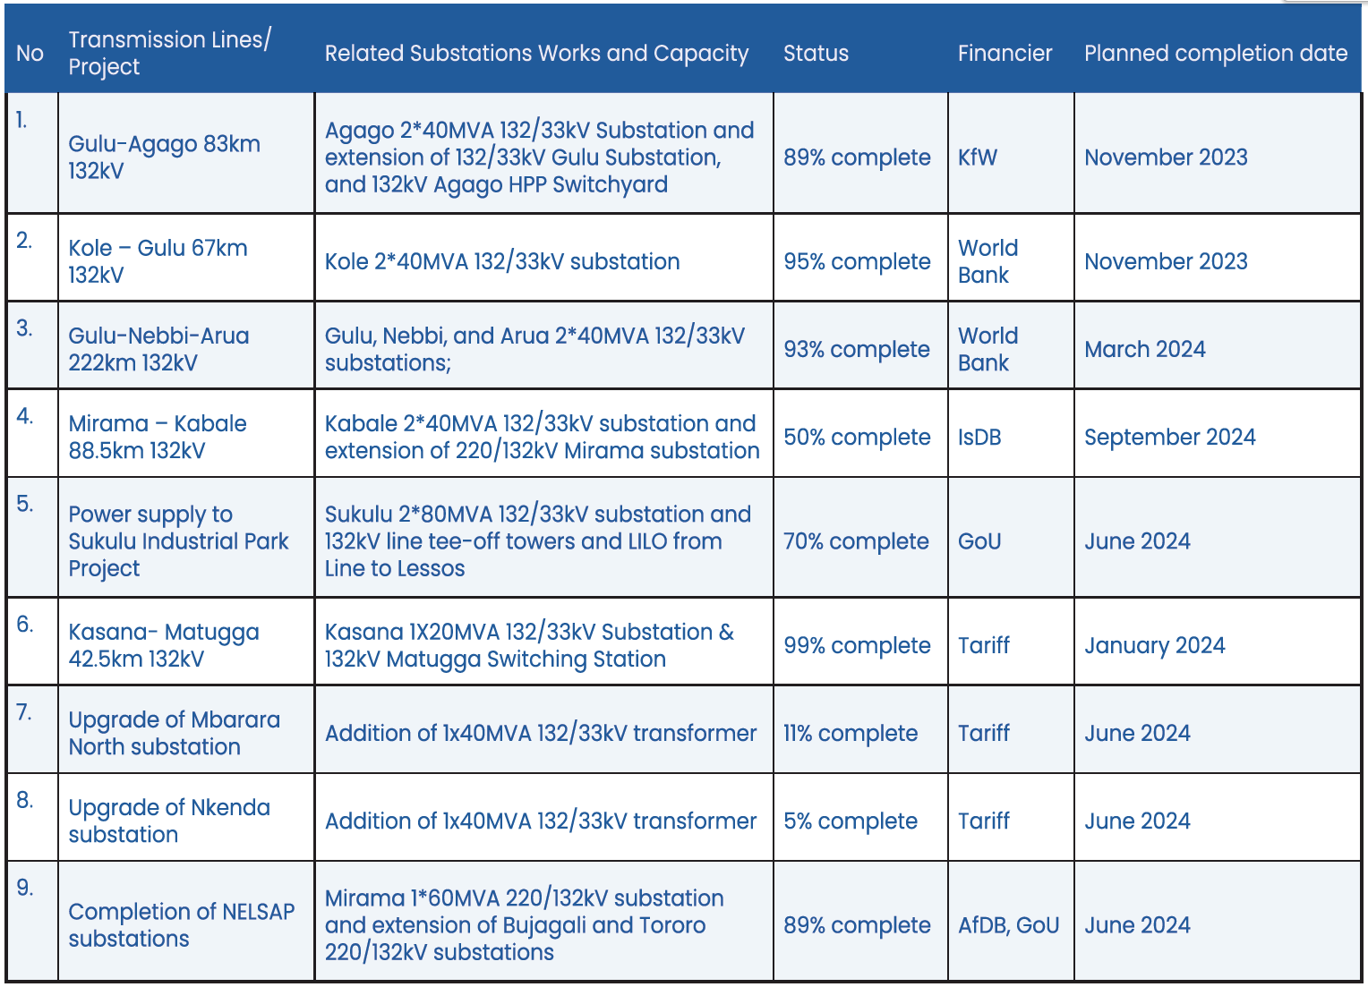
Source: UETCL annual report 2022-2023
Table 40 Committed Projects
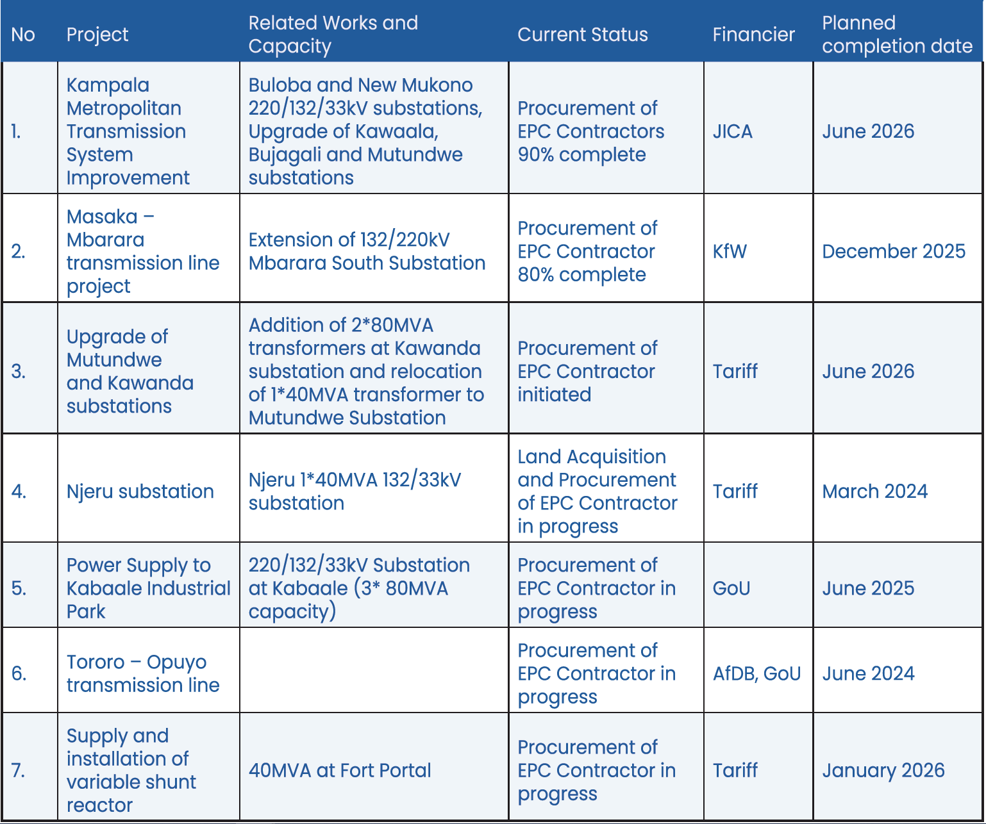
Source: UETCL annual report 2022-2023
The network in Uganda has been interconnected with the grid in Kenya via a 132 kV line from Tororo to Lessos for a number of years. A new 220 kV line on the same link is under construction – expected to be completed in 2025. A 400 kV link between the two countries is also at the planning stage.
A 220 kV link to Rwanda was completed from Mbarara South via Mirama to Shango in 2023. Further interconnections are being considered as indicated in the table below.
Table 41 Regional Interconnection Projects
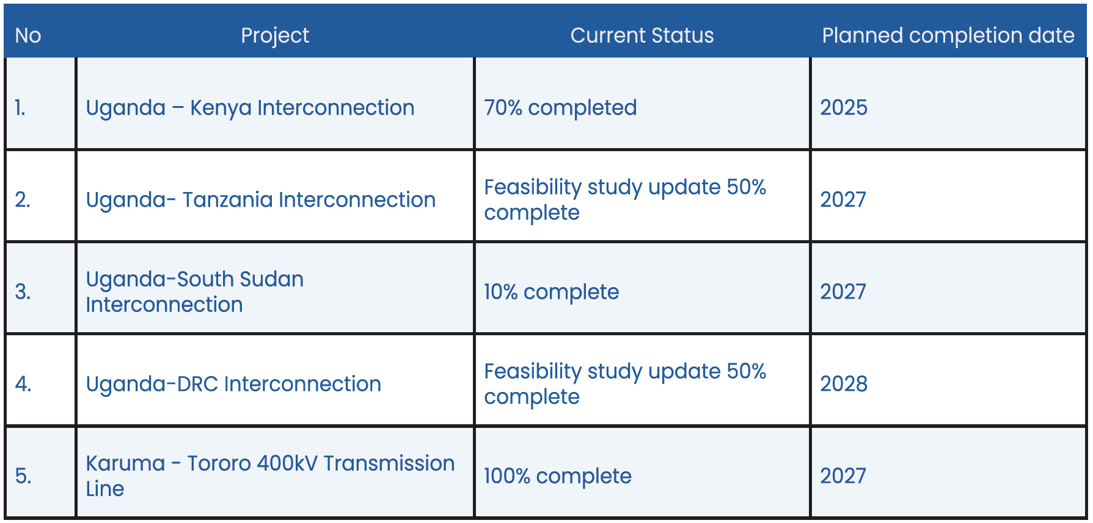
Source: UETCL annual report 2022-2023

Line lengths and capacities
Details on line lengths and thermal capacities are available in the appendices of the “Grid Development Plan 2023-2040” prepared by UETCL. Data on substation transformers are also available in the same document. We will verify that the PSS/E models to be received reflect these data as well as the topology given by relevant maps etc.
In general, the 132 kV network consists of single circuit lines with a single Tiger, Lynx or Goat conductor per phase on the old lines with Starling or All Aluminium Alloy Conductors (AAAC) conductors on newer lines, many of which are double circuit lines. Thermal capacity is relatively low on the older lines and voltage constraints may apply to the longer lines. This will be assessed as part of the simulations in PSS/E. Notably, many of the lines are relatively old.
The 220 kV system has been developed over recent years and consist of double circuit lines with duplex conductors – mainly running from east to west in the southern part of the country – thereby providing a transmission corridor with relatively high transfer capacity.
Initial development of the 400 kV system consists of a double circuit line from Kawanda substation close to Kampala to Karuma and Olwiyo in the northern part of the country.

Network losses and loss reduction plans
Losses on the transmission grid will be estimated for future stages of development reflecting the demand forecast and the most promising generation expansion scenarios. Loss savings from reinforcement and expansion of the system will be accounted for in the planning of the system. Note also the planning criteria described below.

Network component costs
The investment costs for transmission system projects required to support the expansion of the system will be based on a review of investment costs for recent projects in Uganda and the region supported by the consultant’s own database. For the preparation of the IERMP, unit costs per km for new transmission lines and for substations and substation extensions (line bays and transformers will be established). Further detailed feasibility studies of individual projects with detailed assessment of feasible line routes are foreseen to be carried out at a later stage to support investment decisions.

Distribution network
The distribution network consists of an extended 33 kV and 11 kV system throughout the country. The map in the following figure depicts the main distribution lines (2017).
Figure 34 Map of Uganda’s distribution network
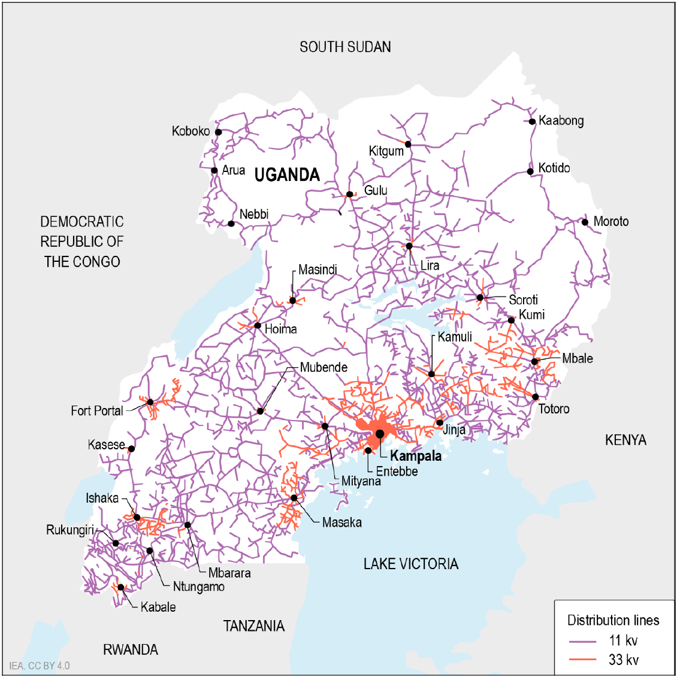
Source: Uganda 2023, energy Policy Review, IEA, 2023; Note: distribution network as in 2017
A recent report (the National Electrification Survey Report-2018, published by the MEMD, January 2020) states that 51% of households have access to at least one source of electricity. 24% of households are connected to the national grid or mini-grids while 27% depends on off-grid solutions including rechargeable batteries and solar devices.
In urban areas, grid supply is the main source for two of three households while in urban areas one of three use off-grid solutions as their primary source of electricity (mainly solar systems).
The following table provides a summary of grid connections per region.
Table 42 Households with grid connection
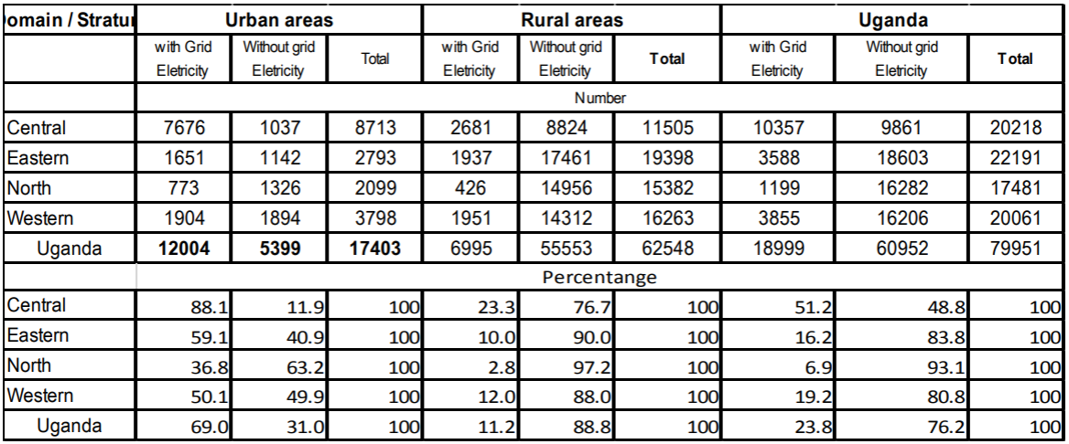
Source: National Electrification Survey
As part of the IERMP, we will review electrification plans in order to establish cost per new connection / kW consumption. To the extent that available background material provides adequate information, we will seek to establish costs in typical urban and rural areas and distinguish between electrification and intensification projects or similar.

Import options analysis
Uganda is bordered by five countries (Kenya, Tanzania, Rwanda, DRC, and South Sudan) each with varying degrees of power connectivity to Uganda. Connections currently exist to Kenya to the east as well as Rwanda and Tanzania to the South. All five neighbouring countries along with Uganda are members of the East African Power Pool (EAPP).
The EAPP was formed in 2005 with Uganda joining in 2012. The primary objectives defined include to reduce power costs within the region, facilitate power trading, increase energy availability and increase grid stability. Uganda’s position at the geographical centre of the EAPP can be seen in the figure beyond – it is part of a relatively dense area of transmission infrastructure within the region.
Figure 35 Map of existing and planned transmission lines in Uganda and EAPP, 2022
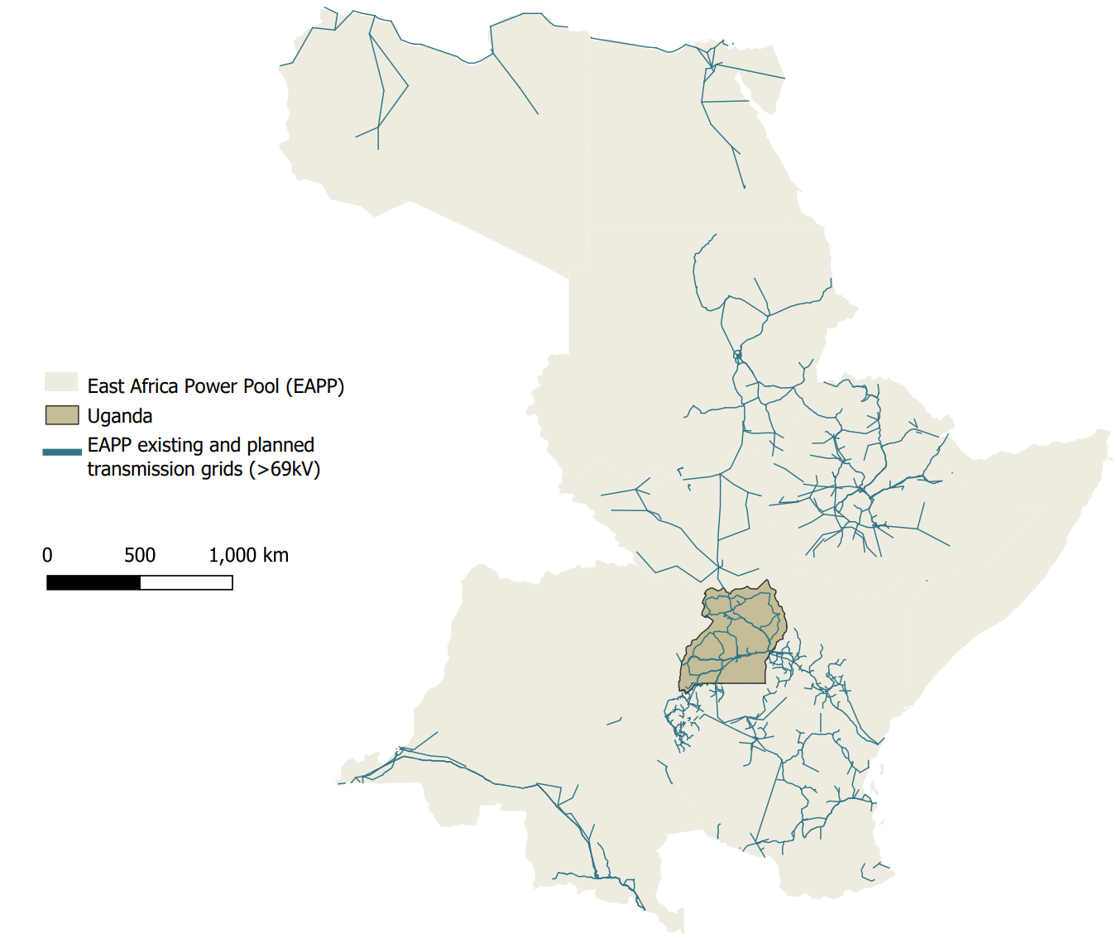
Source: IEA Uganda Energy Transition Plan 2022
The Eastern African Power Pool developed a least cost plan in 2014 that considers the cost of generation in each EAPP member country and optimises flows across countries looking at the least cost options. The regional optimisation resulted in Uganda being a net exporter up to 2032 using its low cost hydro resources to export electricity to Kenya, Rwanda, Tanzania, South Sudan and DRC. From 2032, the plan considers that it would be least cost for Uganda to become a net importer by importing electricity from DRC. However, this assumes the development of interconnectors between Uganda and DRC, strengthening of the network in DRC and the development of Inga hydro power project which have not materialised yet and look highly unlikely to be developed over the next decade.
The next subsections discuss import opportunities for Uganda for each of the five neighboring countries to be considered in the IERMP.

Potential for imports from Kenya
The network in Uganda has been interconnected with the grid in Kenya via a 132 kV line from Tororo to Lessos for several years. The maximum capacity of the existing line is 40MW and was mainly developed for stability reasons of the Ugandan and the Kenyan systems. Uganda has been a significant net power exporter to Kenya in recent years. The UETCL system operation data of 2023 details total export of 249.48 GWh and imports of 33.65 GWh.
In 2014, Rwanda signed a power purchase agreement with Kenya to import up to 100 MW that will be wheeled over Uganda’s network. Subsequently, a wheeling agreement was signed between Uganda, Kenya and Tanzania. Following the wheeling agreement, Uganda embarked on a construction of a 220kV and 400kV line that will wheel this power.
The 220kV and 400kV system of lines between Uganda and Kenya is under construction and is expected to become operational in 2025. A 220kV high voltage line will transmit power from Bujagali hydro to Tororo before being stepped up to 400kV and transmitted along additional new 400 kV infrastructure to Lessos in Nandi County, Kenya. According to recent reports the 131km section of line between Bujagali and Tororo and associated substations is 90% complete and will have a capacity of 300 MW. Reports from August 2024 suggest the Kenya side is currently facing delays.
The optimised import and export flows between Uganda and Kenya from the EAPP master plan indicate that the highest potential for the utilisation of the line is for electricity exports from Uganda to Kenya. The line is hardly utilised for imports in the EAPP master plan as shown in the table below. However, due to the existence of imports from Kenya at current conditions, imports from Kenya will be considered as a candidate option for the IERMP.
Table 43 Optimised least cost imports from Kenya, % of interconnector capacity
From | To | 2025 | 2030 | 2035 | 2040
Kenya | Uganda | 0% | 0% | 1% | 2%
Uganda | Kenya | 63% | 64% | 44% | 51%
Source: EAPP Master Plan 2014 - Volume I: Main report
To model imports from Kenya in the IERMP, the proposed cost reflective tariff of industrial customers connected to the 220kV system in Kenya will be assumed. This is detailed in the table below.
Table 44 Electricity tariff assumed for imports from Kenya for the IERMP
 | Energy charge (KSh/kWh) |  | Monthly charge (KSh/kWh) |  | Demand charges  (KSh/kVA)
 | Peak  (7am-9pm) | Off-peak  (9pm-7am) | Peak  (7am-9pm) | Off-peak  (9pm-7am)
CI6 TOU | 7.78 | 4.53 | 0.03 | 0.02 | 981
Wheeling charge | 2.11 |  | - |  | -
Source: Power Market Study in the Electric Power Sub-Sector, Ministry of Energy and EPRA, 2021

Potential for imports from Tanzania
Uganda is currently connected to Tanzania via a 132 kV transmission line. The existing line is currently used only for electricity exports and no imports according to the UETCL system operation data.
A 400kV cross national transmission project (92km 400kV Mosaka (Uganda) – Mutukula – Mwanza (Tanzania) transmission line, 151km Wobulenzi - Masaka and associated substations (2 x 250 MVA 400/200kV Masaka substation) has been under discussion since 2011. A feasibility study was conducted and completed under the NELSAP project in 2011, after an inter-governmental memorandum on the connection. However, the project failed to attract further interests and it was recently agreed to update the feasibility study in order to fit in the current status and technical requirements. A new feasibility study to update the 2011 one was initiated in 2023 under the financing of the World Bank and EDPP and is expected to be completed in 2027.
According to the EAPP development plan the discussed transmission line would be mainly used to export electricity from Uganda to Tanzania and the line would hardly be used for imports. The optimization results of least cost plan of EAPP foresee minimal inflows from Tanzania to Uganda from 2030 considering the cost of generation between the two countries, as shown in the table below.
Table 45 Optimised least cost imports from Tanzania, % of interconnector capacity
From | To | 2025 | 2030 | 2035 | 2040
Tanzania | Uganda | 0% | 1% | 1% | 1%
Uganda | Tanzania | 52% | 47% | 38% | 33%
Source: EAPP Master Plan 2014 - Volume I: Main report.
Given the uncertainty for the development of the transmission line and the results of the optimisation of the EAPP master plan, imports from Tanzania do not seem to be a competitive option for Uganda to be included in the IERMP. Generation costs in Tanzania (plus wheeling) are higher than generation costs in Uganda. For the IERMP it will be assumed that the line would be developed to facilitate exports.

Potential for imports from DRC
No transmission level connection currently exists between Uganda and DRC. However, distribution level connections to Eastern DRC do exist to supply the Eastern system of DRC which is not interconnected to the main DRC system. The Eastern system of DRC is heavily reliant on diesel generators and imports from Uganda constitute a less costly option.
A feasibility study for the development of a transmission line to DRC was completed in 2012 (72.5km 400kV (220kV) Nkenda (Uganda) – Mpondwe (DRC) transmission line (2x220kV bays at 220/132kV Nkenda substation. There was however no funding that has been committed to the development of the line.
An update of the feasibility study was initiated in 2023. In January 2024 the feasibility study and ESIA study were 45% and 35% completed respectively. The 2024 UETCL corporate strategic plan suggests the line could provide 250 MW of connective capacity to Eastern DRC. The rationale behind the project is to leverage excess electricity from the recently constructed Karuma and Isimba hydropower projects to displace expensive diesel generators currently in use in DRC and provide electricity to rural communities in the Eastern DRC. The 2019 African development bank report on the status of the project targets $160 million USD to realise about 352.2 km of transmission lines and four associated substations.
The EAPP master plan included the interconnection to DRC as a least cost option, initially to export electricity to Eastern DRC and after a decade to interconnect to the main DRC system and potentially import electricity from Inga hydropower project. The optimised electricity flows of an interconnection with DRC with the above assumptions are shown in the table below.
Table 46 Optimised least cost imports from DRC, % of interconnector capacity
From | To | 2025 | 2030 | 2035 | 2040
DRC | Uganda | - | 64% | 50% | 63%
Uganda | DRC | 0% | 2% | 3% | 1%
Source: EAPP Master Plan 2014 - Volume I: Main report
To initiate the possibility of imports from DRC, Inga hydropower project would have to be developed together with an interconnector to DRC main system and the strengthening of the transmission lines within DRC. Given the current status in DRC and historical evidence, it is highly unlikely that the above projects could be developed within the planning horizon of the IERMP and therefore imports from DRC will not be considered as an option.

Potential for imports from Rwanda
A 220kV connection between Shango in Rwanda and Mbarra in Uganda was completed in June 2023. In the remainder of the year 91.25 GWh of electricity was exported from Uganda to Rwanda with imports of 7.58 GWh. The significant net export is due to Uganda’s abundant hydropower generation which is substantially cheaper than Rwanda’s current reliance on expensive thermal generation. There are no current plans for extending the recently completed 220kV connection between Rwanda and Uganda.
Even though the results of the EAPP master plan optimisation foresee that the interconnector will be used mainly for exports, they also foresee opportunities for imports from Rwanda to Uganda, as it is shown in the table below.
Table 47 Optimised least cost imports from Rwanda, % of interconnector capacity
From | To | 2025 | 2030 | 2035 | 2040
Rwanda | Uganda | 1% | 10% | 8% | 9%
Uganda | Rwanda | 15% | 11% | 12% | 12%
Source: EAPP Master Plan 2014 - Volume I: Main report
To assess the possibility imports from Rwanda to Uganda in the IERMP as a candidate option, the electricity tariff of Large industrial customers in Rwanda will be considered. The Large industrial tariff of Rwanda is shown in the table below.
Table 48 Electricity tariff assumed for imports from Rwanda for the IERMP
 | Energy charge (FRW/kWh) | Maximum demand charge (FRW/kVA/month) |  |  | Customer service charge (FRW/month)
 |  | Peak  (6pm-10.59pm) | Shoulder  (8am-5.59pm) | Off-peak  (11pm-7.59am)
Large industrial customer tariff | 94 | 7,184 | 2,004 | 886 | 10,000
Wheeling charge | 23.28 | - | - | - | -
Source: Rwanda Energy Group (REG), 2025

Potential for imports from South Sudan
No transmission level connection currently exists between Uganda and South Sudan. A memorandum of understanding was signed between South Sudan and Uganda in 2015 to develop transmission and distribution infrastructure to connect the two countries. By June 2023 the project had secured funding from the African development bank for a feasibility study. The feasibility study is yet to be completed (expected in 2027) but an ESIA on both sides of the border has been completed.
The project is planned to be a 400kV overhead transmission line between Olwiyo (Uganda) and Juba (South Sudan). The line length is expected to be 308km with 138km in South Sudan and 170 km in Uganda – with new 400kV compatible substations implemented in Juba and Olwiyo. The draft feasibility report put an estimated cost of $300 million. The UETCL grid development plan puts the expected flow along the line between 50 and 260 MW.
The line is expected to be utilised in the short run for exports but in the medium to longer run it could also be utilised for imports depending on the development of the power sector in South Sudan. South Sudan has substantial hydropower capacity that could be used for exports if the projects materialise. The EAPP master selected as least cost options South Sudan’s hydropower candidate projects and assumed that they could be developed within a decade (eg in 2024 from 2014). However, none of these have materialised over the past decade. Import and export flows on the interconnector (assuming hydropower development in South Sudan in 2024) resulted in the trades shown in the figure below.
Table 49 Optimised least cost imports from South Sudan, % of interconnector capacity
From | To | 2025 | 2030 | 2035 | 2040
South Sudan | Uganda | 17% | 39% | 26% | 7%
Uganda | South Sudan | 68% | 2% | 1% | 14%
Source: EAPP Master Plan 2014 - Volume I: Main report
Given the lack of success of South Sudan to develop the domestic hydropower plants over the past decade and the pre-mature status the projects still partake, the IERMP will assumed that imports from South Sudan will not be available at a competitive price over the planning horizon (eg that the development of the hydropower plants that could make imports from South Sudan competitive will not be developed in the near future).

Potential for imports from Ethiopia
Scope for imports to Uganda from Ethiopia is reliant on development of a new interconnector between South Sudan and Ethiopia as well as the development of hydro projects in Ethiopia.
A memorandum of understanding was signed between South Sudan and Ethiopia in 2022 to build a 357km, 230kV transmission line connecting the two countries. This has been followed by the release of a terms of reference seeking an entity to conduct a feasibility study for a connection in February 2025 funded by the African Development Bank.
For the IREMP imports from Ethiopia to Uganda will be considered feasible from 2030, and the import tariff will be assumed the HV Ethiopia industrial tariff plus wheeling costs.

Import risk matrix
Table 50 Import risk matrix
Imports from | Planning risks | Implementation risks | Operational risks
Kenya | - n/a | - n/a | - If the price in Kenya will be competitive for imports
Tanzania | - A transmission line was selected as a least cost option in the EAPP regional master plan. However, it was selected on the grounds of exporting electricity to Tanzania and not for imports.  - A feasibility study was developed in 2011 but it failed to attract further interest.  - A new feasibility study was initiated in 2023 and is expected to completed in 2027. | - When will the feasibility study be completed?  - Will the project attract interest given that it failed to attract investments in 2011?  - Will the government of Tanzania agree on a draft PPA to import electricity from Uganda?  - How long will it take to negotiate a PPA? | - Timing of commissioning  - The line will not be needed for imports if other less costly alternatives are developed in Uganda (which are available).
DRC | - A transmission line was selected as a least cost option in the EAPP regional master plan to import electricity from DRC given that Inga could be developed.  - Feasibility studies have not been initiated for an interconnector to import electricity from DRC.  - Will DRC decide to move ahead with a feasibility study, and when? | - The development of Inga has been delayed for decades and its implementation is still a very risky project.  - Interconnectors will also have to be developed to enable the opportunity to import power from DRC.  - DRC will have to strengthen and interconnect its transmission systems (Eastern DRC with main grid).  - Current status in DRC make the implementation of interconnectors and Inga hydropower project very unlikely. | - Timing of commissioning  - Transmission capacity given that the interconnector would be used to supply other systems/countries as well.
Rwanda | - A 220kV interconnector was developed in 2023 | - A 220kV interconnector was developed in 2023  - When will a draft PPA be available?  - How long will it take to negotiate a PPA?  - Will the PPA price be reasonable? | - Maintenance of the line  - Ability of Rwanda’s power system to actually export electricity will depend on the implementation of Rwanda’s power sector plans.
South Sudan | - Will South Sudan initiate feasibility studies and attract interest to develop its hydro power plants which is a precondition to make imports a competitive option?  - A feasibility study for an interconnector is under development but its orientation is for exports from Uganda. | - The actual development of hydropower plants in South Sudan is uncertain. | - Timing of commissioning
Ethiopia | - Feasibility study for a connection between Ethiopia and South Sudan is underway, however, still reliant on construction of connection between South Sudan and Uganda | - Wheeling charges require negotiation  - When will the necessary feasibility studies and construction be ready | - Timing of commissioning of connections between South Sudan with Ethiopia and Uganda.  - Adequate capacity of hydropower in Ethiopia and competitiveness of costs if wheeling is added
Source: ECA analysis

Policy considerations and targets
The following are the key laws in Uganda’s energy sector:
- Electricity Act (1999, amended 2022)
- Petroleum Supply Act (2003)
- Mining Act (2003)
- Atomic Energy Act (2024)
- Petroleum Acts (upstream and midstream) (2013)
- Biofuels Act (2013)
- National Climate Change Act (2021).
The Ugandan government has established the National Climate Change Mechanisms Taskforce in 2022 to address opportunities related to both Article 6 of the Paris Agreement and voluntary carbon markets.
The national policies and plans that guide the MEMD in meeting legislative objectives include Vision 2040, The Third National Development Plan (NDP III), The National Energy Policy (NEP) for Uganda 2023 and the Energy Transition Plan 2023 (ETP). The key policy targets from these key documents as well as other known targets on carbon emissions and the build out of renewables that are relevant to the IERMP are analysed below.

Vision 2040
Published in 2013 its main objective is to transform Uganda into “a modern and prosperous country” by aspiring to “change the country from a predominantly low-income to a competitive upper-middle income country within 30 years”. The energy sector plays an important role in achieving this.
Vision 2040 provides guidance on the installed capacity per technology type in 2040 mentioning that this will be determined after detailed feasibility studies of the energy mix. The following indicative mix is identified: hydro power (4,500 MW); geothermal (1,500 MW); nuclear (24,000 MW); solar (5,000 MW); biomass (1,700 MW); peat (800 MW) and thermal (4,300 MW), giving a total of 41,800 MW.
The energy related targets it sets are:
- raise per capita electricity consumption to 3,668 kilowatt hours (kWh) by 2040, from 75 kWh in 2010 (by 2020 it was around 100 kWh)
- increase the share of the population with access to electricity to 80% by 2040, from 11% in 2011, (by 2020, 20% of the population was connected to the grid, while a further 27% benefitted from various off-grid solutions)
- 5,000 MW of installed solar PV capacity to be developed by 2040.

National Energy Policy for Uganda 2023
The NEP for Uganda 2023 focuses on expanding the electricity transmission and distribution grid networks; increasing energy efficiency; promoting the use of alternative sources of energy; and strengthening the policy, legal and institutional framework. It provides a detailed list of challenges and policy priorities in most energy subsectors, including electricity, renewable energy, energy efficiency, rural electrification, clean cooking and nuclear power. It does not cover petroleum as the National Oil and Gas Policy was under review at the time.
NEP includes a review of historical changes that occurred since its last publication in 2002, a period during which a situation of severe electricity capacity shortage was reversed to one of capacity surplus. There was also a shift from primarily private sector-led growth to increased use of public-private partnerships (PPPs), with public financing being targeted at increasing affordability.
Within the NEP are defined targets along a number of key metrics including electrification and sources of electricity generation, the key targets are outlined in more detail in the table below.
Table 51 Selected targets from Uganda’s National Energy Policy 2023
Indicator | Baseline (2021) | Target (2040)
Households with at least one source of clean and modern energy on- or off-grid | 50% | 100%
Rate of electricity access (grid-connected) | 24% | 65%
Electricity generation capacity (MW) | 1,251 | 52,481
Electricity consumption (kWh per capita) | 100 | 578
Population using clean cooking fuels and technologies | <15% | 50%
Energy consumption from renewable sources | 92.5% | >95%
Increased energy diversification (energy resources in the energy mix) | 5 | 8
Energy intensity (MJ per 2017 USD GDP) | 9.97 | 3.7
CO₂ emissions from energy activities (Mt CO₂-eq) | 7.39 | 10.1
Source: MEMD, Energy Policy for Uganda 2023.

Climate change and environment
Electricity only accounts for 1% of national emissions. Uganda’s NDC has an unconditional and conditional mitigation target compared to Business as Usual (BaU). The unconditional contribution by 2030 is a 5.9% reduction of BaU by 2030 (8.78 MtCO2e) and the conditional contribution by 2030 is a 18.8% of BaU by 2030 (27.97 MtCO2e), providing a full economy wide contribution (unconditional plus conditional) of 24.7% of BaU or 36.75 MtCO2e. The energy sector’s 2030 NDC contribution is still overall only 1.57% of the total 24.7%.
Uganda’s ETP sets 2065 as the Net Zero target year for the energy sector. More recent announcements by the energy ministry suggest this target is to be brought forward by three years to 2062.
Priority NDC actions in the electricity sector include improving access to electricity to reduce dependence on biomass, promoting the use of renewable energy sources and energy efficient technologies, increasing access to clean cooking options, and rehabilitating and climate-proofing electricity transmission infrastructure.

Renewables
The Renewable Energy Policy (2007), the Uganda Green Growth Development Strategy (2017), and the Third National Development Plan (2020/21-2024/25) set out specific targets.
Although the Renewable Energy Policy (REP) was published in 2007 with targets for the years 2012 and 2017, it is useful to see the progress that has been made. In relation to the electricity industry there was a target to have 1,420 MW of renewable generation installed by 2017 made up predominantly of large hydro, followed by small hydro co-generation, geothermal and municipal waste. This was missed in 2017 but achieved with the commissioning of the Karuma hydro power project of 600 MW in 2024. REP also aimed to increase the contribution of renewable energy sources other than large hydropower to more than 60% of generated output by 2017, however this is unlikely to be achieved anytime soon. Significant things REP has achieved include the establishment of higher feed-in tariffs as a standardised PPA for renewable projects; established a number of financial and fiscal preferences for renewables; and created a Renewable Energy Department at the MEMD. It also ensured security of supply with the installation of 200 MW of expensive emergency diesel generation after a drought in lake Victoria.
The Uganda Green Growth Development Strategy of 2017 aims to increase biomass co-generation by sugar companies; enhance solar power potential, especially for on-grid and local supply, to reach 5,000 MW by 2030; target exploitation of geothermal energy to reach 450 MW by 2030 and 1,500 MW by 2040; and increase utilisation of large and small hydro plants from 50-60% to 80%.
The Third National Development Plan under the objective to “Increase adoption and use of clean energy” is looking by mid-2024 to “construct 200 off-grid mini-grids based on renewable energies”; “promote use of new renewable energy solutions (solar water heating, solar drying, solar cookers, wind water pumping solutions, solar water pumping solutions)”; “adopt electric transport solutions”, eg, solar power motorcycles, bicycles, tricycles; “develop a framework for net metering”; and “build local capacity in renewable energy solutions”. Progress has been made on all but the mini-grids target has not been met and net metering has not yet commenced.
The Energy Policy for Uganda published in 2023 states that “The government shall promote the sustainable development and utilisation of all renewable energy resources in a socially and environmentally responsible manner”. The Energy Policy highlights issues and strategies to address them, but without specifying timelines and targets.

Oil and gas sector policies
The oil and gas sector in Uganda is overseen by the MEMD, which is responsible for granting and revoking licenses, initiative, developing, and implement oil and gas policies, submitting draft legislation, and negotiating petroleum-related agreements. At a higher level, Parliament engages in oversight of the sector and the Cabinet needs to approve PSAs, opening areas for petroleum exploration, and granting exploration and production licenses.
Relevant legislation for the sector include:
- The Petroleum (Exploration, Development, and Production) Act, 2013, which provides a framework for regulating upstream oil and gas activity.
- The Petroleum (Exploration and Production) (Conduct of Exploration Operations) Regulations, S.I. 150-1.
- The National Oil and Gas Policy for Uganda, 2008, which includes policies calling for national participation in the oil and gas sector and supporting the development and maintenance of national skills and expertise.
The Petroleum Production and Exploration Department (‘Petroleum Authority’) is tasked with carrying out oil and gas sector policies. This includes monitoring and regulating petroleum activities, reviewing and approving proposed exploration activity, appraising licensee production forecasts, reviewing and approving licensees’ submitted budgets, and assessing field development plans.

Summary of policy targets to be accounted in the IERMP
A summary of key targets from the mentioned documents relevant for the IERMP are detailed in the table below.
Indicator | Target | Deadline | Source
Solar PV installed capacity | 5,000 MW | 2040 | Vision 2040
Geothermal capacity | 1,500 MW | 2040 | Vision 2040
Nuclear capacity | 24,000 MW | 2040 | Vision 2040
Installed generation capacity | 52,481 MW | 2040 | NEP 2023
Energy consumption from renewables | >95% | 2040 | NEP 2023
Energy resources in the energy mix | 8 | 2040 | NEP 2023
Length of transmission lines | 4,354 km | 2025 | NDP III
GHG reduction (unconditional vs. BaU) | 5.90% | 2030 | Nationally Defined Contribution
GHG reduction (conditional vs. BaU) | 18.80% | 2030 | Nationally Defined Contribution
Geothermal capacity | 1500 MW | 450 MW by 2030, 1500 MW by 2040 | Green Growth Dev. Strategy
Solar capacity | 5000 MW | 2030 | Green Growth Dev. Strategy
Net-zero emissions (energy sector) | Net-zero | 2065 (possibly 2062) | ETP / Ministry
Source: Vision 2040, The Third National Development Plan (NDP III), The National Energy Policy (NEP) for Uganda 2023 and the Energy Transition Plan 2023 (ETP).

Planning criteria and modelling approach
Least-cost generation development plans for any power system are prepared by identifying a set of candidate plants and supply options and assessing the present-valued economic costs (capital, fuel and operating costs) of alternative sequences and combinations of investments that satisfy demand over the planning horizon (20-year projection starting from 2023) at a given level of reliability.
The least cost planning analysis is conducted in economic terms using appropriate shadow pricing and external costs where appropriate. In an economic analysis, historical costs are treated as sunk, taxes and subsidies are excluded, an appropriate economic/social discount rate is used, and values are applied to environmental impacts where appropriate (e.g., the value of greenhouse gas emissions).
Climate change, electrification, environmental, social and other policy targets will also be taken into consideration in choosing the optimal plan. This is done either by placing an explicit value on certain emissions or quasi-qualitatively by, for example, constraining the least-cost plan in certain ways to set a target for the use of renewables or placing a cap on the use of fossil-fuelled generation. The targets that will be used for the IERMP were described in Section 5.
The output of the least cost plan will be an optimised generation, transmission, and demand side management (DSM) development plan covering a 25-year period with associated costs for each scenario. The plan will determine the optimal mix of imported and domestically produced electricity that meets selected targets for different scenarios as well as the optimal mix of renewable resources. A risk analysis using the results of each scenario and of the sensitivity analysis will be conducted to assess demand risks, supply risks, security of supply risks, environmental and social risks, and policy implications for the optimised portfolios.
The result will be a climate resilient IERMP which is robust and flexible, minimising costs and risks while meeting key objectives which include reliability, security of supply, local resource use and minimisation of adverse social and environmental impacts. The generation proposals will be complemented by a transmission plan incorporating essential grid services for system stability and reliability, also addressing the current bottleneck situation.

Generation plan
The generation least cost plan will be produced by assessing all possible combinations of power plant options and selecting the combination of options that meets the demand at lowest cost subject to technical constraints and policy targets. This will involve the simulation of the dispatch of the system in Uganda at hourly intervals for the planning horizon to capture variations of supply and demand at hourly intervals.
Dispatch modelling simulates the operation of the power sector at each time interval (typically by hour) for all possible combinations of power generation options given their technical, financial and economic characteristics. The results of each simulation can be used to identify the least cost plan. Dispatch modelling also allows planners to investigate multiple scenarios in terms of generation mixes as well as any other policies or sensitivities. The software that will be used for the IERMP is PLEXOS.
The results of the dispatch simulation provide information on total capital expenditures; operating costs; fuel costs; emissions; revenues by unit; average, hourly, and regional prices; realised capacity factors over time; and reserve margins, among others.
The costs for integrating generation options to the grid will be included in the analysis which will be done in parallel to the transmission plan. Essentially the generation and transmission least cost plans will be done iteratively until they converge to the least cost solution as illustrated in Figure 36.
Figure 36 Least cost plan modelling process
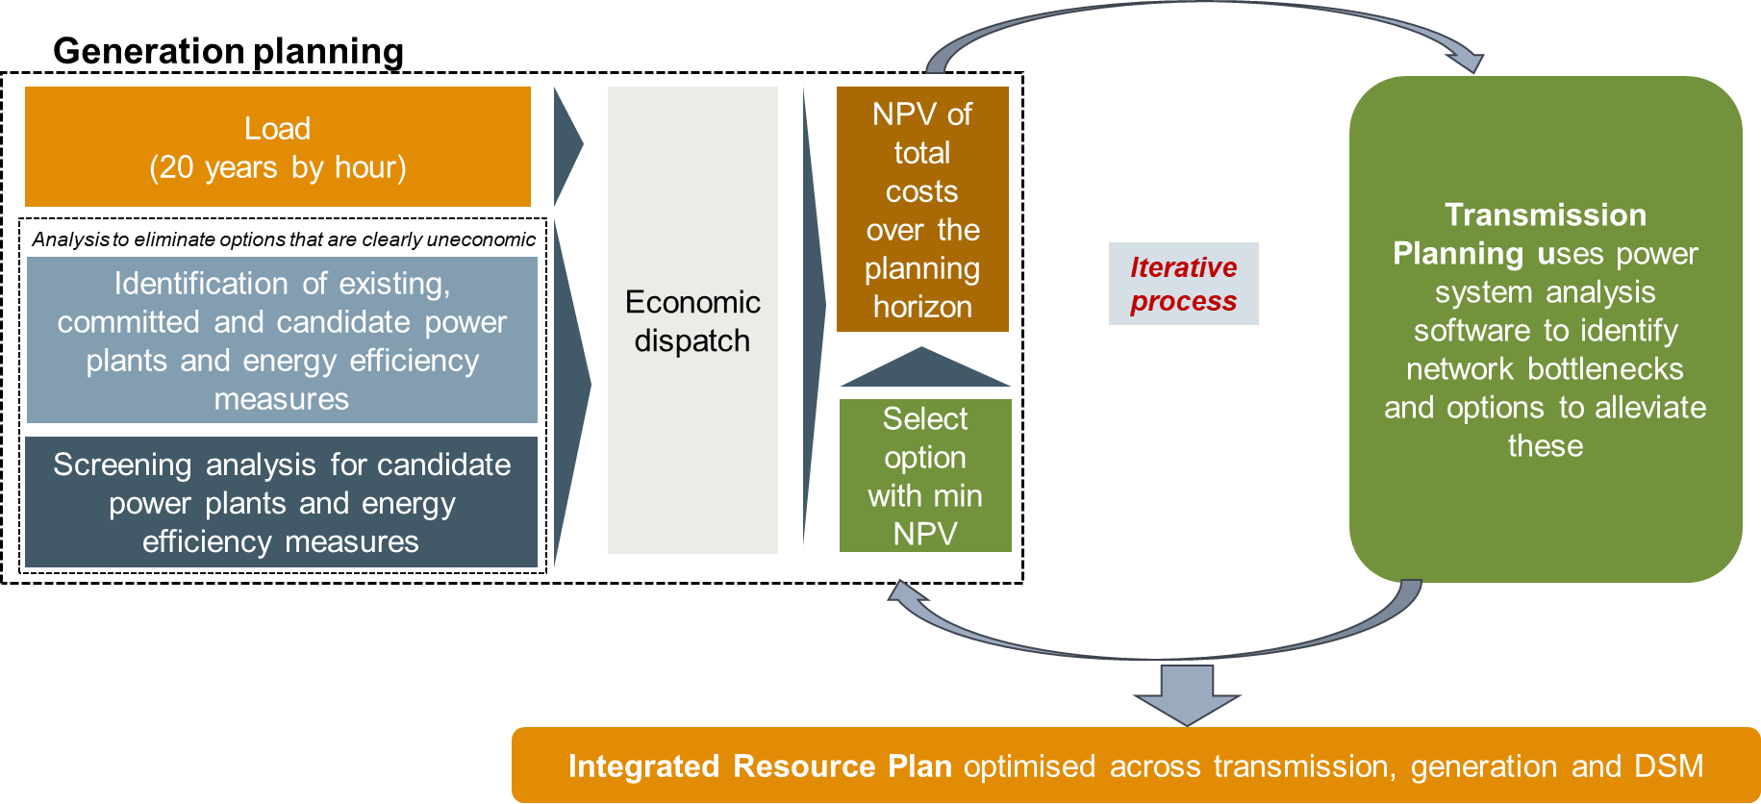
Source: ECA

Transmission plan
The work on the transmission expansion plan will build on the load forecast and the generation expansion planning process described above. The power system studies will also take account of import/export options and work on identification of suitable RES power plants locations. On the latter assessment, the analysis of the power system will also support identification of grid capacity for connection of intermittent renewable plants – both from the point of grid capacity in the local area and the system’s ability to integrate highly variable output from wind and solar PV power plants.
Initial work on the transmission development plan will cover the update or preparation as relevant of a computer model of the transmission system including relevant interconnections to neighbouring systems. The model will be prepared in PSS/E and will document all transmission lines and main power plants on the system along with main power transformers at bulk supply points and the peak and light load at the same bulk supply points. The transmission planning will be based on a set of planning criteria as detailed below.
The transmission expansion plan will ensure that evacuation of power from plants included on the power generation plan can be facilitated while meeting the expected load growth throughout the system. Different grid options, both with respect to voltage and conductor size and configuration, will be assessed to arrive at an optimum reinforcement and expansion plan. The study will consider cost of investments, cost of technical losses and cost of operation and maintenance of each option. Timing of the different projects will also be sought optimised. The planning criteria will ensure a minimum level of reliability, however, where higher levels of reliability may be justified, the study will also take account of cost of supply interruptions in the economic assessment of relevant projects.
Furthermore, fault levels will be documented for all substations in the grid to provide background information on the rating of main equipment (i.e., along with information on maximum loading as provided by the load flow studies).

Distribution plan and electrification
We will build on the electrification plans developed under the MEMD and the World Bank, and the on-going works on demand forecast, energy efficiency, and year-to-year tariff supported customer connection programs. From these documents and the Consultant’s experience from similar electrification programs, we will estimate costs of reinforcement and extension of the distribution systems to meet growth in demand and an increased electrification ratio. This may entail using for instance generic costs per new connection – differentiating for instance between urban and rural areas.

Modelling software

PLEXOS for the Generation least cost plan
The software agreed to be used for the least cost planning analysis is PLEXOS. PLEXOS is a proven simulation software tool that uses cutting-edge mathematical programming and stochastic optimisation techniques, combined with the latest data handling techniques, to provide a robust analytical framework for a range of market participants.
The planning software (PLEXOS) will seek the investment plan with the lowest present-valued costs but constraints will be imposed on the model optimisation. The operating modes of PLEXOS are illustrated below. These modes are usually used for different planning or operating time horizons. The following table describes typical time horizons that PLEXOS can be used to model. For the analysis, LT Plan will be used for the capacity expansion planning problem.
Table 52 Execution modes with typical horizons
Modes | Power System Analysis | Main Output | Typical Horizons
Long-Term (LT) Plan | Generation/Transmission Expansion, Resource Planning, Project viability, Renewable integration/timing | Least-cost plans | 20-30 years
PASA (Project assessment of System Adequacy) | Outage scheduling, (Convergent or classical) Monte-Carlo random events, Regional Capacity Share. | Maintenance Schedule | 1 year - 10 years
Medium-Term (MT) Schedule | Hydro-thermal Coordination, Long-term Take-or-Pay Contracts, Competition Solution (LRMC recovery, Nash Cournot, Bertrand), MT Risk Management | Operating Policies | 1 year - 10 years
Short-Term (ST) Schedule | Day/Week/Hour ahead market simulation. Renewable impact, CCGT operations, Optimal Bidding and ST risk management. | Detailed Operation | 1 day - 1 week
Real-Time (RT) Schedule | Instantaneous Intra-hour market, coupling simulation. | RT economic dispatch | 1-30 min
Source: Adapted from Energy Exemplar.

PSSE for the transmission least cost plan and load flow analysis
The software agreed to be used for the network analysis is PSSE. PSSE is a transmission planning and operations software widely used for system analysis by utilities, universities, research institutes and consultants all over the world.
The software package can be used to perform a wide variety of analysis functions, including power flow, dynamics, short circuit, contingency analysis, optimal power flow, voltage stability, transient stability simulation, and much more.
PSSE provides for easy data handling and exchange of information across a number of platforms for power system analysis. The software also makes use of graphical ways to present inputs and simulation results.
PSSE will be used in conjunction with PLEXOS.

Modelling demand, generators, storage and imports

Demand modelling
For the least cost plan modelling and analysis, the annual demand will be disaggregated at hourly intervals using the annual hourly load profile of 2023. 2023 is considered as a representative year for the profile of the demand and was approved by stakeholders to be used as a representative load profile for the IERMP. The impact of electric vehicle charging and other emerging loads on the load profile was analysed in the Demand forecast report and will be incorporated in the analysis.
The modelling of the system load at hourly intervals to derive the least cost plan is important for power system planning purposes. Generation must be designed to meet demand at every hour with demand fluctuating by hour. At the same time, renewable energy generators cannot produce electricity and their ability to generate at each interval has to be taken into consideration. The generation profile of renewable energy generators by hour must be superimposed to the demand by hour to ensure that the plan can meet the demand at all hours.

Thermal generators modelling
Thermal power plants are dispatched based on the least cost approach. The PLEXOS model calculates the variable operating costs of each power plant at each interval and ranks power plants by merit order. Considering the load at each interval, technical constraints and costs of generation for each generator, the model recognises which power plants should operate in each interval to minimise costs.
The main features to estimate the operating costs of the existing, committed and candidate power plants are described in the previous subsection and include maximum available generating capacity of each unit, fuel costs (calculated from the heat rates and fuel prices), build costs by the year of construction for candidate options, fixed O&M cost, variable O&M cost, availability of hydro resources, network constraints, forced outage rates, maintenance outage rates, project earliest date of commissioning (for committed power plants and candidate power plants) and assumed decommissioning dates for all units.

Hydro modelling
Hydro should be dispatched whenever load increases above a certain level, with that level set such that all the stored hydro energy will be used perfectly (e.g. cost minimised) over the period in question. If the level is set too high, the stored energy with very low variable cost of generation will not be fully used. If it is set too low, available hydro generation will used in periods when it is not needed, and costs will be higher than necessary.
The above principles are applied to optimise hydro power generation given the average annual energy that is available from the power plants, the maximum capacity and the cost of power production. Scenarios with dry years will also be simulated for hydro generators to assess the impact of drought on the least cost plan.

Solar and wind power plants modelling
To model the operation of intermittent renewable energy generators (i.e. solar PV generators, wind generators, etc), hourly production profiles will be used. The hourly production profiles were sourced from hourly historical data on solar irradiation or wind speeds by location. Different production profiles are developed for each location to reflect the differences in solar irradiation in each area and wind speeds in each area. For each candidate project, the hourly production profile will be scaled to match the assumed annual capacity factor of the candidate project.

Storage modelling
Storage systems such as BESS are modelled based on standard fundamentals of a least cost system approach. Storage plants will be permitted in the model to charge or discharge each hour. The least cost optimisation will result in energy being input into the battery when the marginal cost of electricity is cheap – for example at off-peak times and discharged when it is expensive at peak times. The objective function is to minimise total system costs.

Interconnections modelling
Transmission connections to neighbouring countries will be included in the simulation. Instead of modelling neighbouring regions at a highly granular level like Uganda each interconnected country will have an associated cost of power based on a combination of historic analysis and forecast studies to give a plausible cost of electricity over the time horizon of the simulation.
The least cost optimisation will result in power flows that follow economic fundamentals. If the cost of electricity imports is cheaper than Uganda power generation, there will be import flows of power into Uganda. Flows will respect known transmission capacity constraints and the forecast view of the development of transmission countries to neighbouring countries across the time horizon of the simulation.

Planning criteria
The primary objective of generation expansion planning is to find the least cost long-term expansion scenario that supplies the forecast demand at an acceptable or specified level of reliability.

Generation planning criterion for the IERMP
There are usually two types of reliability criteria used in generation expansion planning:
- A deterministic criterion – it is based on the ability of firm generation capacity to meet the demand in the event of the unforeseen loss of a generating unit. The deterministic reliability criteria are normally expressed in three different ways: (i) a fixed amount of capacity in MW to account for the random outage of one, two or more largest units, (ii) a percentage of annual peak demand, or (iii) a percentage of annual peak demand plus a fixed amount of capacity.
- A probabilistic criterion – it is based on a number of hours of unserved energy per year. It includes both the loss of load probability (LOLP), where a 1% LOLP indicates that the installed generation will not, on average, be able to meet the forecast demand in a given year for 87.6 hours; and the expected unsupplied energy (EUE), which is the quantity of expected energy that a system would not be able to serve with the planned generation system in a given year, expressed either in MWh or as a percentage. Both are obtained from the convolution of the load demand and available generation taking account of plant availability and reliability.
The grid code of Uganda requires “the operating reserves to be large enough to cover the loss of the largest generating unit in the system.” Assuming that the largest unit of the system is Karuma units (eg 100 MW) and that peak demand in 2023 was 986 MW, the required reserves margin would be 10%. UETCL’s Corporate Strategic Plan 2024-2029 published in 2024 also outlines a target reserve margin of 10%.
In line with the planning criteria set in Uganda, reliability of supply in IERMP will be ensured by targeting a reserve margin (deterministic criterion) of 10% of firm capacity above the peak demand relative to peak demand. The same reserve margin will be used throughout the study horizon.
The contribution of different generating technologies is an important parameter to avoid overvaluing generating plants which cannot be depended upon to always deliver firm power. The contribution of different generating technologies will be determined by the minimum expected level of production at the time of peak demand. For storage options, the derating factor will be set to 0% for 1h duration batteries, 25% for 2h duration batteries and 50% for 4h duration batteries.

Transmission network planning criteria
The “Grid Development Plan 2023-2040” prepared by UETCL is understood to be based on a typical N-1 planning criteria matching the criteria for the grid in the EAPP. We propose to use similar criteria for the studies to be conducted as part of the preparation of the IERMP.
The N-1 reliability criteria ensures that the transmission system can sustain the outage of a single element (for instance a transmission line or power transformer) without loss of load or loss of synchronism – thereby avoiding cascading faults that may black-out part (or all) of the system. To the extent that cost of losses or cost of outages justifies further investment, such investment will be considered to ensure that the system provides an overall least cost solution considering generation options and supply to load centres.
The planning criteria applied by UETCL furthermore allows for short-time overload up to 120% of the continuous thermal rating although this is “depending on the age and physical condition of the equipment”. Considering the uncertainties in future development and load growth, we propose to carry out the IERMP based on no short-time overload, thereby leaving room for operational margins. The thermal capacity for all components will therefore be set at 100% of the rated continuous capacity.
Substation voltages will furthermore be limited to +/- 5 % of normal voltages in normal operation and +/- 10 % during contingencies as shown in the table below.
Table 53 Voltage limits under normal and contingency operation (kV)
Voltage level | Normal operation |  | N-1 contingencies
 | Minimum | Maximum | Minimum | Maximum
400 kV system | 380 | 420 | 360 | 420*
220 kV system | 209 | 231 | 198 | 242
132 kV system | 125.4 | 138.6 | 118.8 | 145
66 kV system | 62.7 | 69.3 | 59.4 | 72.6
Source: Grid Development Plan 2023-2040” prepared by UETCL. Note: UETCL states 440 kV as the maximum value in this case. Maximum equipment rating is 420 kV and operation at higher voltages should be limited to ensure no damage to the equipment on the system.
It will be assumed that the power factor of the loads on the system will be corrected at distribution level or by switched compensation in key substations. Main power plant generators on the system and any dynamic VAR systems (SVCs, STATCOMs) will be used to support reactive power requirements following disturbances on the system. Line shunt reactors will be included when required to ensure safe energisation of long lines.

EAPP planning criteria to be adopted in the IERMP
Although the Easter African Power Pool (EAPP) is not mandating a specific margin of generation capacity above peak demand the most recent planning gap analysis benchmarks the quality of security supply against a target of 15% of peak demand. A 10% reserves margin criterion will be adopted for the IERMP in line with the regulations in Uganda.
In evaluating the current level of security, the EAPP applies capacity credit, a number to indicate the chance of production during peak demand. Capacity credits are calculated on a plant specific basis – if specific information does not exist the following capacity credits are used for different technologies.
Table 54 EAPP Capacity credit assumptions
Generation Type | Capacity Credit
Thermal | 100%
Nuclear | 100%
Geothermal | 100%
Hydro, Reservoir | 100%
Hydro, Run of River | 50%
Waste | 50%
Wind | 5%
Solar | 0%
Source: EAPP Power balance statement, 2020
The above derating factors will also be applied to the IERMP, however, the derating factors for Solar PV and Wind to system the system peak demand will be set more accurately by their generation profiles (using Uganda’s Solar irradiation and wind speed hourly estimates) at time of system peak.

Economic and financial parameters

Discount rates
The analysis is carried out using a social discount rate (SDR) which is the rate of discount which reflects society's preference for present as opposed to future consumption, i.e. a measure of society's inter-temporal and inter-generational preferences. The SDR can also be thought of as the rate of return on capital expected by society, rather than the investment criteria that may be used by the private sector.
Because the SDR in the first interpretation is essentially a value judgment, it is not appropriate that the value be set by outside consultants. It is rather a key parameter to be set by the IRP Working Group.
The Government of Uganda may already have established an SDR to be used in evaluating national infrastructure projects. If not, corresponding to the different definitions of the SDR, there are two approaches to assigning a value. The first is based on the social rate of time preference adjusted for the economic growth rate (higher SDRs for rapidly growing economies), while the second is the social opportunity cost of capital which quantifies the government’s borrowing constraints.
Typical practice for national economic studies is to set the SDR at between 6% and 10%. This rate is then used in this study to calculate the net present value (NPV) of input and output costs, expressed in real terms. High SDRs like 10% favour short-term gains while lower SDR values make it more likely that projects will be chosen with high up-front costs and social and environmental benefits spread over the long term. Renewable energy projects have cost-benefit profiles that fit this pattern, so low discount rates support decarbonisation.
For this IERMP we propose using a social discount rate 10%.

Cost and present worth datum
All costs will be expressed in constant 2023 prices. All present worth and discounting calculations will also use 2023 as the reference point.

Duties and taxes, Interest During construction
Duties, taxes, and interest are not included in this economic study. Interest is a financial cost and as such is excluded from the economic evaluations. The construction period varies by technology, and this affects the cost to develop the projects in present value terms. This is considered by distributing the capital expenditure over the entire construction period.

Planning horizon
As per the requirement outlined in the TOR, the plan is to cover a development period of 25 years and it is intended to model the system from 2023 to 2050.
In order to adjust for end-of-planning-horizon distortions, it is a common practice in integrated resource planning to account for the full residual values of each investment. The PLEXOS model incorporates the post-horizon value of a project into deriving economic investment decisions.

IERMP scenarios and sensitivities
Scenarios and sensitivities are modelled to handle the uncertainty of key assumptions and provide insights to key policy questions. Table 55 outlines the scenarios and the sensitivities to be conducted in the IERMP. This selection was agreed upon after discussion with stakeholders at the resource assessment Workshop. In total, 5 scenarios and 8 sensitivity analysis will be simulated for the IERMP.
Only the policy targets scenario includes supply side targets taken from the Vision 2040 and NEP 2023 documents. This reflects that the inferred generation from supply targets are significantly higher than the forecasted base demand. Therefore, the policy targets scenario uses an expanded demand forecast consistent with the expansion in supply targeted by policy.
Table 55 Scenarios and sensitivities for the IERMP
Scenario name | Demand | Supply scenarios and emission targets
Scenarios
Unconstrained | Base transition | - No policies, targets or constraints
This scenario is used as a Benchmark scenario to compare costs and benefits across scenarios.
Delayed  transition | Delayed transition | - Net-zero emissions by 2065  - 18.8% GHG reduction by 2030
The delayed transition scenario reflects a slow economic growth trajectory.
Base transition | Base transition | - Net-zero emissions by 2065  - 18.8% GHG reduction by 2030
The Base transition scenario reflects the forecasted economic growth by international institutions and the government of Uganda and the implementation of policies and plans of the Government of Uganda.
Ten-fold growth strategy | Ten-fold growth strategy | - Net-zero emissions by 2065  - 18.8% GHG reduction by 2030
The Ten-fold growth strategy scenario reflects the Ten-fold growth strategy of the Government of Uganda.
Policy targets | Policy targets | - Net-zero emissions by 2065  - 18.8% GHG reduction by 2030  - Vision 2040 and NEP 2023 generators capacity targets
The Policy targets scenario adopts the economic growth, policies and plans mentioned in NEP 2023.
Sensitivities on the Base transition scenario
Dry hydro conditions | Base transition | - Dry years available generation for hydro power plants
The Dry hydro conditions sensitivity considers the impact of climate change on the least cost plan assuming dry hydro conditions prevailing throughout the planning horizon.
Nuclear path | Base transition | - Force nuclear to the mix if not selected as a least cost option
The Nuclear path sensitivity will force nuclear power plants to the capacity mix in case they are not selected as least cost options to identify the impact of such a policy decision.
Delayed natural gas availability | Base transition | - Delay the development of the gas pipeline with Tanzania by 5 years (eg by 2038)
The Delayed natural gas availability sensitivity will explore the least cost plan assuming that natural gas from the perspective pipeline will not be available in 2033 but later.
Delayed nuclear development | Base transition | - Delay the development of the nuclear power by 5 years (eg by 2038)
The Delayed nuclear development sensitivity will explore the least cost plan assuming that nuclear power cannot be implemented as planned (eg in 2033) but later.
Regional integration | Base transition | - Allow imports from EAPP (all other scenarios will not allow imports from EAPP and will be modelled to support self-sufficiency)
The Regional integration scenario will allow imports from EAPP to explore the benefits and costs from regional integration.
Rapid reduction of RES/BESS capital costs | Base transition | - Rapid reduction in BESS & RES capital costs
All other scenarios assume that RES and BESS capital costs reduce over time as shown in section 3. This sensitivity will explore the impact on the least cost plan with a more rapid decrease on RES and BESS capital costs in comparison to the other scenarios.
High natural gas prices | Base transition | - High fuel price scenario
All other scenarios assume the base fuel price forecast shown in section 2.13. This sensitivity will adopt the high fuel price forecast of section 2.13 to explore its impact on the least cost plan.
Discount rate +/-3% | Base transition | - Discount rate adjusted up and down 3%
This sensitivity explores the impact of lower or higher discount rates on the least cost plan.
Source: Agreed with MEMD and stakeholders during the Preliminary studies Workshop. Note: Only the policy targets scenario includes supply side targets taken from the Vision 2040 and NEP 2023 documents. This reflects that the inferred generation from supply targets are significantly higher than the forecasted base demand. Therefore, the policy targets scenario uses an expanded demand forecast consistent with the expansion in supply targeted by policy.

Annexes
- Maps with excluded areas for solar PV and wind development
Exclusion parameters for solar PV and wind development are listed in the table below.
Table 56 Exclusion criteria for solar PV development
# | Land use type | Included | Excluded
1 | Water |  | X
2 | Trees |  | X
3 | Flooded vegetation |  | X
4 | Crops | X
5 | Built area |  | X
6 | Bare ground | X
7 | Snow/Ice |  | X
8 | Rangeland | X
Source: ECA and Norconsult analysis
Exclusion areas for the above parameters are shaded with black colour in the following maps.
Figure 37 Maps with exclusion areas (in black) for solar PV development
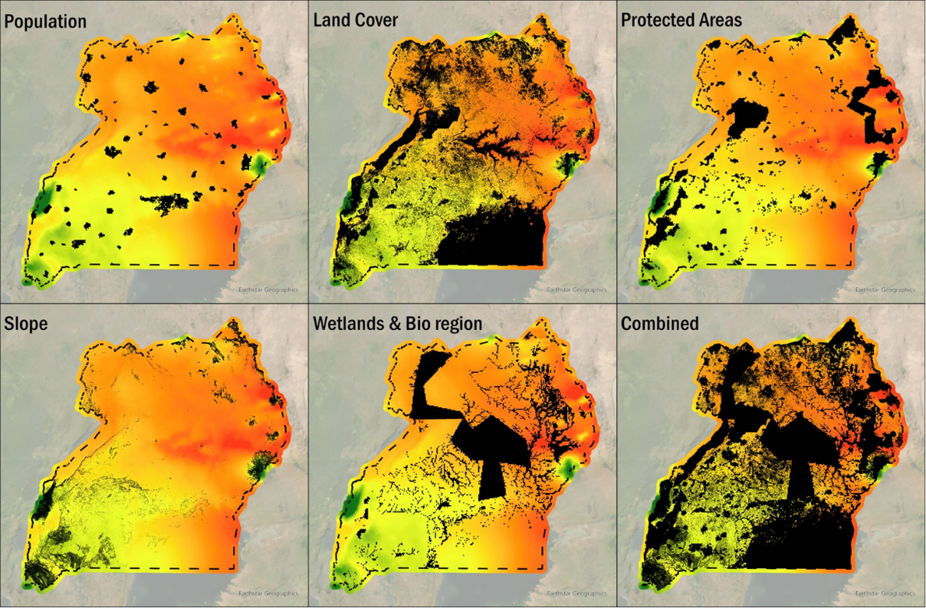
Source: ECA and Norconsult analysis

Ministry of Energy and Minerals Development, Key Achievements in 2022/23 FY towards Vision 2040
Reuters, 12 May 2023, Uganda signs oil exploration deal with unit of Australia’s DGR Global.
Ministry of Energy and Minerals Development, 2022 Statistical Abstract, Tables 2.3 and 2.4
IEA, 2023, Uganda Energy Transition Plan, Figure 2.26
Ministry of Energy and Minerals Development, The Annual Resource Report 2023 - Final Draft
As indicated by the Ministry of Energy and Minerals Development in July 2025.
The negotiations with Alpha MBM Investments started after negotiations with one consortium missed an extended deadline.
Uganda Radio Network, 20 July 2024, Refinery Negotiations On, FID Not Yet In Sight.
Uganda Radio Network, 20 July 2024, Refinery Negotiations On, FID Not Yet In Sight.
Ministry of Energy and Minerals Development, 2022 Statistical Abstract, 2.1.8
Ministry of Energy and Minerals Development, 2022 Statistical Abstract, 2.1.7
Petroleum authority of Uganda -- Government’s of Tanzania and Uganda to conduct feasibility study for natural gas pipeline
Merrill, M.D., and Tewalt, S.J., 2008, GIS representation of coal-bearing areas in Africa: U.S. Geological Survey Open-File Report 2008-1258
Planned for 2030 with a capacity of 1.4 GW.
Planned for 2034 with a capacity of 24.1 GW.
Uganda mineral profile 2011
IAEA reviews Uranium exploration plan amid Uganda’s journey to domestic nuclear power, July 2024
https://www.oecd-nea.org/nea-news/2004/22-1-uranium.html
World Energy Council Peat Strategic Insight 2013
Peatland overview in Uganda
Uganda Vision 2040
International Energy Agency, Climate Impacts on African Hydropower, June 2010
Overview of hydropower resources and development in Uganda, Katutsi et.al 2021
Status of Geothermal Exploration in Uganda, Bahati. Et al., 2008
ERA geothermal license report March 2023
Renewable Energy Consumption and Economic Growth in Uganda (Mutumba, Mubiinzi, Milly and Otim)
MEMD 2023 Statistical abstract
The potential of energy recovery from municipal solid waste in Kampala City, Uganda by incineration (Amulen et.al 2022).
Hydraulic conditions of the Ugandan portion of Lake Victoria, (2005),
Analysis of Lake Victoria vegetation and shoreline monitoring data (2012)
https://www.iea.org/reports/world-energy-outlook-2024
https://www.eacop.com/
Oilprice.com, 13 June 2024, Standard Bank to Move Forward With Funding $5-Billion African Oil Pipeline.
Uganda National Oil Company – Kampala Storage Terminal
https://www.engineeringtoolbox.com/fuels-higher-calorific-values-d_169.html
https://www.iea.org/reports/world-energy-outlook-2024
Assuming a conversion rate of 3.36 GJ/MWh.
The only exception with a dam is Bujagali hydro power plant.
To prioritise sites with the highest generation potential and consequently lower costs.
To excludes development in areas with water, trees, flooded vegetation, built area, snow/ice, etc.
To exclude zones with a slope higher than 20%.
To exclude areas for solar development in wetlands, lakes, rivers and bio regions.
To exclude solar PV development in protected areas.
To prioritizes sites that are closer to the existing or planned grid.
Assuming a solar performance ratio of 80%
Australian Energy Market Operator, 2024, National Renewable Energy Laboratory (NREL), 2023 and the International Energy Agency (EIA), 2024.
Floating solar panels could provide much of Africa’s energy
Murchison falls Lake Victoria summary
Example projects from Singapore suggest 130MWp of floating solar per km² of water surface, "World Bank report on Sembcorp Tengeh Floating Solar Farm, Singapore",
To prioritise sites with the highest generation potential and consequently lower costs.
To excludes development in areas with water, trees, flooded vegetation, built area, snow/ice, etc.
To exclude zones with a slope higher than 20%.
To exclude areas for wind development in wetlands, lakes, rivers and bio regions.
To exclude wind development in protected areas.
To prioritizes sites that are closer to the existing or planned grid.
Assuming a solar performance ratio of 80%
2023 Renewable Power Generation costs (IRENA, 2024)
IRENA Power generation costs (2023) study assumes fixed O&M equal to 2% of capex
IRENA Power generation costs (2023) study assumes fixed O&M equal to 2% of capex
IAEA, Project Management in Nuclear Power Plant Construction: Guidelines and Experience
UETCL 2023-2040 development plan
With a capacity less than 50 MW
IRENA, Green Hydrogen Breakthrough, 2021.
Lazard assumes a 98% capacity factor and 15-year lifetime, lifetime is inflated and to reflect an assumed capacity factor of 70%
1.2% of capital costs, as reported in NREL DOE Hydrogen and Fuel cells program
An energy degradation per cycle is derived from these values, assuming 1 cycle per day (AEMO).
Gives an indication of the cost of producing one unit of energy (MWh) under specific conditions.
UETCL - completion of all electro-mechanical works at Bujagali, Tororo and Mirama
Kenya's delay frustrates regional power line plan
Daily Monitor -- Inside Uganad, Tanzania power lines deal (May 2022)
IEA – Uganda Energy Policy 2023
African Development Bank project information memorandum Aug 2019
MEMD June 27 Press Release
AfDB - South Sudan -- Uganda Power Interconnection Project
AdDB, EU to finance Uganda-South Sudan power interconnection project
Africa Energy portal - South Sudan and Ethiopia sign MoU for electrcity supply
ToR for consultancy service for the preparation of a feasibility study of the South Sudan and Ethopia interconnection project
Karuma Project seems to have been fully tested and synchronised in February 2024 according to this source https://www.africa-energy.com/live-data/article/final-unit-commissioned-ugandas-karuma-hydro-hydroelectric-power (accessed 1 August 2024). However, this source suggests it will be commissioned in August 2024 https://www.newvision.co.ug/category/news/karuma-hydro-power-project-launch-set-for-aug-NV_191870 (accessed 1 Aug 2024). It could be that February was testing only and the official commissioning is Aug 2024.
Does not include demand side targets, covered via the demand forecast
The_Electricity_(Primary_Grid_Code)_Regulations,_2003_SI_24
UETCL Corporate Strategic Plan 2024-2029 (2024)
There is an extensive literature on the SDR. See for example Serebrisky, Ancor Suárez-Alemán (2015) “Time Goes By: Recent Developments on the Theory and Practice of the Discount Rate” and Missaka Warusawitharana (2014), “The social discount rate in developing countries”.

